**GlobiScope Analysis Software**for the Globisens QX7 Digital Microscope

**Quick Start Guide**

Contents

[GlobiScope Overview 1](#_Toc385498320)

[Overview of home screen 2](#_Toc385498321)

[General Settings 2](#_Toc385498322)

[Measurements 3](#_Toc385498323)

[Movie capture 4](#_Toc385498324)

[Gallery 5](#_Toc385498325)

[Graphics and Annotation 6](#_Toc385498326)

[Help 6](#_Toc385498327)

# GlobiScope Overview

GlobiScope is a very intuitive and easy-to-learn application: 6 icon-based buttons control all the features of the software. Microscopes today don’t need an eyepiece; instead objects can be viewed via software on a screen in high resolution. This allows for more accurate viewing as well as a more collaborative learning experience since many students can view the screen at same time. Furthermore, the teacher can project the screen onto a white board for the entire class to see and perform analysis.

With GlobiScope data can even be recorded and stored as snapshot or video clip files. Data frames can be collected at fixed intervals or manually. The data playback can run faster than real-time making very slow developing scientific phenomenon viewable. In addition to data analysis, the software allows layers of graphics and annotation to be added to any data view.

# Overview of home screen

In the GlobiScope main screen the large video screen on left shows the specimen seen by the microscope.

To the right of the main display screen **six icon buttons** control all the GlobiScope features: Settings, Measurements, Movie capture, Gallery, Graphics, Annotation and Help.

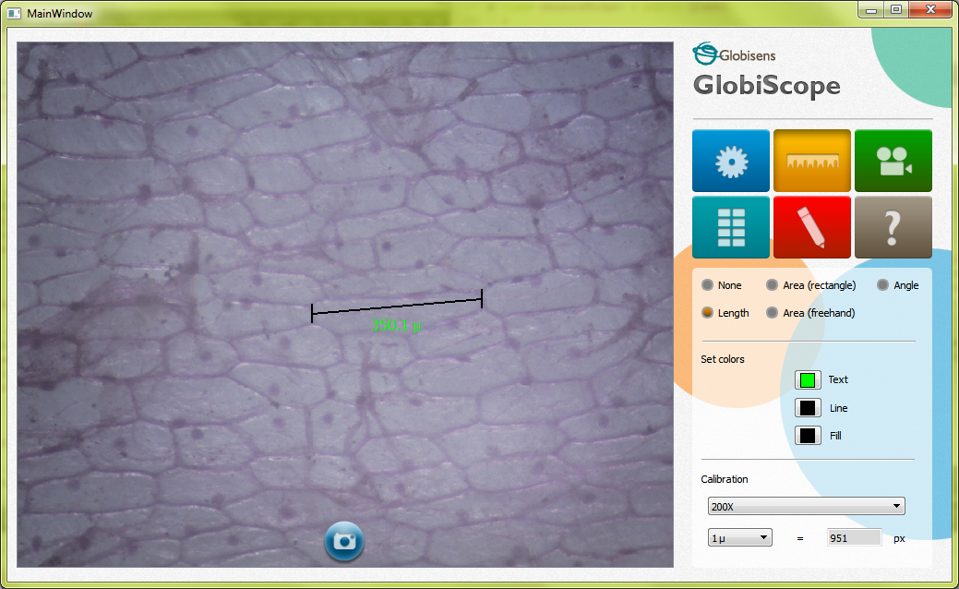

The area at the bottom right corner of the software automatically changes according to the different modes of the software. When taking a snapshot, the gallery view is displayed automatically

The **circular camera icon** in the center bottom of the screen allows you to manually capture snapshots of data. The image seen in video screen shows the real-time view.



## General Settings

**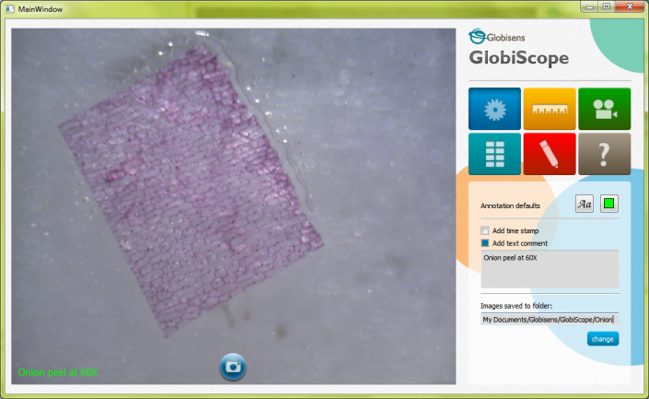  
Add time stamp:** This allows the user to add the time the image was taken. The timestamp and grid can be customized, allowing the user to select a color that will be easy to read and stand out from the viewed object.

**Show grid**: This allows the user to get a sense of the real dimensions of the viewed object, with the reference to the known dimensions of the grid. When clicked on a grid appears over the viewing screen. At the bottom right corner there is a scale that allows the user to understand the dimensions of the grid. The scale is based on the magnification used – 10x, 60x or 200x.

**Image format:** This allows the user to select from four different image formats: JPG, TIFF, PNG and BMP.

**Images saved to folder:** Users can choose to save their files in the default folder or control where image files are stored.

**Take a snapshot:** This allows users to schedule a snapshot, even when they are not there – either taking a single snapshot at a later time, or a scheduled movie (see movie capture section).

## measurment_button.png Measurements

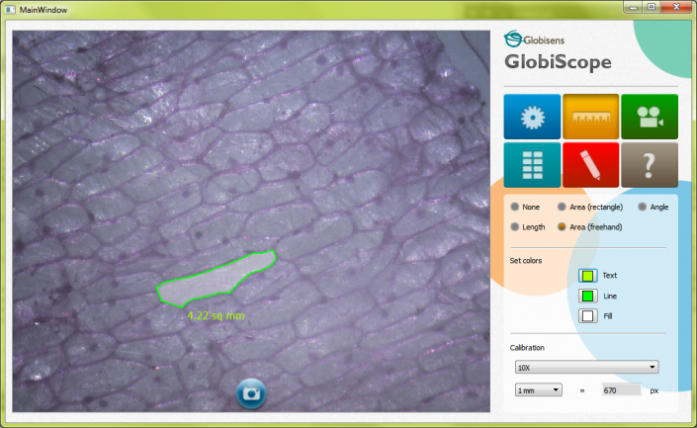  
In measurements mode, the user can measure length, angle and area: For measures to have real values the microscope’s lens should be inputted – 10x, 60x or 200x.

**Length:** This provides a ruler on the screen which can be dragged and scaled to measure different elements on the screen.

**Angle**: The angle being measured can be decreased or increased by dragging this object on the screen. First position the angle: By hovering over the angle point, the mouse becomes a hand icon allowing you to drag the angle around the screen. By placing the mouse on either line, the stretch icon appears which allows the user to increase or decrease the angle; as well as increase the length of the range for better accuracy and convenience.

**Area (freehand)**: This allows the user to draw a frame over the object to measure its area. The area to be measured becomes shaded, with the measured area of the shaded area shown on screen.

**Area (rectangle):** This allows a rectangle to be panned or stretched to measure an object area on screen.

**Set colors**: Once again this customized feature accommodates the measuring of all substances by allowing the user to select colors that will be clear and stand out from the background. The easy interface allows users to control the colors of text, line and fill.

**Lens:** As mentioned earlier this allows the user to get correct measurements according to the type of lens the microscope is using.

**Units**: – This allows users to select the unit of measurement to be millimeters, centimeters, or microns.

**Calibration:** As explained, the software shows the measurement values, converting image pixels to physical values. In case a higher accuracy is needed, the software allows manual calibration.

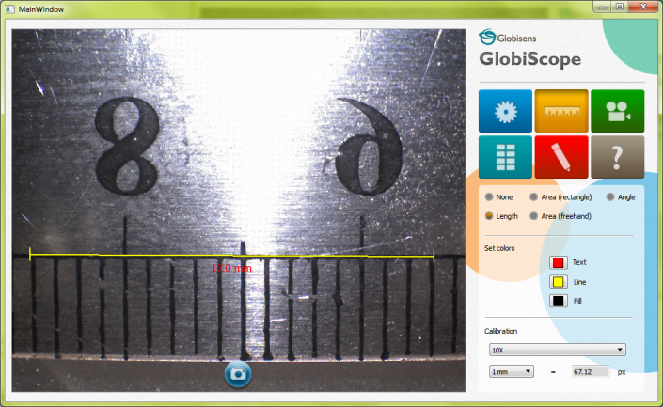The process is as follows:

1. Place an object with known dimensions (e.g. mm paper, ruler) under the microscope.
2. View the microscope online, and use the Length measurement tool to measure the reference object.
3. Calibration is performed by entering the real known length at the "**Real length**" field, and clicking "**Calibrate**"

## movie_button.png Movie capture

**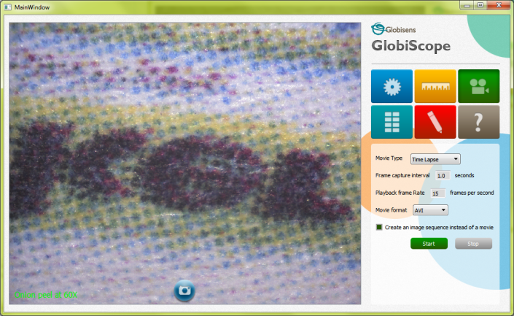**

**Movie type:** Users can select the movie type: Time lapse or stop motion.

**Frame capture interval**: Having selected time lapse then the user can define the interval of snapshots taken and define the total number of captured images. The minimum capture interval is every half second.

When selecting time lapse mode two control buttons: “**Start**” and “**Stop**” are available. When selecting stop motion only the “**snap**” control button is available. Here the frame capture interval is not necessary, since frames are taken manually and can be later wrapped together as a movie.

**Playback frame rate**: When making a movie, this allows the user to determine how fast the playback will be of the collected images. The default is set to 15 frames per second.

**Movie format:** There are a number of movie formats available including AVI, MOV and MP4.

**Create an image sequence instead of a movie**: Here the collected frames are placed in a folder from which the user can select specific frames or make their own movie with selected images.

As each **frame** is taken, the progress indicator beneath the control buttons is updated.

Beneath that are the scheduling buttons allowing selection of capture start time, following which how many captured frames to stop.

## gallery_button.png Gallery

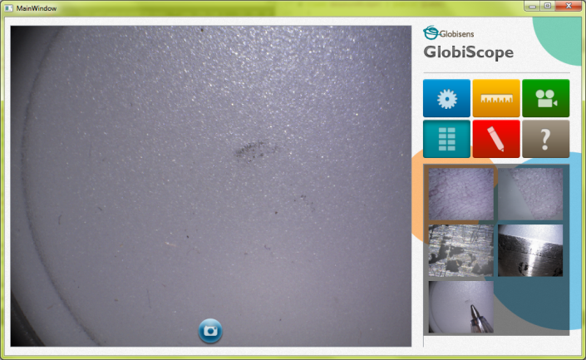  
The gallery appears in the bottom right frame. It can be opened by clicking on the gallery icon and also automatically opens whenever an image or movie is captured.

Clicking on the gallery shows all the collected data in three formats: As images, as a folder or collection of images and as a movie icon for a recorded video. Hovering with the mouse over each file also shows its name.

Clicking on a still image will show the image in the larger viewing display to the left. The image viewer has four controls featured on the screen: Save, print, brightness and contrast.

The top left “back” button will take you back to the live microscope.

Clicking on a movie icon will show the movie with standard video screen controls at the bottom of the screen: Start, stop, forward, backwards etc.

## draw_over_button.png Graphics and Annotation

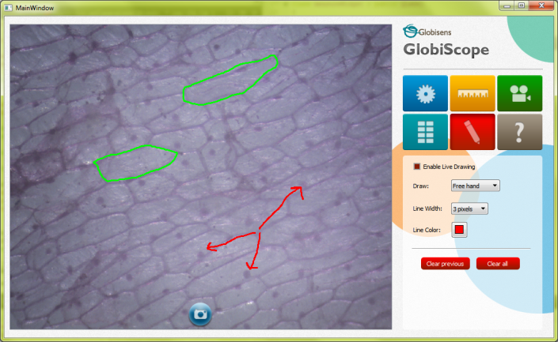  
There are three available modes of drawing.

**Enable freehand**: This allows the user to draw whatever shape they want. Simply click enable live drawing box and then draw over the screen by dragging the mouse. Selecting the pixel changes the line width and the color box allows the user to select the color of the line.

**Lines:** This allows the user to draw with straight lines; again the width and color of the line can be adjusted.

**Text**: Here writing the text in the box and clicking add will add the text to the viewed image in the left side screen. Then using the hand icon of the mouse, the text can be dragged to wherever the user wants it to appear on the screen.

**Clear previous** – clears the last drawing and **Clear all** clears all previous drawings

## help_act_button.png Help

Clicking on this button will open the quick start guide PDF