

**2012**

Globisense Marketing

2012

Labdisc Teacher Training Notes

**Table of Contents**

Contents

[The Importance of Hand-held Learning 3](#_Toc330887526)

[Manual Science Experiments 3](#_Toc330887527)

[Labdisc - it’s Time for Something New! 4](#_Toc330887528)

[Configurations for Every Science 5](#_Toc330887529)

[Experiment Workshop 6](#_Toc330887530)

[Free fall 7](#_Toc330887531)

[Boyle’s gas law 8](#_Toc330887532)

[Walk in the park 9](#_Toc330887533)

[Day and night temperature change 10](#_Toc330887534)

[Sound beat 11](#_Toc330887535)

[pH level in soft drinks 12](#_Toc330887536)

[Science Experiment Table 13](#_Toc330887537)

[Teacher Questionnaire 15](#_Toc330887538)

[Appendix 1: Labdisc Gensci Data Logger Specifications 16](#_Toc330887539)

[Appendix 11: Labdisc Gensci Built-in Sensor Specifications 17](#_Toc330887540)



# The Importance of Hand-held Learning

Together, analysis software, data loggers and sensors allow students and teachers to experience real science in key fields including biology, chemistry, physics and environmental science.

Just like real scientists, students can activate the process of hypothesis, data measurement and collection, followed by data analysis and reporting. Automating repetitive manual data collection increases the rate of experiment success and allows students to focus on the pedagogically valuable elements of the process: Data analysis, result prediction and scientifically evaluated conclusions.

When science experiments are performed as a means to solve every day challenges then students can grasp the importance of the discipline as a whole and the younger this starts the better. Hypothesizing and analyzing with early hands-on science builds a key foundation for logical and reasoning skills.

# Manual Science Experiments

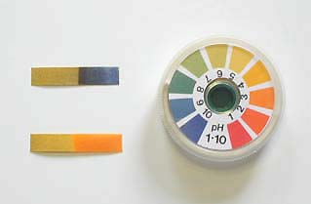Most science students perform science by recording data “manually” - a very different thing from experiencing science “hands-on”. This is not only more time consuming and boring, but has a huge potential for human error and as a result unsuccessful experiments. This is the case whether using litmus paper in chemistry; measuring endothermic reactions with semi-accurate thermometer readings; or calculating complex physics concepts such as initial velocity and acceleration with only a marble, stopwatch, measuring tape and graph paper. By the time students have repeatedly collected and recorded data manually, there’s not much of the 45 minute lesson left to understand the real science behind the experiment.

All the exciting science concepts that can only be explored with digital data collection, such as recording a sound wave, or a transient response in an electrical circuit are impossible when manually experimenting. This is simply because in order to measure such fast changing phenomena, students would need to collect thousands of samples per second. Equally very slow acting phenomena which require data collection over an extended period of time are not feasible for manual data collection. An example of this would be changes in temperature, humidity, light and sound over a 24 hour period.

# aii-in-one_diagram.pngLabdisc - it’s Time for Something New!

Globisens has listened to educator needs with the Labdisc - applying latest 21st Century technology to resolve the limitations of current data logging solutions for school. Four models, with up to 15 built-in sensors, enable K-12 science investigation in various fields including environmental science, physics, biology and chemistry (a fifth model, the Labdisc Primo serves elementary school science).

Globisens has packed a complete laboratory into a single small disc

The Labdisc replaces a big box of up to 20 individual items - data loggers, sensors, sensor cables and communication cables with a single device. Since all built-in sensors are automatically tested and calibrated, the Labdisc saves teachers hours of setup and calibration time every week.

**The Labdisc is a truly plug n’ play solution as it:**

1. Delivers a complete Lab on a disc with up to 15 sensors built-in
2. Offers very high accuracy, high sampling resolution and fast recording
3. Saves teachers lab setup time – requiring only 15 Labdisc units to be handed out
4. Ensures lessons run smoothly and calmly as teachers don’t need to manage between 60 and 100 different items on the Lab table

# Configurations for Every Science

The Labdisc middle and high school line includes **4 unique models** dedicated to the broadest range of school science, with **10 to 15 built-in sensor** configurations.   
(The Labdisc Primo is also available for elementary school science with 7 built-in sensors).

|  |  |
| --- | --- |
| Globisense Enviro View.jpg | Labdisc for **environmental studies** built-in sensors include:  Ambient Temperature, Barometer, Colorimeter, Disolved Oxygen, External Temperature, GPS, IR Temperature, pH, Relative Humidity, Sound Level, Turbidity, UV.  http://www.globisens.net/sites/default/files/images/models/enviro/sensors.gif **Typical activities include:**  Temp/light over 24 hours, acid rain, turbidity, water quality, temp./RH in urban areas using GPS, altitude and air pressure, heat absorption and cloud warming effects. |
| Globisense_Gensci View.jpg | Labdisc for **general science** built-in sensors include:  Air Pressure, Ambient Temperature, Current, Distance (Motion), External Temperature, GPS, Light, Microphone, pH, Relative Humidity, Sound, Universal Input, Voltage.  http://www.globisens.net/sites/default/files/images/models/gensci/sensors.gif **Typical activities include:**  Travelling speed with GPS, Newton’s Laws, sound waves, electrical currents, pH titration, endothermic and exothermic reactions Boyle’s Law, specific heat and microclimate. |
| C:\Users\rebecca\Documents\COMPANIES\GLOBISENSE\labdisc\product photos\Lbdc_biochem_L_View.jpg | Labdisc for **biochemistry, biology and chemistry** built-in sensors include:  Air Pressure, Ambient Temperature, Barometric Pressure, Colorimeter, Conductivity, Dissolved Oxygen, External Temperature, GPS, Heart Rate, Light, pH, Relative Humidity, Thermocouple, Turbidity and Universal Input. http://www.globisens.net/sites/default/files/images/models/biochem/biochem.jpg **Typical activities include:**  Skin temperature, pulse rates before and after activity, sweat production and photosynthesis, solid, liquid and gas phase changes and pH titration. |
| physio.jpg | Labdisc for **physics** built-in sensors include:  Accelerometer, Air Pressure, Ambient Temperature, Current, Distance (Motion), External Temperature, Light, Microphone, Universal Input, Voltage.  http://www.globisens.net/sites/default/files/images/models/physio/physio.jpg **Typical activities include:**  Lenz and Boyle’s Laws, resistor networks, light source efficiency, light vs. distance, sound beat and wave superposition, Newton’s Second Law and free fall acceleration. |

# Experiment Workshop

This teacher training workshop is an opportunity to review and perform some interesting recorded experiments. We will explore Newton’s 2nd Law – measuring free fall acceleration; Boyle’s Gas Law measuring air pressure inside a container and consider the data analysis following a field trip – Walk in the Park – where a unique city microclimate was found in a green park.

This document also contains three more easy-to-perform experiments: Day and night temperature changes – recording temperature and light values over a 48 hour-period; Sound beat – visualizing and measuring a sound wave and comparing the different pH levels found in common soft drinks.

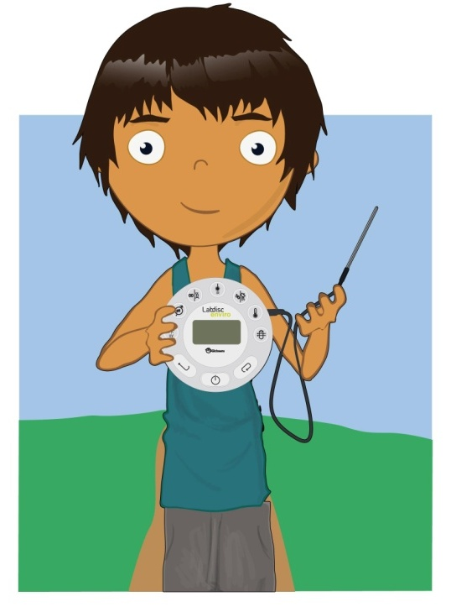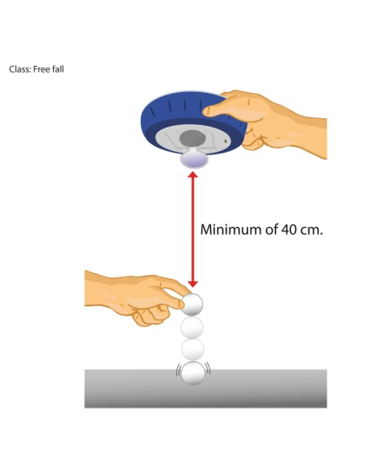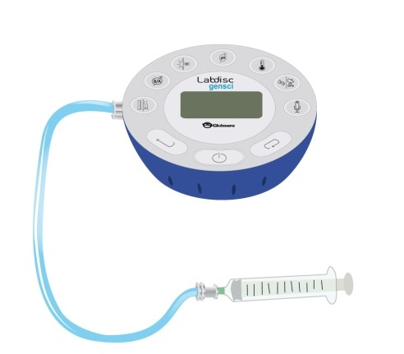

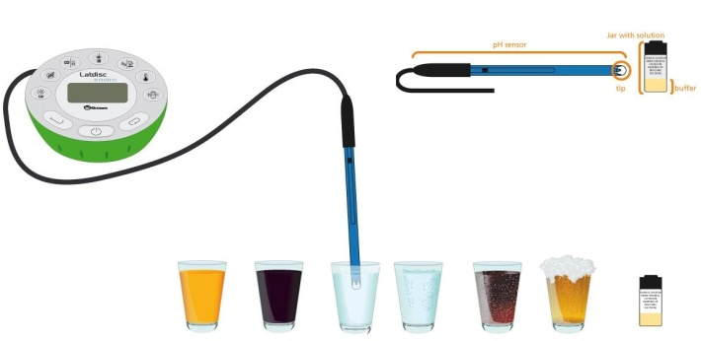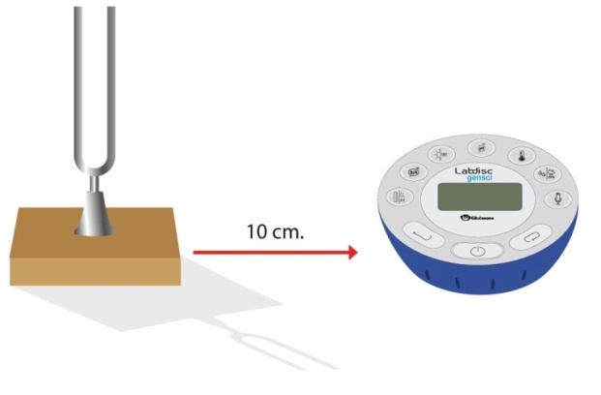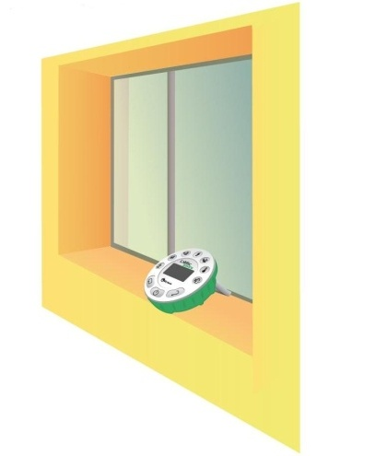

All the experiments featured in this document can also be found in the GlobiLab application, together with interactive experiment activity sheets.

## Free fall

***Measuring Newton’s classic 2nd Law - free fall acceleration***

**Equipment:** Labdisc distance sensor, ping-pong ball, hard surface**Sampling rate:** 25/sec   
**Amount of samples:** 1000

* Hold the Labdisc distance sensor 1 to 1.5 meters above the surface
* Start recording and drop a ping-pong ball from 40cm beneath the distance sensor onto the surface

The graph below, with a clear registration of the ball bounces, should be similar to the one you come up with:

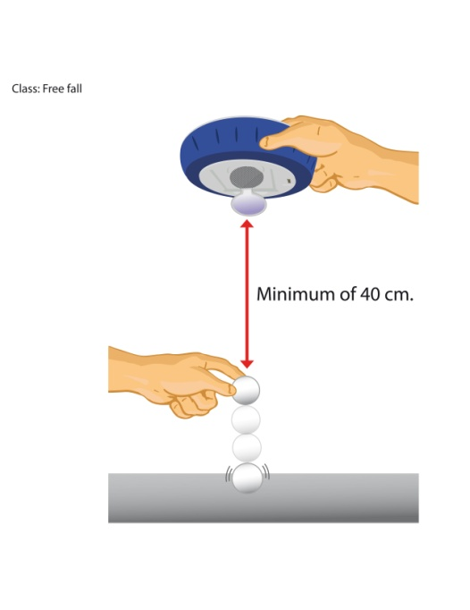

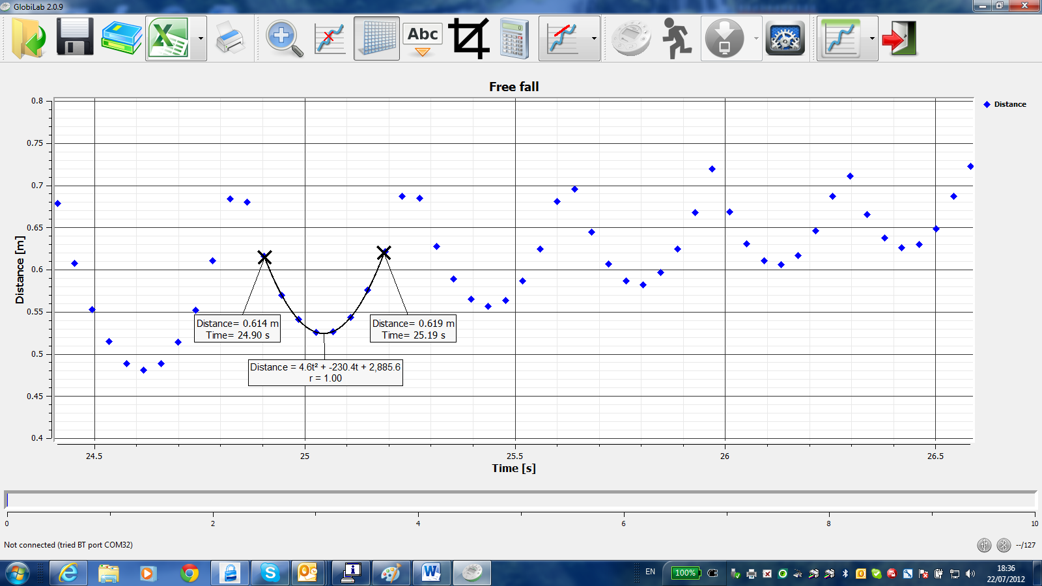

* Place the markers on the first and last sample of a single ball bounce
* Use the ***Quadric Regression*** to get a mathematic expression of the best parabolic graph connecting the distance graph
* According to Newton’s Law, the Distance ***D*** = $\frac{1}{2}a × t^{2}$
* Thus the coefficient of $t^{2}$ in our Quadratic Regression represents half the acceleration

NOTES:  
-----------------------------------------------------------------------------------------------------------------------------------  
  
-----------------------------------------------------------------------------------------------------------------------------------  
  
-----------------------------------------------------------------------------------------------------------------------------------  
  
-----------------------------------------------------------------------------------------------------------------------------------

## Boyle’s gas lawC:\Users\rebecca\Documents\COMPANIES\GLOBISENSE\labdisc\Experiments\final_experiments\Experiment images\boylelaw.jpg

***Verify Boyle’s Ideal Gas Law***

**Equipment:** Labdisc air pressure sensor, 100ml syringe connected to the air pressure tube

**Sampling rate:** Manual

**Amount of samples:** 10

To prove the Ideal Gas Law **P x V = NRT** - the multiplication of the air pressure in a container, by the container volume is a constant, take a manual air pressure reading when the syringe piston is set to 60ml. Then repeat at 50ml, 40ml, 30ml and 20ml.

The bar-graph view below should be similar to the one you come up with.

* Select bar-graph view in the GlobiLab software
* Export the data to excel
* Add 2 columns to the spreadsheet: Volume and P x V multiplication
* Observe that all 4 sets of P x V multiplication show the same value!

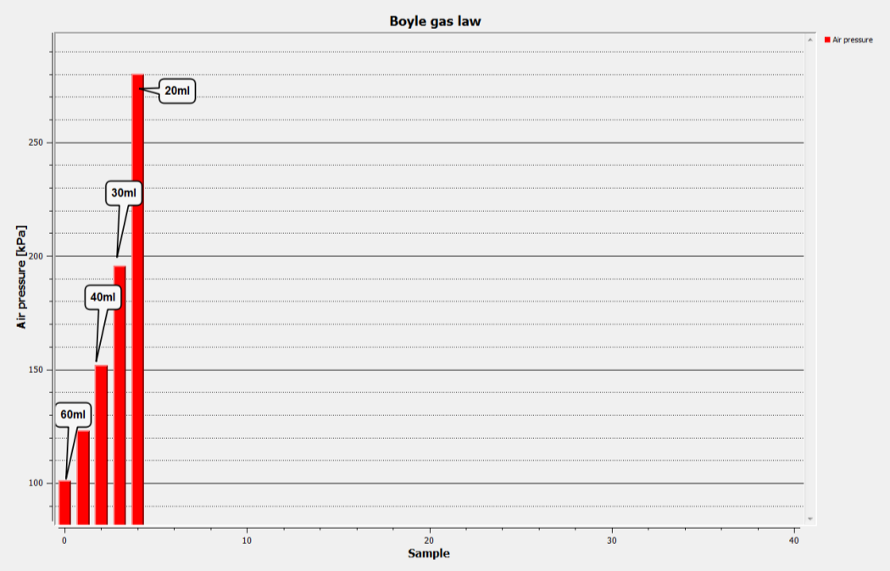

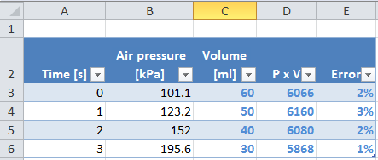

NOTES:  
-----------------------------------------------------------------------------------------------------------------------------------  
  
-----------------------------------------------------------------------------------------------------------------------------------  
  
-----------------------------------------------------------------------------------------------------------------------------------  
  
-----------------------------------------------------------------------------------------------------------------------------------

## Walk in the park

****

***Experiencing a unique city microclimate***

**Equipment:** Labdisc GPS, humidity and temperature sensor**Sampling rate:** 1 sec   
**Amount of samples:** 1000

* Measure temperature and relative humidity at a busy intersection
* Measure them again in a green park located 400 m away
* Download data to the computer and select ***Map*** view

The screen below should be similar to the one you come up with:

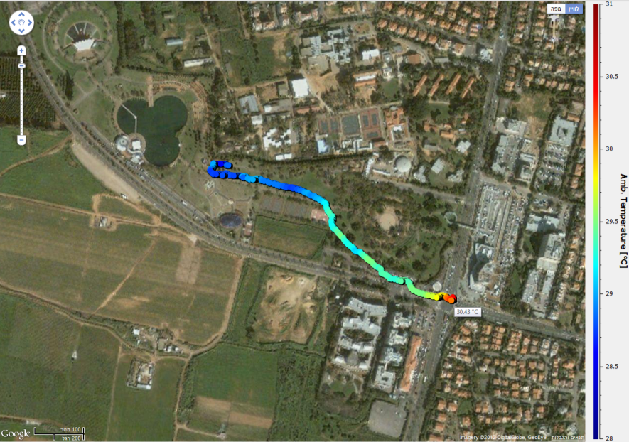

* The changing line of color shows the temperature decreased inside the park
* The humidity can be displayed to see how it increased inside the park
* Both phenomena are due to vegetation water transpiration, which increase park humidity levels, while cooling it, by taking heat from the environment for the water evaporation

NOTES:  
-----------------------------------------------------------------------------------------------------------------------------------  
  
-----------------------------------------------------------------------------------------------------------------------------------  
  
-----------------------------------------------------------------------------------------------------------------------------------  
  
-----------------------------------------------------------------------------------------------------------------------------------

## Day and night temperature change



***Measuring light and temperature changes over 48 hours***

**Equipment:** Labdisc light and ambient temperature  
**Sampling rate:** 1/min  
**Amount of samples:** 1000

* Leave the Labdisc measuring on a window-sill for 48 hours
* Afterwards download the collected data to the computer

The graph below should be similar to the one you come up with.

## 

* Using markers, we can clearly see a correlation between night and low temperature
* We can also measure the peak values of the measured light and temperature

NOTES:  
-----------------------------------------------------------------------------------------------------------------------------------  
  
-----------------------------------------------------------------------------------------------------------------------------------  
  
-----------------------------------------------------------------------------------------------------------------------------------  
  
-----------------------------------------------------------------------------------------------------------------------------------

## Sound beat



***Measuring sound waves***

**Equipment**: Labdisc microphone sensor, tuning forks

**Sampling rate:** 25,000/sec   
**Amount of samples:** 10,000  
The Labdisc was positioned between two standard tuning forks, producing a sound harmonic of 440Hz. On one tuning fork a small metal ring slightly changes the tuning fork harmonic to 435Hz.

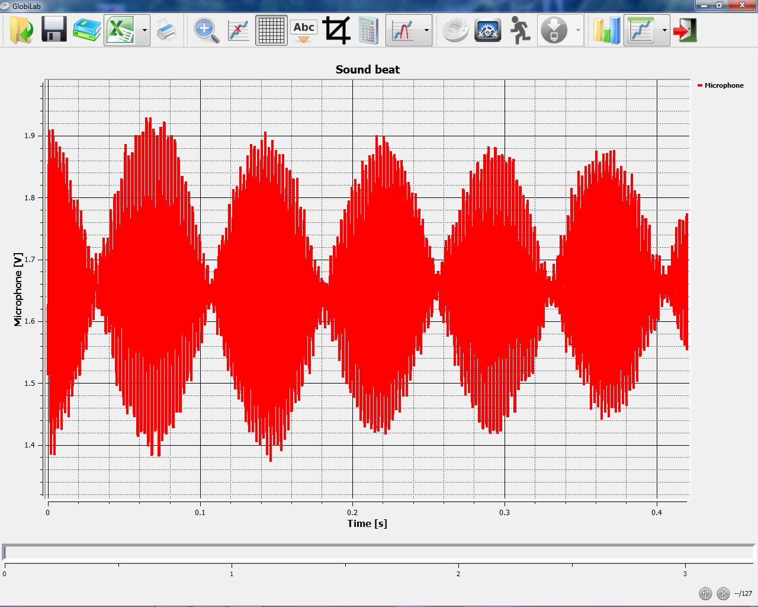  
  
The graph below, describing the super position of the two standing waves, should be similar to the one you come up with. Using the magnifying icon, focus on a few cycles of the sine wave and measure its frequency.

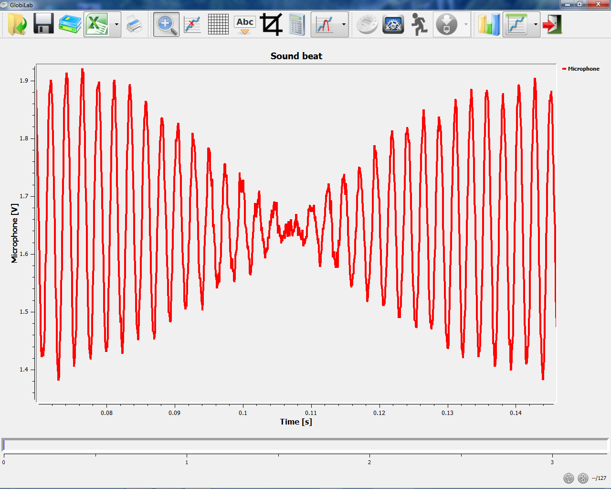

NOTES:  
-----------------------------------------------------------------------------------------------------------------------------------  
  
-----------------------------------------------------------------------------------------------------------------------------------  
  
-----------------------------------------------------------------------------------------------------------------------------------  
  
-----------------------------------------------------------------------------------------------------------------------------------

## pH level in soft drinks



***Comparing different pH levels***

**Equipment:** Labdisc pH sensor; cup of tap water, lemon and Coca Cola

**Sampling rate:** 10/sec

**Amount of samples:** 1000

Using the pH sensor we compare the pH level of tap water, lemon juice and Coca Cola.

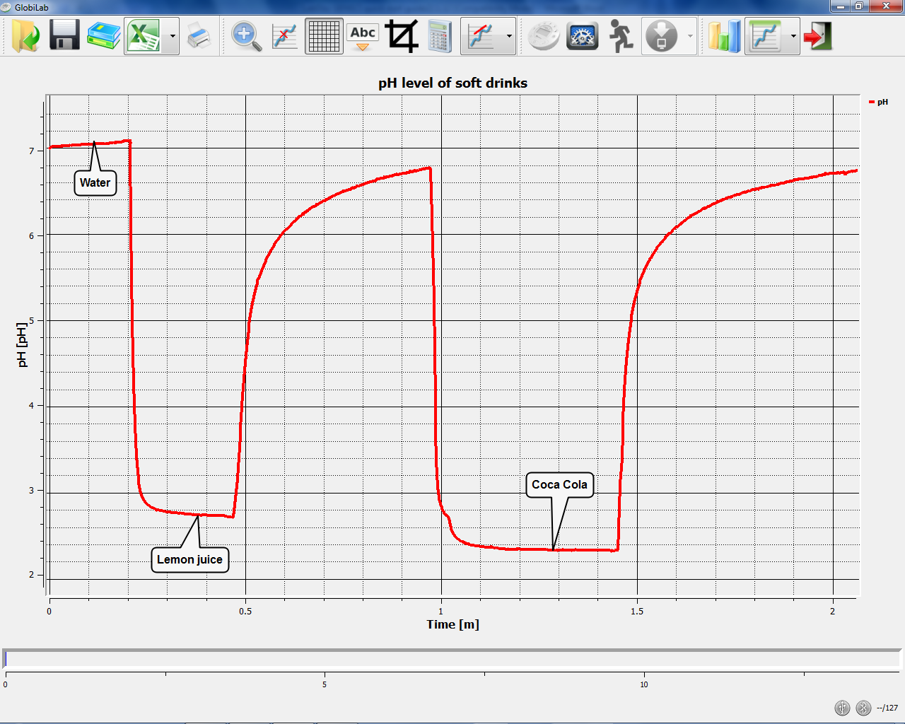

The graph below should be similar to the one you come up with:

Analyzing the graph shows: Water is neutral and lemon juice is acidic with a pH level around 2.8pH. However, Coca-Cola is surprisingly more acid than lemon juice with a pH level of 2.5pH. This is due to the phosphoric acid (corrosive to our teeth) used in Coca-Cola.

NOTES:  
-----------------------------------------------------------------------------------------------------------------------------------  
  
-----------------------------------------------------------------------------------------------------------------------------------  
  
-----------------------------------------------------------------------------------------------------------------------------------  
  
-----------------------------------------------------------------------------------------------------------------------------------

# Science Experiment Table

|  |  |
| --- | --- |
| **Subject** | **Activity** |
| **Biology** | **“Skin Temperature”** Comparing skin temperature after putting our hand in cold water, exposing our hand to the sun etc. Discover if skin temperature is the same as body temperature. |
| **“Sweat Production”** Covering our hand with a plastic bag, while measuring temperature and relative humidity to explain the principle of the body’s cooling system – sweat**.** |
| **“Photosynthesis”** Recording air pressure and light level, while using an Elodea water plant sealed in a test-tube - to measure the effect of photosynthesis and the relation between light intensity and oxygen production by the plant. |
| **“Our Heart Rate”** Measuring the heart rate before and after exercise and recording useful information to determine physiological parameters. |
| **"Photosynthesis” Same** as previous activity with the use of DO2 electrode instead of the air pressure sensor. |
| **Chemistry** | **“Phase Changes: Solid, Liquid and Gas”** A classic activity measuring the freezing and boiling point of water. |
| **“Specific Heat”** Heating different liquids to the same temperature (70˚C) and comparing the cooling curves of these liquids to explain which has the higher specific heat. |
| **“Endothermic and Exothermic Reactions”** Performing different measurements to examine which reactions release or consume heat. |
| **“pH Titration”** Classic Acid and Base titration - measuring pH and temperature change (also using an external temperature sensor). |
| **“What Do We Drink?”** Measuring the pH of different soft drinks. |
| **“Boyle’s Law”** Measuring the connection between volume and pressure: PV=NRT, by using a syringe to show the linear relation between volume and air pressure. |
| **"Lambert-Beer law"** Determining the relationship between a solution concentration and its light absorbance |
| **“Altitude Effect on Boiling Point”** Measuring the boiling point of water at different altitudes using the external temperature and barometersensors. |
| **"Candle flame"** Exploring the temperature zones of a candle flame. |
| **"Diffusion"** TBD |

|  |  |
| --- | --- |
| **Environment/Biology** | **“Altitude and Air Pressure”** Using the Barometer and GPS sensors to travel from high to low places, measuring the change in air pressure and altitude. |
| **“Cloud Effect on a Winter’s Day”** Measuring the sky’s temperature on a clear sky day and on a cloudy day and explaining how clouds keep ground heat from radiating into the atmosphere. |
| **“Day and Night”** Recording the variations of temperature and light during a period of 24 hours to establish relations between them. |
| **“Acid Rain”** Collecting rain in different area and verifying the acidity of the rain as it relates to pollution. |
| **“Water Bodies”** Measuring temperature and humidity near rivers or other water bodies to determine their effect on temperature and humidity. |
| **“City Micro Climate”** Measuring the changes in noise, temperature (and humidity) in different urban areas. |
| **“Water Quality”** Comparing drinking water turbidity to other water taken from lakes and ponds. |
| **“UV & Sun Block”** Measuring and comparing the level of ultraviolet radiation, resulting from the intervention of sunlight beam through different types of filters such as sunglasses and sun blocks. |
| **Physics** | **“Lenz Law”** The connection between electric and magnetic fields. |
| **“The Principle of Resistor Networks”** Measuring the current and voltage of two simple electric circuits (in series and parallel) and determining the differences between them |
| **“Light intensity”** Measuring and comparing the luminosity of a candle, a flashlight and natural day-light. |
| **“Light Versus Distance”** Recording light intensity while moving away from the light source. |
| **“Travelling Speed”** Using the GPS sensor to measure walking speed, running and/or biking speed, ideal activity for creating a contest between students. |
| **“Free Fall ”** Measuring the free fall acceleration using a ping-pong ball. |
| **“Sound Level Versus Distance”** Measuring sound level decay over distance. |
| **“Sound Waves”** Recording sound waves and sound wave interference. |
| **“Absorption of Heat”** Measuring and comparing the internal temperature of different colored containers full of water after being exposed to sunlight. |
| **"Hooks Law"** Using a metal spring to investigate the spring coefficient K and the equation F = -kx. |
| **"Friction"** investigating the static and dynamic friction of a body moving on different surfaces. |
| **"Harmonic motion"** Investigating the motion of a mass on a spring. |
| **"Newton 2nd Law"** - Using a cart pulled by a constant weight to prove Newton Law of motion - F = ma. |

# Teacher Questionnaire

***Please complete and return to*** [***info@globisens.com***](mailto:info@globisens.com)

* + - 1. How well do you believe the Labdisc can motivate and engage students in science?

Very  Quite  Moderately  Barely  Not at all

* + - 1. How important is the wireless communication for in-class mobility and a “cleaner” working area?

Very  Quite  Moderately  Barely  Not at all

* + - 1. What advantages do you feel the built-in sensors and auto calibration bring?

Saves lab prep time   
 More convenient package, storage and inventory   
 No small items that can get lost during the Lab session  
 All the above

* + - 1. How well do the Labdisc features support mobility and field experiments? (e.g. internal memory size, 150 hour battery life, device dimensions, LCD screen)?

Very  Quite  Moderately  Barely  Not at all

* + - 1. How well do the 12-bit resolution and sampling rate of up to 25,000 samples per second facilitate the experiments you need to conduct?

Very  Quite  Moderately  Barely  Not at all

* + - 1. How effective are the available data display options for different measures (graph, table, digital display, analog monitor, change color, bar columns, maps) in meeting data viewing and analysis needs?

Very  Quite  Moderately  Barely  Not at all

* + - 1. How well does the possibility of displaying GPS data combined with data from sensors on the satellite map enable effective and useful data presentation in environmental studies?

Very  Quite  Moderately  Barely  Not at all

|  |  |
| --- | --- |
| **Globisense_Gensci View.jpgLabdisc Gensci Data Logger Specifications** | |
| **Parameter** | **Labdisc Gensci** |
| **Supported Platforms** | Standalone, PC, MAC, iPad |
| **Built-in Accessible Sensors** | 13 sensors:  Air Pressure, Ambient Temperature, Current, Distance (Motion), External Temperature, GPS, Light, Microphone, pH, Relative Humidity, Sound Level, Universal Input and Voltage |
| **Max. Sampling Speed** | 24,000/s |
| **Sampling Resolution** | 12-bit |
| **Internal Data Storage** | 100,000 samples |
| **Internal Rechargeable Battery** | LiPO 7.2 V |
| **Battery life** | > 150 hours |
| **Display** | Graphical LCD 64 x 128 pixels |
| **Keypad** | Yes |
| **Communication** | USB V2.0 |
| **Wireless Communication** | Bluetooth V2.0 |
| **Remote Data Collection** | Yes |
| **Automatic Sensor Testing & Calibration** | Yes |
| **Size** | ɸ= 132, H = 45 mm |
| **Weight** | 200 gr. |
| **Temperature range** | -10 to 50 °C |
| **Standard Compliance** | CE, FCC |

|  |  |  |
| --- | --- | --- |
| **Labdisc Gensci Built-in Sensor Specifications** | | |
| **Sensor Type** | **Max. Range** | **Accuracy** |
| **Air Pressure** | 0 to 300 kPa | ±2.5 kPa |
| **Ambient Temperature** | -10 to 50 °C | ±1°C |
| **Current** | -1 to 1 A | ±2 % |
| **Distance (Motion)** | 0.4 to 10 m | ±2 % |
| **GPS** | N/A | ±3 m |
| **Light** | Multi-range 55,000 lx | ±15 % |
| **Microphone** | 0 to 5 V | ±2 % |
| **pH** | 0 to 14 pH | ±2 % |
| **Relative Humidity** | 0 -100 %RH | ±6 % (10%-90%RH) |
| **Sound level** | 58 to 93 dBa | ±4 dB |
| **Temperature** | -25 to 110 °C | ±2 °C |
| **Universal input** | 0 to 5 V | ±2 % |
| **Voltage** | -30 to 30 V | ±2 % |

|  |  |
| --- | --- |
| **Analysis Software Specifications** | |
| **Parameter** | **Description** |
| **Data Retrieval** | Online up to 100s/s, or download Labdisc stored data |
| **Data Display** | Line Graph, Table, Meters, Google map |
| **Communication** | USB, Bluetooth |
| **Data Logging Configuration** | Sensor selection, sampling rate, sampling points |
| **Data Manipulation** | Placing and moving up to 2 markers on the graphs zoom in/out, graph cropping, graph coping, functions such as: derivative and regressions |
| **Data Export** | Automatic export to EXCEL |
| **OS** | PC, MAC, iOS |