**Mobile Science Cart**

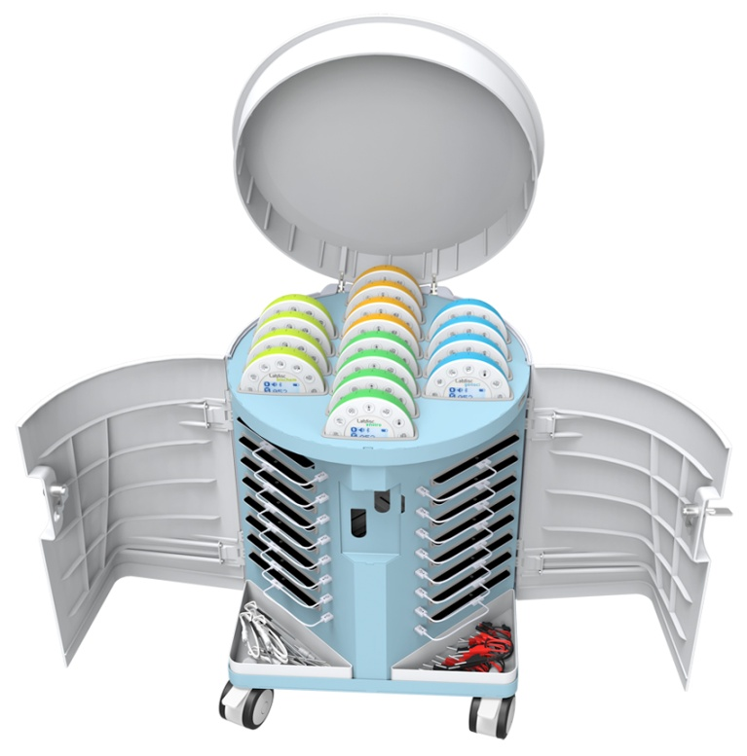**Quick Start Guide**

Mobile Science Cart overview 1

Using the cart 1

Storing and charging elements in the cart 2

Connecting the cart to the wall electricity 3

Charging the Labdisc units 3

Locking the cart 4

Mobilizing the cart between classrooms 5

Cart specifications 5

# Mobile Science Cart overview

The Labdisc wireless science lab was developed to make teaching science as engaging as possible as well as convenient. Expanding this concept of organized and accessible 21st century science learning, Globisens delivers schools a **mobile science laboratory with a storing/charging trolley containing 16 tablets and 16 Labdiscs units** for an entire class.

# new trolley.png

# Using the cart

An average class of 30 students requires one Labdisc and tablet set per two students. The mobile science cart is used to store, charge and mobilize an entire science lab for a full class of students. This includes 15 Labdiscs and 15 tablets for the 15 pairs of students, plus an additional Labdisc and tablet set for the teacher.

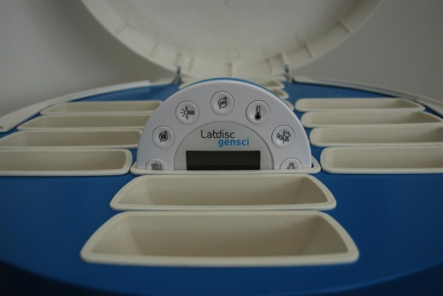

# Storing and charging elements in the cart

With a total of five doors, the Mobile Science Cart offers organized and centralized storage. Stored Labdiscs and tablets are charged using 6V and 5V outputs at 350 Watts. The top door provides access to up to 16 Labdisc units. Two front doors provide access to up to 16 tablet computers. Two back doors and two front plastic trays provide access to specialized storage compartments for electrodes and various accessories necessary for multiple sensor science experimentation.



The front doors of the Cart open to stacked storage and charging for up to 16 10” screen tablets.

The pneumatic top cover of the Cart can be lifted revealing charging storage for up to 16 Labdisc units. Any combination of Labdisc models can be stored and charged simultaneously.

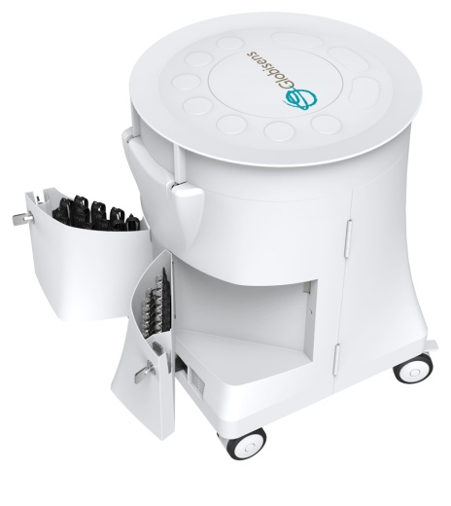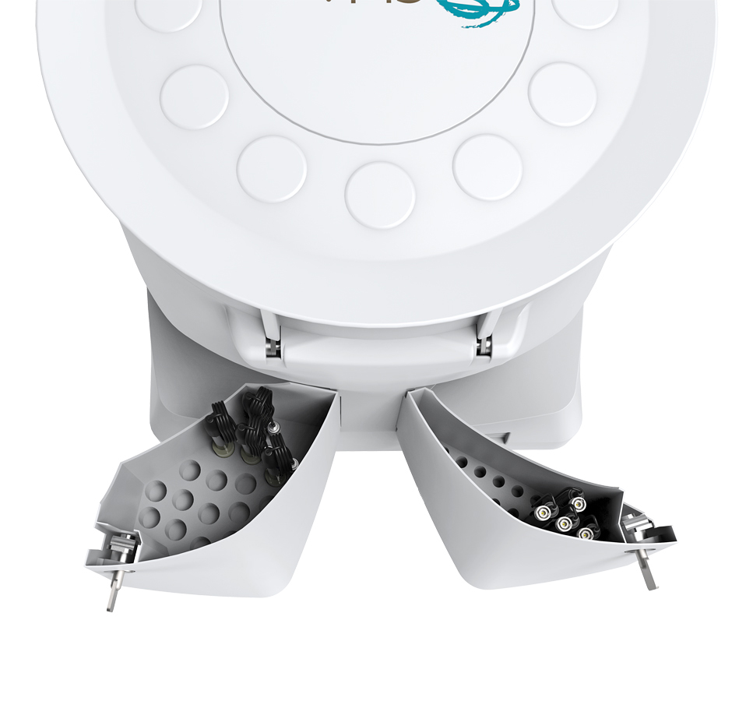

From the back of the Cart two pouch pockets pull out for the neat and compact storage of Labdisc electrodes such as pH and conductivity electrodes.

# Connecting the cart to the wall electricity

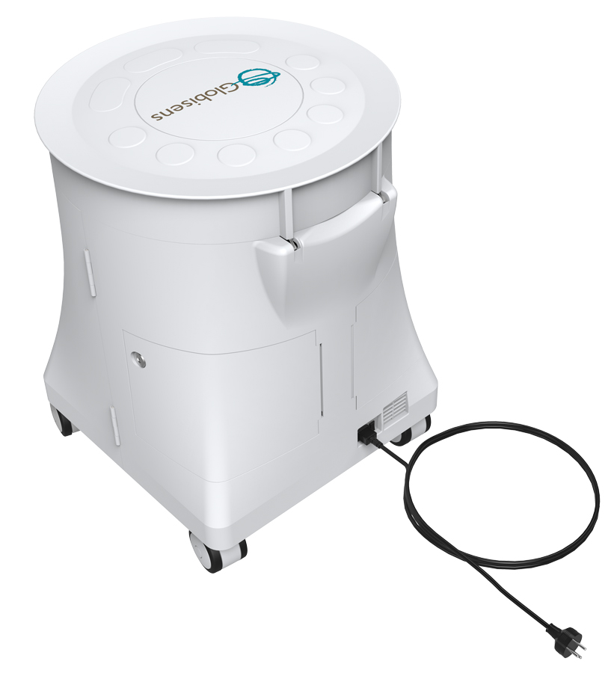  
When stationary the Mobile Science Cart can connect to an electricity wall socket.

The electricity cable plugs into an electricity cable socket found on the back of the Cart.

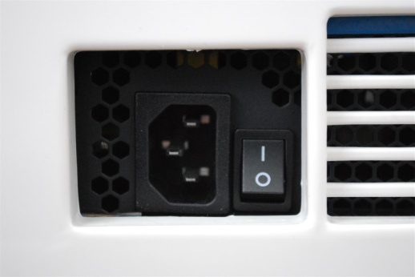

Entry point for electricity cable socket

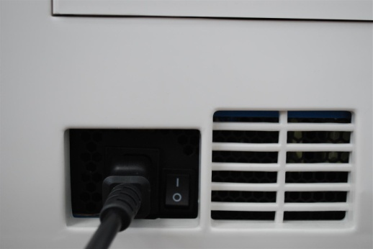

Cart with electricity cable plugged in

# Charging the Labdisc units

Labdiscs are stored and charged in the Mobile Science Cart. Each Labdisc easily inserts to one of the top plastic cradles. Each cradle contains two charging pins that fit into the Labdisc charging contacts, as shown in the pictures below.

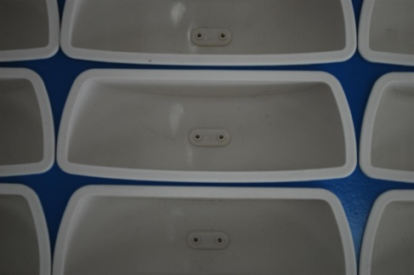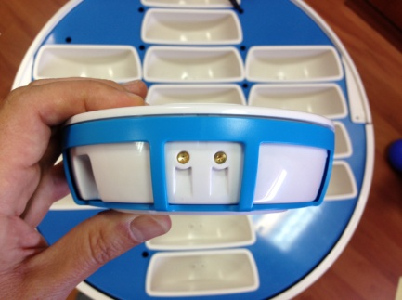

# Locking the cart

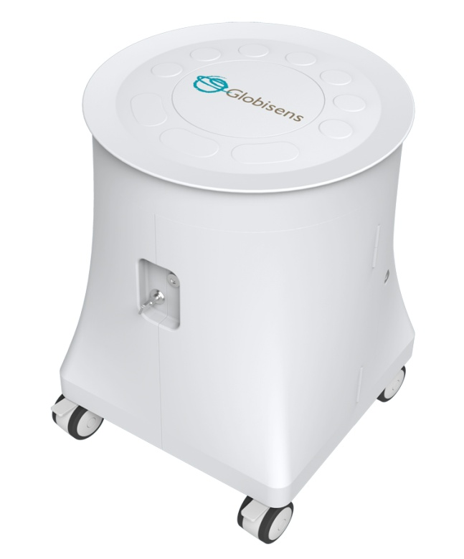The ruggedized steel framed trolley allows all equipment to be safely stored away – with an anti-theft locking system, as well as a metal tab for wall locking.

The metal key locks the front door securing the tablets and accessories.

# 

# 

Turning the key to a vertical position unlocks the doors

Turning the key to a horizontal position locks the doors

# Door open.JPGDoor locked.JPG

# Mobilizing the cart between classrooms

The unique ability to mobilize the science lab brings real inquiry-led experimentation via a fully functioning science lab to every class throughout the school. This removes the problem of mobilizing the students to a special room devoted to a cluttered science lab.

The cart is mobilized by two front and two back heavy duty silicon wheels. All wheels have breaks. After pushing the cart to the desired location, the wheels can be locked to secure the cart in one position.

Click the wheel lock down to lock the wheels and immobilize the cart

Push the wheel lock up to unlock the wheels and mobilize the cart

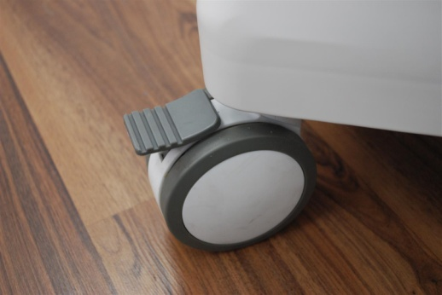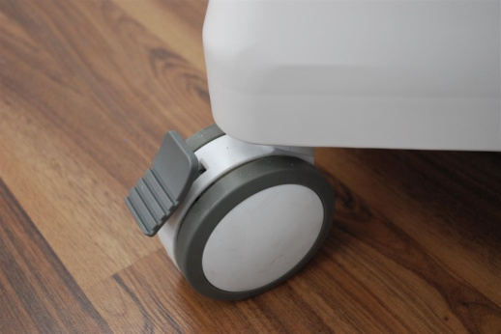

|  |  |
| --- | --- |
| **Parameters** | |
| Material | Stainless steel construction and plastic ABS injections for all doors |
| Doors | Top door for accessing the Labdisc units, two front doors for accessing the tablets, two back doors for accessing the Labdisc electrodes |
| Labdisc support | Carries up to 16 Labdisc units |
| Tablet support | Carries up to 16 10” tablets, |
| Built-in charger | Built-in charger 5 V and 6 V output. Total power 350 W. UL, FCC and ISO-9001 certified |
| Wheels | Heavy duty silicon wheels. All 4 wheels with brakes |
| Size | H 691 mm W 526 mm Depth 526 mm |
| Weight | 27 kg (with no Labdisc and no tablets) |
| Electricity | 110/220 VAC |
| Heat dissipation | Fan ventilation |

# Cart specifications

*Rev:7.6.14*

Rev: 11.5.14