|  |
| --- |
|  |



**Mini**

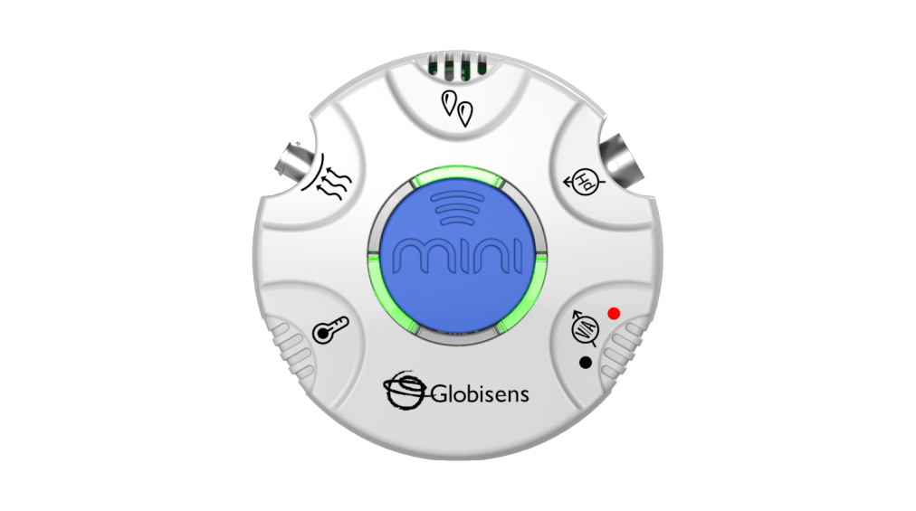

**Mini**

**GlobiLab Software**

**Quick Start Guide**

This Guide is intended to help you get your Mini up and running quickly. For more detailed instructions, please see the *Getting to Know Your Mini* document in the [Getting Started](http://www.globisens.net/support#4) section of <http://www.globisens.com>.

**Table of Contents**

1. Mini Hardware Overview 1

1.1 What’s in the Pack 1

1.2 Ports and Controls 1

1.3 Built-in Sensors 3

1.4 Using the Mini 4

1.5 Configuration of the Mini 5

2.0 GlobiLab Software 6

2.1 Software Installation 6

2.2 Software Functions 6

2.3 Software Icons and their Functions 7

2.4 GlobiLab Software for the iPad 10

2.5 GlobiLab Software for Android Tablets 14

3.0 Mini – GlobiLab Communication 17

3.1 USB Connection 17

3.2 Bluetooth Wireless Communication 17

3.2.1 Set the Mini to Pairing Mode 17

3.2.2 Pairing the Mini with a Windows PC 17

3.2.3 Pairing the Mini with a Mac OS 18

3.2.4 Pairing the Mini with iPad 19

3.2.5 Pairing the Mini with Android 20

1. Mini Hardware Overview

1.1 What’s in the Pack

|  |  |
| --- | --- |
| ① Mini data logger  **1**  ② Temperature probe  ③ Air pressure tube  **1** | ④ Banana cables    ⑤ USB charging cable  ⑥ Plastic clip  ⑦ Ear clip |

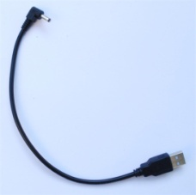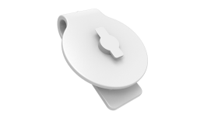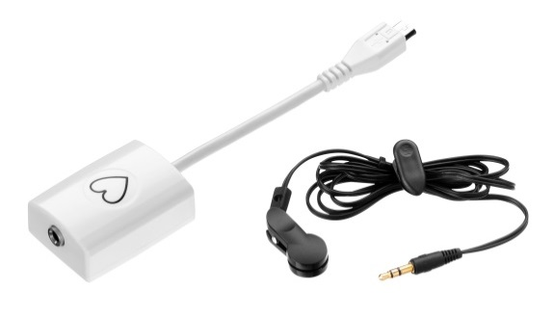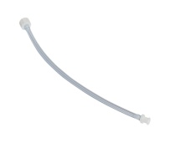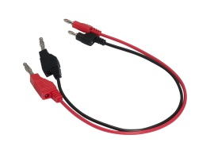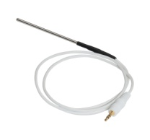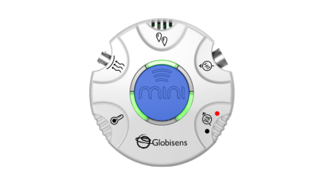1.2 Ports and Controls

**6**

**7**

**5**

**4**

**3**

**2**

**1**

The picture below reviews the Mini ports, sensors and display:

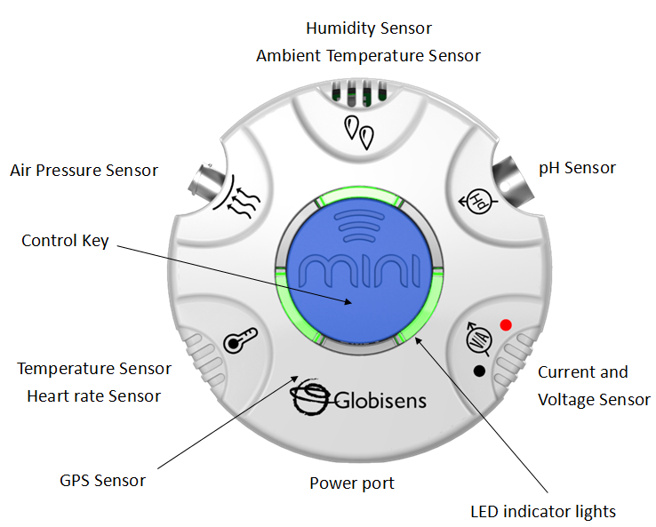

1.3 Built-in Sensors

The Mini comes with 9 built-in sensors as listed in the table below:

|  |  |  |  |  |  |
| --- | --- | --- | --- | --- | --- |
| **Icon** | **Type** | **Range** | **Description** | **Max Sample Rate** | **External Accessories** |
|  | Ambient Temperature | -10◦C to 50◦C | Measuring ambient temperature | 1/sec | None needed |
|  | External Temperature | -25◦C to 125◦C | All purpose stainless steel temperature probe | 10/sec | Temp probe |
|  | Heart Rate | 0 to 200 bpm | Measuring heart rate | 100/sec | Ear clip |
|  | Air Pressure | 0 to 300 kPa | Measuring air pressure | 10/sec | Plastic tube |
|  | Relative Humidity | 0 to 100% RH | Measuring relative humidity | 1/sec | None needed |
|  | pH | 0 to 14 pH | Measuring pH level | 10/sec | pH electrode (purchased separately) |
|  | Voltage | -30 to +30 V | Measuring electric voltage | 25,000/sec | Banana cable |
|  | Current | -1 to +1A | Measuring electric current | 25,000/sec | Banana cable |
|  | GPS | N/A | Measuring longitude, latitude, course speed | 1/sec | None needed |

1.4 Using the Mini

Before using the Mini for the first time, the unit should be charged for six hours using the USB cord. This cord can be plugged into any computer or standard wall socket. While charging, the LED lights will blink red. When the Mini is fully charged, the LED lights will change to green.

The center blue button controls many of the Mini’s functions.

|  |  |  |
| --- | --- | --- |
| **Key & Charger Status** | **Operation Mode** | **LED Indication** |
| **Short press** | When idle | Green light rotates through all 6 LEDs |
| When logging | Green light rotates through all 6 LEDs |
| Sensors currently sampling will show a light indicator for 3 seconds |
| Manual logging | Green light continues rotating through all 6 LEDs. Sample is taken by pressing the center blue key. Sensors recording will show light indicator for 3 seconds. |
| Low battery | Red light flashes and rotates through all 6 LEDs |
| **Long press (3 sec)** | Entering Bluetooth pairing | All 6 LEDs flash:  green-red-green |
| During logging | Stops the logging session and returns to idle mode |
| **Charging with the USB cord** | Charging | Charging LED flashes red when the battery is being charged |
| Once the battery is charged, the charging LED color changes to green |

1.5 Configuration of the Mini

All Mini configurations are performed from the GlobiLab software menu. Your Mini must be paired with the computer or tablet that you plan to use with it. See Chapter 3.0 below for instructions on how to pair the Mini with your computer/tablet.

2.0 GlobiLab Software

2.1 Software Installation

You can also download the software from the Globisens website at <http://www.globisens.net/support#2>. Simple instructions will take you through the installation of the **GlobiLab** software.

2.2 Software Functions

A quick overview of the major features of the GlobiLab software is below. For more detailed instructions on how to use the GlobiLab software please read the *Getting to Know the Mini* document in the [Getting Started](http://www.globisens.net/support#4) section of our website.

2.3 Software Icons and their Functions

|  |  |
| --- | --- |
|  | Selecting the ***Open-project*** icon opens the stored activity *.XML files and displays all its graphs and graphical attributes. |
|  | Selecting the ***Workbook*** icon opens the activities folder, where users can choose from a variety of PDF activities. |
|  | Clicking the ***Display-options*** small triangle icon allows the user to select one of the following six display options:  Meter View  Table View  Graph View  Map View  Mixed Meter & Graph View  Mixed Table & Graph View |
|  | **Sensor legend**:   1. A left click on the sensor name makes it active and changes the y-axis to this sensor’s units/scale. 2. A single right click on the sensor name changes a line graph to individual data points 3. A second right click on the sensor name removes this sensor graph from the display 4. A third right click on the sensor name returns to a line graph on the display   The default graph title is **New Experiment**. Changing this title is done with a double left mouse click over the title. A small text dialog box will open where the new title can be entered.  When displaying two or more sensors – a right click on the graph x-axis title will open a dialog box to assign either a sensor or time as the x-axis. |
| Meter View | A left mouse click on the four bottom blue dot icons will change the number of meters on the screen to: 1, 2, 4 or 6 meters. A left click on any of the meters will open a dialog box for meter type selection and assigning a sensor for this meter. |
| Marker | A left mouse click, near any of the graphs, will place a marker on the graph. Hovering over any of the markers, while pressing and holding the left mouse button and dragging the mouse, will move the marker over the graph and will show the values as the marker moves along the graph line. Selecting the ***Marker*** icon again, exits the ***Marker*** mode. |
| Annotation | Allows a left mouse click to open a dialog box where text and images can be entered. Pressing the ***Annotation*** icon again exits the ***Annotation*** *mode*. |
| Mathematical Functions | Pressing the ***Function-options*** small triangle icon allows the user to apply the mathematical functions listed below between the graph markers:  ***Linear regression*** will display the best linear line that fits the graph between the locations of two markers. Next to the line the software will open a small text box displaying the linear line equation: Y= aX+b.  ***Quadric regression*** will display the best parabolic line (2nd degree) that fits the graph between the locations of two markers. Next to the line the software will open a small text box displaying the parabolic line equation: Y= aX²+bX+c.  ***FFT*** is used to split the graphic display to show the original measurements in a time scale in the top window and to show its harmonics, on a frequency scale in the lower window.  ***Smooth*** is used to average a graph. Every sample is an average of the two readings before and two after samples. It can be useful in case the graph is very noisy.  ***Derivative*** measures the sensitivity to change of a quantity in one data source determined by another quantity or another data source. |
| Run/Stop | Starts or stops a data collection. |
|  | Creates an overlay with a second data collection over the original graph for comparison. |
|  | ***Selective download*** opens a table listing all stored recordings. Selecting one of the lines on the table and pressing download will download this specific recording to the computer. |
|  | ***Setup*** icon opens a dialog box, where users can select/remove sensors, set the sampling rate and the amount of samples for the next data recording. |
|  | ***EXCEL*** icon saves the file in a *.CSV format, prompts the user for a file name and then automatically opens EXCEL and exports the experiment data into the spreadsheet. |
|  | **GlobiLab *status bar*** at the bottom right corner of the software includes 3 icons:   1. **USB indicator** – the USB Indicator is always grayed out because the Mini offers no USB communication. 2. **Bluetooth indicator** – when blue indicates a Bluetooth wireless communication between the computer and the **Mini**. A right mouse click on this icon will open a list of recognized **Mini’s.** Click on one to connect. 3. **Memory info** – shows how many experiments are stored in the **Mini’s** memory, out of a maximum of 127. In the example above there are 7 stored experiments out of 127. A right mouse click on this section will allow users to erase all stored data or just the last recording. |

2.4 GlobiLab Software for the iPad

The GlobiLab software for iPad (iPad, iPad 2 and 3rd generation iPad models) is available in the App Store. GlobiLab wirelessly communicates between the Mini and the iPad using a Bluetooth connection.

The following steps provide a guide on the installation and implementation of the GlobiLab App for iPad.

|  |  |
| --- | --- |
|  | ***Download and install the GlobiLab application***   1. Tap the iPad App Store icon. 2. Search for **“GlobiLab”**. 3. Press the green **FREE** button to install the application. |
|  | ***Set wireless communication between the Mini and the iPad***   1. Go to *iPad Setting - Bluetooth* and select your **Mini** from the Devices list. 2. The iPad should immediately connect to your **Mini** and change its status to “connected”. 3. Close the setting and open the **GlobiLab** software. |
|  | ***Select Meter View***   1. Tap **Meter view** to see the current values of the **Mini** sensors. 2. Tap one of the Meters and scroll the sensor wheel to select a different sensor type for an existing Meter. 3. Select a different Meter type from the horizontal line of icons. |
|  | ***Data collection***   1. Tap the **SETUP** icon to enter the SETUP screen. This dialog box allows you to select the sensors, sampling rate and number of samples for the next data recording. 2. Tap the **RUN** icon to start recording and observe the graph build on the screen. You can switch the display view by tapping the Bar or Table Graph key at the bottom. 3. To stop recording tap the **STOP** icon. |
|  | ***Download stored measurements***  The **Mini** can store up to 127 different experiments. This is very useful when conducting outdoor data collection or long measurements.   1. Tap the **Download** icon. 2. The iPad will list all stored experiments and show what sensors were used, the sampling rate and how many samples were collected as well as the date/time of the collection. 3. Click on one of the lines in the list to transfer the data to the iPad. Once data is transferred, the iPad will show a graph of the collected measurement. |
|  | ***Data analysis (markers, curve fitting)***   1. Long touch the graph to add a marker. 2. Drag the marker with your finger. The marker text box data will change as the marker moves along the graph line. 3. Tap twice to view the sampling points. 4. Long touch to add a 2nd marker. 5. Place markers at the beginning and end of a section of the graph. 6. Tap the **Curve Fitting** icon and select a function to get the mathematical equation representing the graph. |
|  | ***Graph annotation***  Use a long touch on the background (not on a graph) to create an annotation. The **Edit Annotation** box opens automatically. Here you can:   * Edit or write an annotation. * Add an image using the camera or the image gallery. * Remove the annotation. |
| \***NOTE:** Without an Internet connection, GPS data can be collected but cannot be displayed over Google maps. | ***Use of Map View***  Recording GPS together with other sensors enables the **GlobiLab** software to display these sensors data over the Google maps.   1. Make sure the iPad is connected to the Internet. 2. Tap the **Open** icon and select “Walk in the Park”. This experiment measured the climate in a city park compared to a nearby city cross-road. For more details check the Microclimates movie at: <http://www.globisens.com/resources/experiment-videos>. 3. Tap the color scale on the left and select **Ambient Temperature**. Observe the temperature change while walking from the city cross-road to the park. 4. Tap the colored dots on the map to get a marker with the temperature value. 5. Pinch to zoom the map in or out. 6. See the experiment data in a table, by tapping the Table View and observe the GPS longitude and latitude values. |
|  | **Online help**  **GlobiLab** offers an online help for each of the 5 views: Line, Bar, Table, Meter and Map.   * Open the relevant view. * Tap on the **HELP** icon and observe a list of functions and controls. |

2.5 GlobiLab Software for Android Tablets

The GlobiLab software for Android is available in the Google Play store. GlobiLab wirelessly integrates between the Mini and Android tablets.

The following steps provide a guide on the installation and implementation of the GlobiLab App for Android.

|  |  |
| --- | --- |
|  | ***Download and install the GlobiLab application***   * Tap the Google Play Store icon. * Search for **“GlobiLab”.** * Press the green **FREE** button to install the application. |
|  | ***Set wireless communication between the Mini and the iPad***   1. Go to *Settings – Bluetooth* andscan. Make sure that your tablet is visible to all nearby Bluetooth devices. 2. Select your **Mini** from the list of Available Devices. Hold down the blue button until all LED lights flash red and enter PIN **1234**. Hit **OK.** 3. Close the Settings and open the **GlobiLab** software. |
|  | ***Connect the Mini***   1. Tap the column of menu boxes in the upper right corner of the tablet screen. 2. Select the device that you wish to connect to. |
|  | ***Select Meter View***   1. Tap Meter view to see the current values of the **Mini** sensors. 2. Tap one of the Meters and scroll the sensor wheel to select a different sensor for an existing Meter. 3. Select a different Meter type from the horizontal line of icons. |
|  | ***Data collection***   1. Tap the **SETUP** icon and enter the SETUP screen. This dialog box allows you to select the sensors, sampling rate and number of samples for the next data recording. 2. Tap the **RUN** icon to start recording and observe the graph build on the screen. You can switch the display view by tapping the Bar or Table Graph key at the upper right. 3. To stop recording tap the **STOP** icon. |
|  | ***Download stored measurements***  The **Mini** can store up to 127 different experiments. This is very useful when conducting outdoor data collection or long measurements.   1. Tap the **Download** icon. 2. The iPad will list all stored experiments and show what sensors were used, the sampling rate and how many samples were collected as well as the date/time of the collection. 3. Click on one of the lines in the list to transfer the data to the iPad. Once data is transferred, the iPad will show a graph of the collected measurement. |
| Inline image 1 | ***Data analysis (markers, curve fitting)***   * Long touch the graph to add a marker. * Drag the marker with your finger. The marker text box data will change as the marker moves along the graph line. * Long touch to add a 2nd Marker. * Place markers on the beginning and end of a section of the graph. * Tap the **Curve Fitting** icon and select a function to get the mathematical equation representing the graph. Tap the legend box to change the graph to sampling points. |
|  | ***Graph annotation***  Use a long touch on the background (not on a graph) to create an annotation. Touch the box to open the annotation editing box. Here you can:   1. Edit or write an annotation. 2. Add an image using the camera or the image gallery. 3. Remove the annotation. |
| \***NOTE:** Without an Internet connection, GPS data can be collected but cannot be displayed over Google maps. | ***Use of Map View***  Recording GPS together with other sensors enables the **GlobiLab** software to display these sensors data over the Google maps.   1. Make sure the tablet is connected to the Internet. 2. Tap the **Open** icon and select “Walk in the Park”. This experiment measured the climate in a city park compared to a nearby city cross-road. For more details check the Microclimates movie at: <http://www.globisens.com/resources/experiment-videos>. 3. Tap the color scale on the left and select **Ambient Temperature**. Observe the temperature change while walking from the city cross-road to the park. 4. Tap the colored dots on the map to get a marker with the temperature value. 5. Pinch to zoom the map in or out. 6. See the experiment data in a table by tapping the Table View and observe the GPS longitude and latitude values. |
|  | **Help**  Tap the ? at the left end of the menu bar in the upper right corner of the screen to open the Help document. |

3.0 Mini – GlobiLab Communication

3.1 USB Connection

Unlike the Labdisc, the Mini does not communicate data to the computer/tablet via the USB cable. With the Mini, the USB cable is strictly for charging purposes.

3.2 Bluetooth Wireless Communication

Before communicating wirelessly with a Mini for the first time, the Minishould be added as a device to the computer in a process called *pairing*. Pairing only needs to be performed once for any Mini. After pairing is complete the computer stores the connection information, including a unique number for each Mini (found on a small silver sticker on the back of your Mini).

3.2.1 Set the Mini to Pairing Mode

1. Turn on the Mini by pressing the center blue button.
2. Press and hold the center blue button until the LED lights all flash red. Your Mini is ready for pairing.

3.2.2 Pairing the Mini with a Windows PC

1. Start the GlobiLab software.
2. Right click the Bluetooth icon located in the bottom right corner of the screen.
3. This opens up a pop-up menu with a list of Mini devices that may already be paired with this computer. At the bottom of the list select “Find More Labdiscs & Sensors.”
4. The computer opens the “Add a device” dialog box and searches for nearby Bluetooth devices.
5. Your Mini will be displayed as MiniDisc_xxxx where xxxx is the 4 last digits of the Mini serial number sticker. Select this device and press next.
6. Enter **1234** as the PIN. Press and hold the blue center button on the Mini until the LED lights flash red and then press “Ok” on the PC.
7. The computer will indicate that the pairing is successful and load the driver needed for the Mini. Loading the driver may take several minutes.
8. To connect to the Mini, right click on the Bluetooth icon in the GlobiLab status bar, located at the bottom right corner of the screen and select the device you want from the pop-up menu listing the paired devices. When connected, the Bluetooth icon will turn blue and a notice in the lower left hand corner of the screen will indicate that you are connected to MiniDisc_xxxx.

3.2.3 Pairing the Mini with a Mac OS

1. Open the Bluetooth menu from the Mac menu bar and select “Set up Bluetooth Device.”
2. Your Mini will be displayed as MiniDisc_xxxx in the dialog box that opens. xxxx is the last four digits of the Mini serial number.
3. In the next dialog box, press “Passcode Options” and select “Use a Specific Passcode.” Enter **1234** as the passcode.
4. Press and hold the blue center button on the Mini until the LED lights flash red. Press “Ok” and “Continue” on the Mac computer.
5. When the wizard action is complete, the computer will confirm that the Mini has successfully been paired to the Mac.
6. It may take a few minutes for the Mini drivers to load.
7. To connect to the Mini, right click on the Bluetooth icon in the GlobiLab status bar, located at the bottom right corner of the screen and select the device you want from the pop-up menu listing the paired devices. When connected, the Bluetooth icon will turn blue and a notice in the lower left hand corner of the screen will indicate that you are connected to MiniDisc_xxxx.

3.2.4 Pairing the Mini with iPad

1. Open the iPad *settings*: 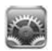
2. Open Bluetooth and make sure Bluetooth is turned on.
3. From the list of available devices, select MiniDisc_xxxx. xxxx will be the last four digits on the Mini’s serial number sticker.
4. When the iPad asks for a PIN code, enter **1234**.Press and hold the blue center button on the Mini until the LED lights flash red and then press “Pair” on the iPad.
5. When you see your Mini listed as Connected, you’re ready to go. To connect again, simply turn on your Mini and open the GlobiLab software. If your Mini does not automatically connect to the iPad, go to the settings menu and select the device that you want to connect to your iPad. You can also press and hold the Logger Setup button.
6. When the Mini is connected - you will see a Bluetooth icon in the corner of the Logger set up button: 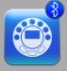

3.2.5 Pairing the Mini with Android

1. Go to *Settings* and make sure Bluetooth is turned on.
2. Turn on the Mini by pressing its blue key.
3. Open the GlobiLab application 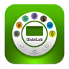.
4. From the GlobiLab menu select “Connect Labdisc”. This menu may be a column of three small boxes to the far right at the top of the screen or it may be a small menu at the bottom of the screen, near the back arrow or home button.
5. The application will open the “Bluetooth pairing wizard” and start searching for Mini devices.
6. Select the Mini_xxxx where xxxx are the last 4 digits on your Mini serial number sticker.
7. Follow the step by step instruction:
   1. Put the Mini in “pairing mode” by pressing and holding the Mini blue key for 3 seconds till all 6 LED are flashing Green-RED-Green.
   2. In the pairing dialog box enter PIN **1234**. Press “Ok”.
8. The App name will change to "GlobiLab (Minidisc_xxxx)" to indicate connection.

Version: 20.5.15