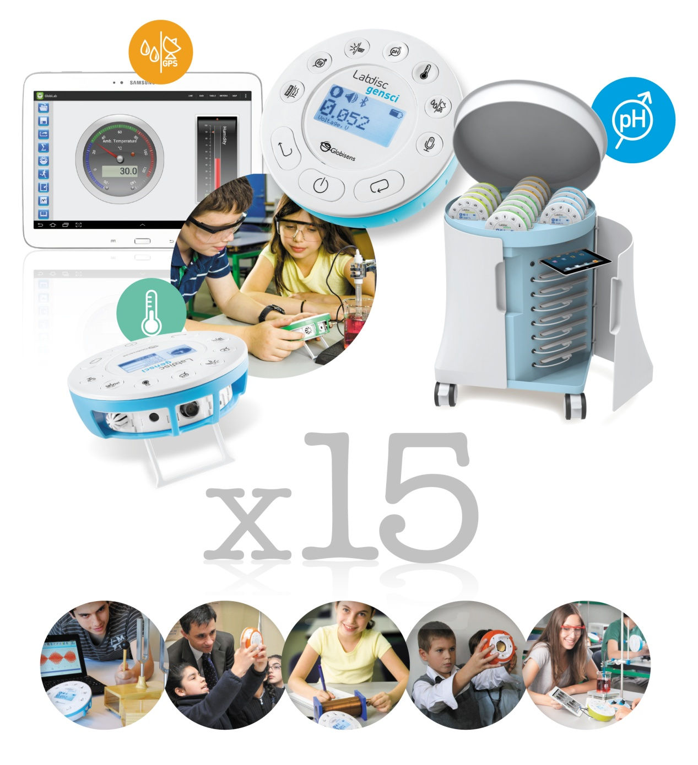

****

**Empowering Science Education**

**Table of Contents**

Contents

[What K-12 Science Students Learn 3](#_Toc419982074)

[Manual science experiments 3](#_Toc419982075)

[Students find collecting data manually boring 4](#_Toc419982076)

[Data Logging Technology Revolution 4](#_Toc419982077)

[Rejecting hands-on teaching practices 5](#_Toc419982078)

[Labdisc - it’s time for something new! 5](#_Toc419982079)

[Configurations for Every Science 6](#_Toc419982080)

[Labdisc features and benefits 7](#_Toc419982081)

[All-in-one disc 7](#_Toc419982082)

[Wireless 7](#_Toc419982083)

[Technology consolidation 7](#_Toc419982084)

[High resolution accurate data recordings 7](#_Toc419982085)

[Unique analysis software 8](#_Toc419982086)

[Broadening the Labdisc Offering 9](#_Toc419982087)

[Experiment Materials and Kits 10](#_Toc419982088)

[A Complete Mobile and Modern Science Laboratory 13](#_Toc419982089)

[Production Reliability and Warranty 14](#_Toc419982090)

[Teacher Training 15](#_Toc419982091)

[Proposal 19](#_Toc419982092)

[Appendix 1: What the Research Shows 20](#_Toc419982093)

[Appendix 2: K-12 Science Experiment Table 21](#_Toc419982094)

[Appendix 3: Labdisc Specifications 26](#_Toc419982095)

# What K-12 Science Students Learn

## Manual science experiments

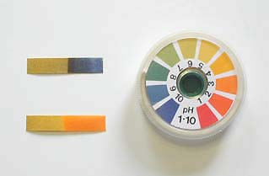Most K-12 students perform science by recording data “manually” - a very different thing from experiencing science “hands-on”. Take chemistry - acids and bases – where litmus paper is used which changes color when immersed in acidic or basic liquids. The paper must be removed immediately, kept in good conditions and the color scale read accurately. Any number of mistakes can be made, so ruining the outcome of the experiment.

When studying Newton’s laws of motion, to calculate complex concepts such as velocity and acceleration. Yet students often only have a marble, stopwatch, measuring tape and graph paper to achieve it. It’s the same story when studying a pendulum where the sophisticated concept behind the experiment shows the earth completes one rotation a day, proving the mass of the earth and acceleration due to gravity. However, by the time students have repeatedly collected and recorded data manually, there’s not much of the 45 minute lesson left to understand the real science behind the experiment.

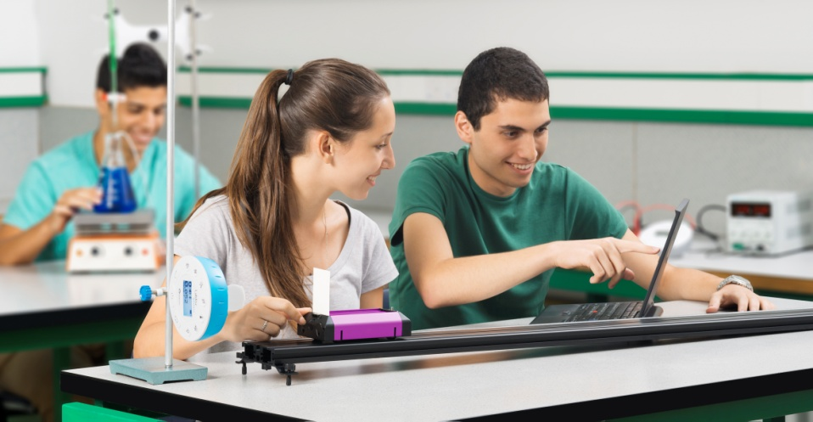Above we’ve described some typical experiments where data can be collected manually. But what about all the exciting science concepts that can only be explored with digital data collection, such as recording a sound wave, or a transient response in an electrical circuit. These experiments are beyond the reach of most K-12 school science experiments, simply because in order to measure such fast changing phenomena, students would need to collect thousands of samples per second. Equally very slow acting phenomena which require data collection over an extended period of time are not feasible for manual data collection. A typical example of this would be changes in temperature, humidity, light and sound over a 24 or 48 hour period.

## Students find collecting data manually boring

The challenge for teachers to engage science students go beyond the limitations of which activities they can explore, the inconvenient, time consuming and tedious experiment processes and disorganized methods for a typical class of 30+ students, not to mention how inaccurate and imprecise experiment results often are.

**The biggest problem is that K-12 science students are bored and convinced that science has no relevance in their lives.**

Many schools find time and budget limitations have focused education on a narrower set of learning outcomes and as a result most children are dropping out science and math. Research shows the number one reason students drop out is because they’re bored. The Bill and Melinda Gates Foundation’s study supported this and showed students feel classes are not relevant to their lives or career aspirations.

The fact is, these same students are very technologically savvy and this can be used to science and math learning’s advantage, helping to cultivate in students the desire to learn. Hand-held technology tools help science students make real-world connections so they understand how science and math concepts are relevant to their lives and futures.

# Data Logging Technology Revolution

Twenty five years ago data logging technology began to enter school systems, offering educators ways to make science experiments easier and cheaper to do. Today, data loggers and sensors are highly featured and able to take thousands of measurements per second, critical in performing simple or complex experiments within the parameters of a 45 minute science lesson. Data logging technology has made a huge contribution to science education. Students have been saved from the tedious and time consuming tasks involved in manual data collection. Instead science educators have been able to focus on the two elements which hold the greatest pedagogic value for any science activity: Experiment design and data analysis.

However, “time constraints” have limited how widely data loggers are used by school science teachers.  
Typically one data logger is used by a pair of students. On average every data logger connects to two sensors, with two sensor cables and one communication cable to each pair’s computer. So a typical class uses: 15 data loggers + 30 sensors + 45 cables.

***On average it takes teachers 1.5 hours to test, calibrate and position a total of 90 items before every Lab lesson, then collect and put everything away afterwards.***

## Rejecting hands-on teaching practices

The pressure of standardized governmental tests, together with technology setup and maintenance means they don’t have time to use data loggers. That’s even assuming the teacher feels confident to use complicated technology successfully in the classroom. These factors all contribute to perfectly good teaching tools wasting away in Lab closets, far from the hands of science students.

***In today’s science learning environment the critical features in data logging are: IMMEDIACY CONNECTIVITY and EASE OF USE.***

# Labdisc - it’s time for something new!

Globisens has listened to educator needs with the Labdisc - applying latest 21st Century technology to resolve the limitations of current data logging solutions for K-12 students, right up to university level science. Five models, with up to 15 built-in sensors, enable science investigation in various fields including environmental science, physics, biology and chemistry.

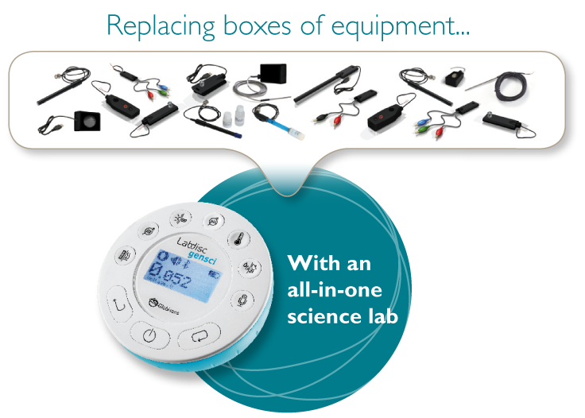Globisens has packed a complete laboratory into a single small disc

The Labdisc replaces a big box of more than 20 individual items - data loggers, sensors, sensor cables and communication cables with a single device. Since all built-in sensors are automatically tested and calibrated, the Labdisc saves teachers hours of setup and calibration time every week.

**The Labdisc is a truly plug n’ play solution as it:**

* Delivers a complete Lab on a disc with up to 15 sensors built-in
* Offers very high accuracy, high sampling resolution and fast recording – essential for K-12 science studies
* Saves teachers lab setup time – Replacing 60-100 to be handed out before eachg lab session, with only one Labdisc per table!
* Saves precious school resources being wasted on multiple small items (like sensors and cables) which inevitably get mislaid and lost during the lab learning session.

# Configurations for Every Science

The Labdisc K-12 line includes **5 unique models** dedicated to the broadest range of school science, with **7 to 15 built-in sensor** configurations.

|  |  |
| --- | --- |
| Globisense Enviro View.jpg | Labdisc for **environmental studies** built-in sensors include:  Ambient Temperature, Barometer, Colorimeter, Dissolved Oxygen, External Temperature, GPS, IR Temperature, pH, Relative Humidity, Sound Level, Turbidity, Universal Input and UV.  http://www.globisens.net/sites/default/files/images/models/enviro/sensors.gif **Typical activities include:** Temp/light over 24 hours, acid rain, turbidity, water quality, temp./RH in urban areas using GPS, altitude and air pressure, heat absorption and cloud warming effects. |
| Globisense_Gensci View.jpg | Labdisc for **general science** built-in sensors include:  Air Pressure, Ambient Temperature, Current, Distance (Motion), External Temperature, GPS, Light, Microphone, pH, Relative Humidity, Sound, Universal Input, Voltage.  http://www.globisens.net/sites/default/files/images/models/gensci/sensors.gif **Typical activities include:** Travelling speed with GPS, Newton’s Laws, sound waves, electrical currents, pH titration, endothermic and exothermic reactions Boyle’s Law, specific heat and microclimate. |
|  | Labdisc for **biochemistry, biology and chemistry** built-in sensors include:  Air Pressure, Ambient Temperature, Barometric Pressure, Colorimeter, Conductivity, Dissolved Oxygen, External Temperature, GPS, Heart Rate, Light, pH, Relative Humidity, Thermocouple, Turbidity and Universal Input. http://www.globisens.net/sites/default/files/images/models/biochem/biochem.jpg **Typical activities include:** Skin temperature, pulse rates before and after activity, sweat production and photosynthesis, solid, liquid and gas phase changes and pH titration. |
| physio.jpg | Labdisc for **physics** built-in sensors include:  Accelerometer, Air Pressure, Ambient Temperature, Current, Distance (Motion), External Temperature, Light, Microphone, Universal Input, Voltage.  http://www.globisens.net/sites/default/files/images/models/physio/physio.jpg **Typical activities include:** Lenz and Boyle’s Laws, resistor networks, light source efficiency, light vs. distance, sound beat and wave superposition, Newton’s Second Law and free fall acceleration. |

## Labdisc features and benefits

All-in-one disc

Teachers' preparation time for a Lab work is dramatically reduced, no longer having to deal with cables and sensors etc. Preparing for class couldn’t be more convenient.

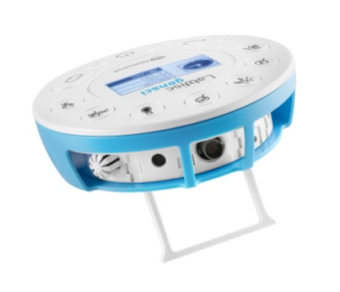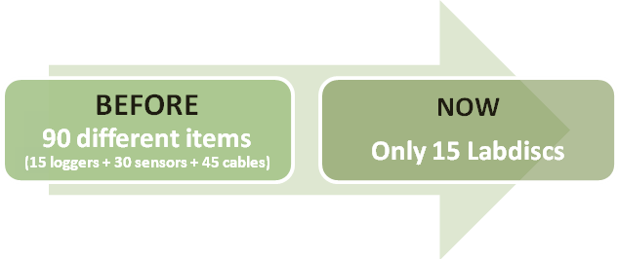

Wireless

The hand-sized Labdisc data logger is a single, cable-free device that acts as a complete Lab with up to 15 built-in wireless sensors. Bluetooth wireless communication fully integrates with all key school technologies and appliances. Connecting to computers, netbooks, interactive white boards, and tablets, the system delivers increased mobility in a cable-free Lab environment.

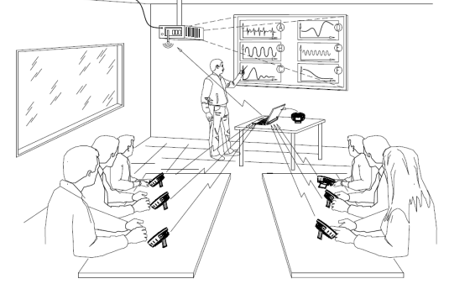Technology consolidation

For so many schools with interactive board technology already a part of the classroom, up to 8 Labdiscs, measuring real scientific reactions, can wirelessly communicate with class interactive board via a single teacher’s computer. This opens the door to collaboration, hands-on and inquiry-based learning, while saving the cost of many computers.

High resolution accurate data recordings

Measuring data at a very high resolution of 12-bit enables a wealth of experiment experience previously unavailable to students. K-12 students can digitally perform classic experiments in sound waves, electricity, mechanics collisions and more. The Labdisc also has high sensor accuracy at ±2% on most sensors, many of them digital sensor, which are much more accurate than analog.

### Unique analysis software

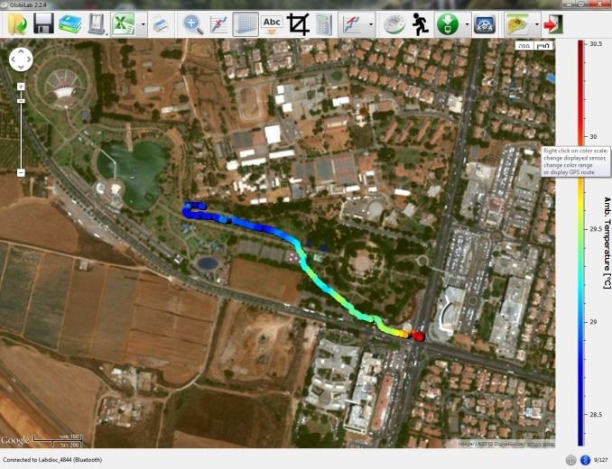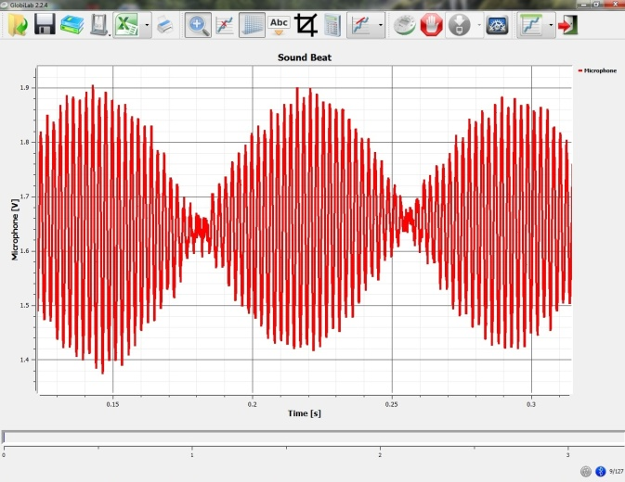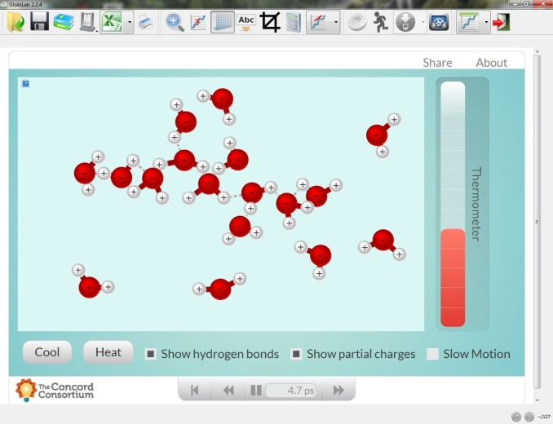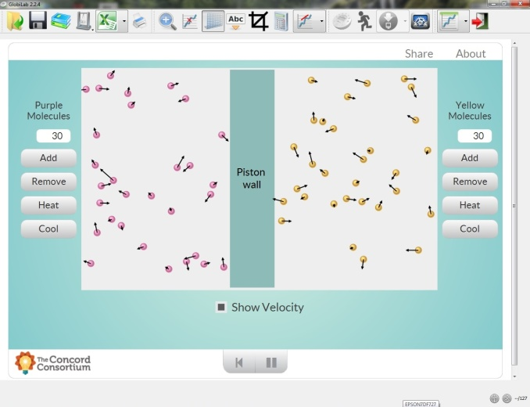  
The Labdisc data analysis software carries all standard features including: Multiple displays, Labdisc setup, functions for mathematic manipulations and Export to Spreadsheets, as well as some unique features including integration with Google Maps, markers, data annotation tools and sophisticated data analysis features. Using the software simulation module, students can compare mathematical simulation to real measurements done by the Labdisc sensors.

# Broadening the Labdisc Offering

Globisens strongly believes in delivering an all-in-one wireless science laboratory. However, some key sensors require large casing and to maintain the compact and portable nature of the Labdisc, they cannot be included in the Labdisc housing. As a result, Globisens have completed the Labdisc built-in sensor range with some carefully selected external sensors to broaden the range of possible experiments for inquiry-based learning. Among the new and high accuracy, quality sensors are Force, Magnetic Field, Respiration, CO2, Voltage and Heart Rate.

Force is one of the key sensors required for experiments in physics. For many sensors wireless communication is an important feature for enabling mobility. However, for a Force and Acceleration sensor, wireless is a “must”: It allows students to connect to moving objects without the need to connect a cable to the sensor which can interfere with the object motion

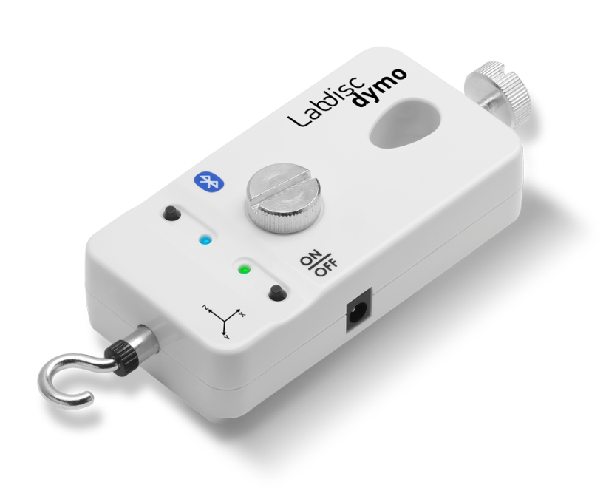By incorporating the Force sensor as a stand-alone unit, wirelessly sending data measurements directly to the GlobiLab software, Globisens has made a world of experiments possible in mechanics and physics. The sensor measures force at a range of ±50N, 3-axis acceleration at a range of ±8g and has a sampling rate fixed at 500 samples per second. Whether exploring simple harmonic motion, friction, collision, impact and momentum or centripetal force, students can easily attach the Dymo to portable Lab trolleys and dynamic carts.

The additional external sensors ensure any curriculum requirement can be satisfied by combining the Labdisc models with a wireless external sensor. It also maintains the unmatchable Globisens price-point per sensor. The Labdisc automatically identifies external sensors, displaying data measurements in the relevant sensor units both on the LCD display and in the GlobiLab data analysis software.

# Experiment Materials and Kits

As a single multi-meter device, the Labdisc replaces all traditional meters and sensors in the Lab. Yet, the Labdisc does not replace experiment materials and accessories such as glassware, chemicals, tuning forks, weights etc.

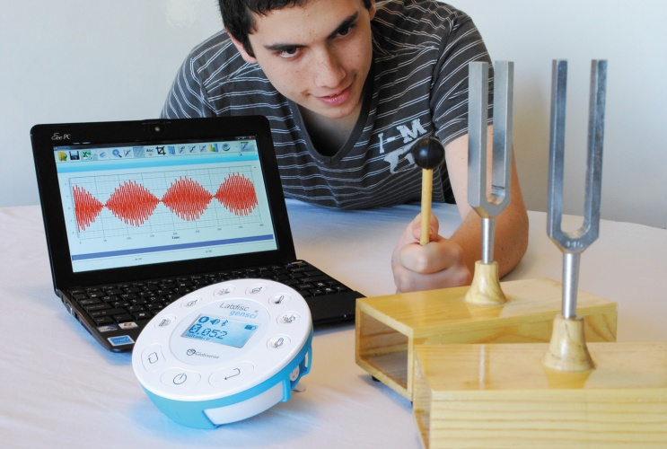As part of the Globisens mission to provide complete science solutions to schools, a series of science kits have been created. These science kits contain all the experiment materials needed to cover the K to 12 science curriculums. Using our experiment cookbooks, students are able to conduct experiments, connect the Labdisc to the experiment materials and measure parameters such as temperature, air pressure, speed, light level and sound waves, to name just a few.

**Physics Science Kit**

|  |  |  |
| --- | --- | --- |
| **P/N** | **Description** | |
| PH-KIT-GENERAL | **Includes all below material for 1 to 2 students covering electricity, waves, magnetism and Newton mechanics.**   |  |  | | --- | --- | | * Set of two tuning forks with wooden resonance box * Electricity board with: 0.47 uF,100 uF, 1000 uF capacitors, 100 Ω, 1000 Ω, 10,000 Ω resistors, diode, SPST switch * Set of 6 x 10 cm black banana cables * Set of 6 x 10 cm red banana cables * 3 x 1.5 V, D type battery holder * Electric coil with 1600 turns and max current of 100 mA. Equipped with 2 banana sockets * Bar magnet length 100 mm | * Air core solenoid has an inner diameter > 3 cm and a length of 15 cm, equipped with 2 banana sockets * Set of 3 metal springs with springs ranging from 4 N/m to 14 N/m * 10 x 1 N slotted mass set * Ping pong ball * Rectangle lab stand with aluminum rod 12 mm diameter x 500 mm length * Aluminum rod 12 mm diameter x 200 mm length * Right angle holder clamp * 2 x 60 mL syringe with luer lock | | |
| PH-KIT-01 |  | **Laboratory power supply, having the following minimum specifications:** |
| • Input voltage: 110-220 VAC |
| • Output voltage: variable 0-30 VDC, Current 0-3 ADC |
| • Digital display of both current and voltage, Current limitation 0 to 3A |

**Chemistry and Biology Science Kit**

|  |  |  |
| --- | --- | --- |
| **P/N** | **Description** | |
| BC-KIT-GENERAL | **Includes all glassware and non-consumables for one student or a team of two students to perform the high school chemistry and biology experiments.**   |  |  | | --- | --- | | * Beakers (10 mL & 30 mL & 150 mL) * Erlenmeyer flasks (10 mL & 25 mL) * Hirsch funnel * Filter flasks (25 mL) * Test tubes (6 x 50 mm) * Wintrobe tube * Wire mesh with ceramic center * Pipette, with tips * Volumetric flasks (10 mL & 25 mL), with stopper * Funnel | * Watch glass * Rubber tubing * Pipette bulb * Periodic chart * 2 x 60 mL syringe with luer lock * Test tube holder (clear Perspex) * Pack of straws * Alcohol burner, 3.5 oz/100 mL (P/N * Tripod, burner, 15 cm x 9 cm x 4 cm (P/N 6346800) * Candles & matches | | |
| BC-KIT-01 |  | **Valves and tubing set for conducting experiments with air pressure.** |
| • 2 x NPT thread with 5/16" hex to 200 series barb, 3/32" (2.4 mm) ID tubing |
| • 3 meter clear PVC tube inner diameter 2.3 mm (P/N UR00-2047C) |
| • 2 x rubber cork for test-tubes |
| BC-KIT-02 |  | **Consumables set including:** |
| • Distilled water, 1 L bottle |
| • Alcohol for burners |
| • Hydrochloric acid, solution, 0.5 M, 500 mL bottle |
| • NaOH solution 0.5 M, 500 mL bottle |
| • Gloves |

# A Complete Mobile and Modern Science Laboratory

Limitless research supports the significant learning gains brought by probeware and data logging technology, helping children experience and understand abstract science concepts (See Appendix 1: What the Research Shows). However, to truly experience hands-on science every student needs access (whether individual, in a pair or in a small group) to a data logging device.

Currently schools attempt to achieve this with a dedicated computer science laboratory: A congested, cluttered and often old-fashioned looking room, outfitted with tens of thousands of dollars worth of equipment. Teachers must then mobilize groups of students to this science lab. They are always limited by the availability of this room (and often the support of a Lab technician), every time they want to introduce curriculum-required experimentation and inquiry-based learning into the science lesson.

Addressing this issue, Globisens has expanded the same concept of convenience, immediacy and ease-of-use that made the condensed wireless Labdisc so successful.

**The Science Mobile Cart**

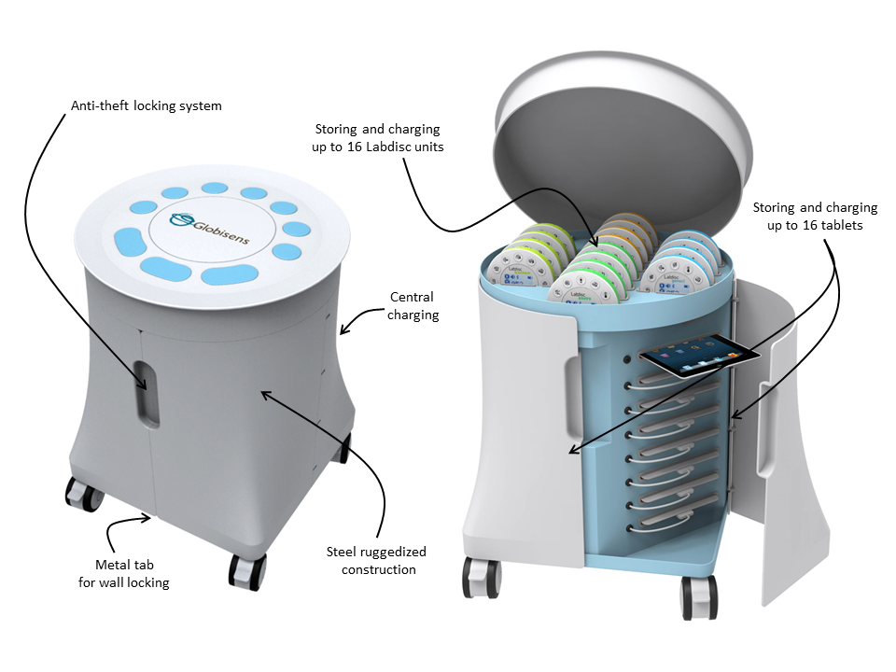

Globisens has developed the Science Mobile Cart in order to mobilize an entire computerized science laboratory to K-12 students wherever they are in school. This not only dramatically reduces the cost of equipping and running a full science laboratory, but also resolves the logistical challenge of transporting the entire class to a different room just to learn science.

Now schools can far more conveniently and affordably develop ICT skills and allow teachers to provide real inquiry-led experimentation to students: Delivering a complete, consolidated and clean digital science learning environment to anywhere in school.

The mobile cart solves the limitations on science learning in school. Storing and charging up to 16 Labdiscs and 16 tablets; this mobile laboratory delivers digital inquiry-based science to every class.

No doubt, a single Labdisc used by teachers during a science lesson can help conduct presentations. However, all the pedagogic research shows that it is the student who has to experience and perform hands-on an inquiry-based experiment in order for optimal learning to take place.

The mobile cart, storing up to 16 Labdiscs is the ultimate solution for the classroom: One Labdisc shared by two students as they conduct hands-on science experimentation. To conduct an effective Lab session, we recommend not more than four students per Labdisc.

# Production Reliability and Warranty

Globisens is a US owned company that operates in more than twenty countries via a dedicated distribution network. The company has a total of 35 employees, more than 28 of whom work in our very modern hi-tech production facility.

Since being first launched in October 2011 the Labdisc has shipped 40,000 units, won two international awards for pedagogic innovation and just been shortlisted for another this year.

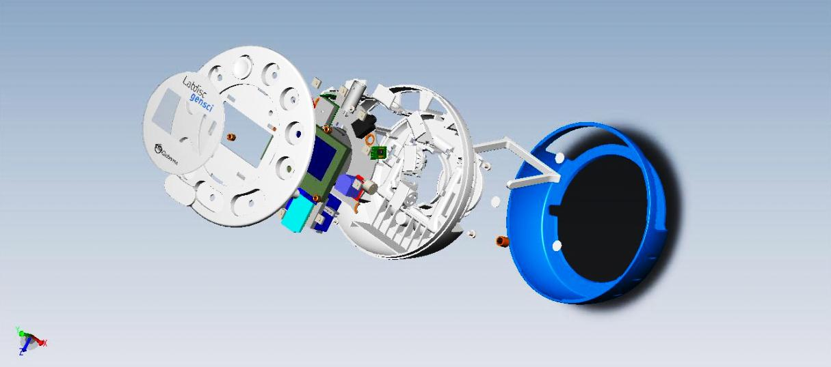The Labdisc is comprised of 600 separate components, all of which are automatically assembled in less than a minute.

All boards must pass a thorough Automatic Optic Inspection (AOI) to confirm that every component has the correct part number and is assembled in its exact location on the board.

A strict quality analysis procedure ensures that 100% of all Labdiscs are tested five times throughout their production. This modus operandi ensures the highest quality and reliability, resulting in a Labdisc return rate of less than 0.1%.

Globisens provides a 12 month warranty that covers all workmanship issues, but does not cover consumables such as batteries and electrodes which can be reasonably expected to last between one and three years depending on usage and storage.

# Teacher Training

Globisens teacher training instructs teachers in how to integrate between the Labdisc technology and the local curriculum. Not only do we enable learning benchmarks to be reached for every lesson, but we empower the teacher with the confidence to excite their students with the wizardry of science and technology.

Globisens training gives teachers the confidence to move away from “chalk and talk” learning and instead “experience” complex science concepts by applying the Labdisc for hands-on experimentation.

**Train the Trainer Model**

Globisens unique teacher-training is based on our own train-the-trainer model. A group of thirty to sixty biology, chemistry and physics teachers are selected and brought to one location for an intensive three-day training course. After becoming familiar with the technology the teachers are split into groups per subject area. They then focus on some of the most frequently-used activities in their field. Within each activity the teachers are trained in using the Globisens technology to design the experiment, compare results, and draw conclusions, with suggestions for further activities supplied. This boutique approach to teacher-training is scalable and flexible, incorporating an indefinite number of teachers into any of the three major science curriculum areas.

At the end of the course each participating teacher is then able to act as a cluster teacher in their local area. They return with a full portfolio of teaching resources including training workbooks, teaching guides, sample lab reports and interactive experiment activity files.

**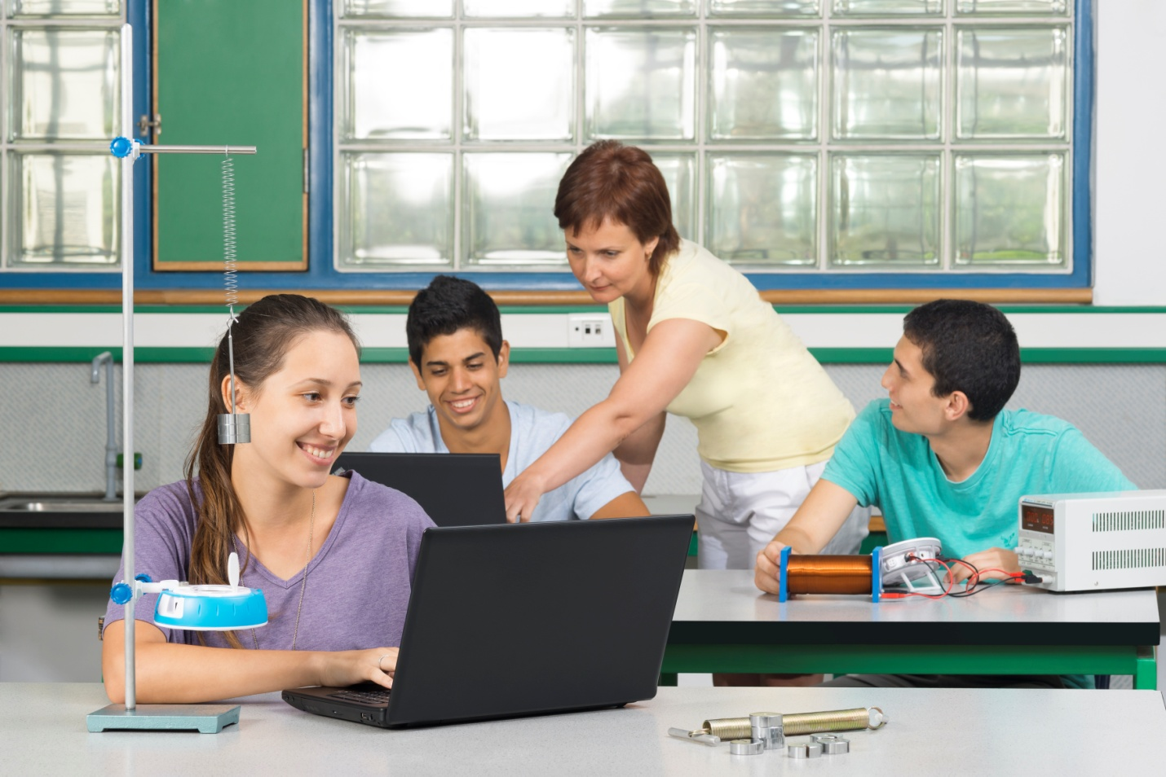**

**Globisens Training Course Agenda**

The Globisens teacher training course covers 25 hours. It is divided into ten short training sessions, or spread over an intensive three-day course.

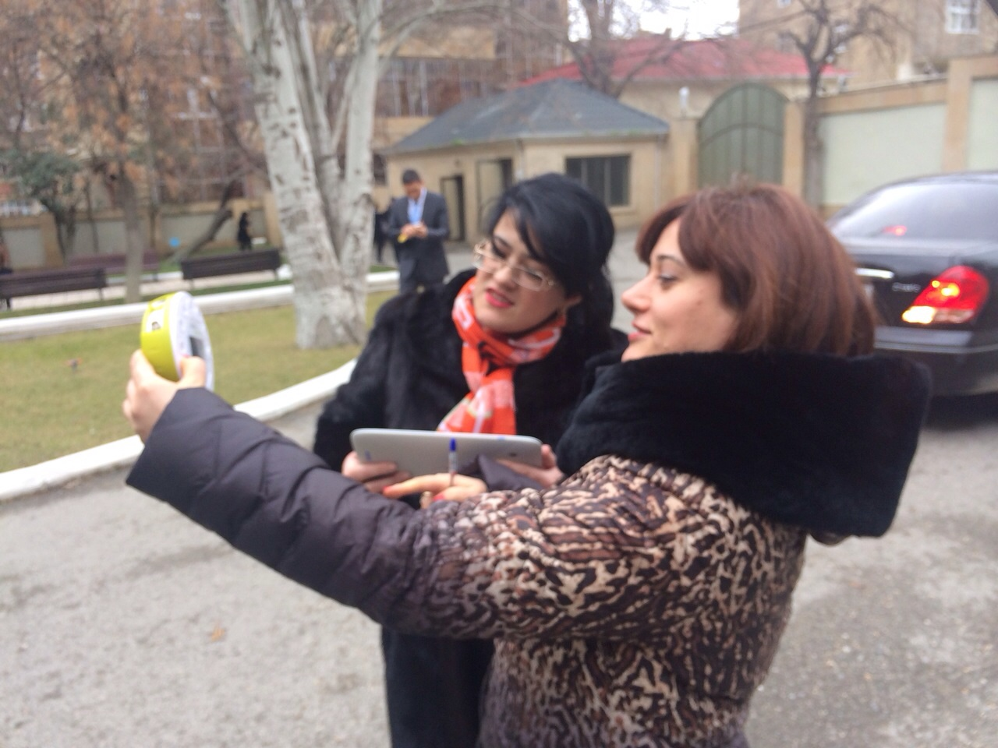The first part of the session focuses on science curriculum development and building a cohesive knowledge base. Establishing and closing all the science knowledge gaps to ensure teachers are up to date with key national science topics and benchmarks for science literacy in Biology, Chemistry, Environmental Science and Physics.

The second part of the session introduces a modern 21st century science lab (the Labdisc science learning environment) to explore the scientific concepts with hands-on experiments. Labdisc implementations have a very fast learning curve for teachers, equipping them with the latest technologies and methodology.

Workshops follow a series of interactive multi-disciplinary activities. These have been developed by pedagogic experts to take advantage of the Labdisc features and enable teachers to use inquiry-based science in their classroom.

Additional interactive curriculum is provided for the teachers to use back in the classroom which fully supports the local national curriculum and targets in K-12 school science.

The Globisens sessions follow stages of objective, theory, activity and analysis. Clear guidelines for every activity are provided so teachers can easily repeat the activities in their classroom, feeling complete confidence in both the technology they use and the learning objectives they meet.

We aim to demonstrate to teachers how within a 45 minute lesson they can achieve successful experimentation performance and data results with all students.

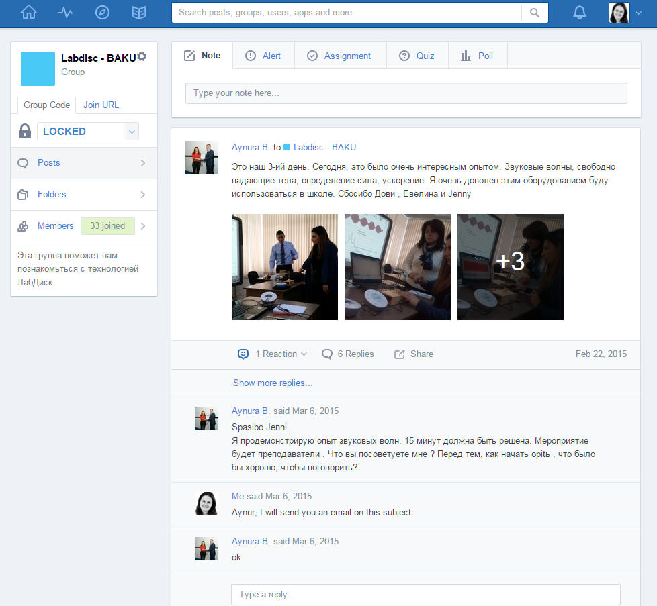**Edmodo Active Learning Community**

Globisens teacher training is built on the Edmodo social learning platform. The Edmodo user interface is quite similar to Facebook, thus requiring no learning curve. Following Globisens intensive training programs, this educational platform enables an active learning community of teachers to be created. It also performs a key supportive role in ongoing distance learning, seamlessly integrating technical, emotional and pedagogical support.

**Content for science teaching:**

Edmodo holds a dynamic library of Labdisc learning materials and activities for science teachers (Biology, Environmental studies, Chemistry and Physics) to follow with their classes. The library’s content is constantly reviewed and regularly updated.

**Ongoing instructor support**

The platform is monitored and managed by a Globisens instructor who provides pedagogic support to the participating teachers. The instructor manages closed forums and live conversations between educators, as well as responding to questions and raising new subjects for discussion.

**Keeping teachers motivated**

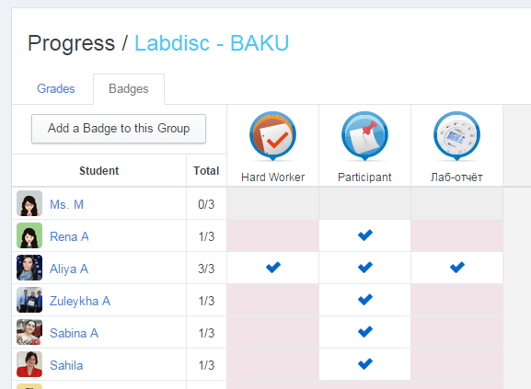Edmodo not only ensures optimal usage for the technology investment in the hands of teachers and students, but also provides project feedback for training, collaboration between schools and incentivizing of teachers.

The interactive and collaborative nature of the Edmodo learning platform allows Globisens to sustain the momentum gained during initial training. Participating teachers and students are encouraged to contribute their own experiments and lab reports, as well as upload short movies they have filmed of the experiment process. In this way they share their experiment methodology and results with their region’s educator community, as well as offering the MOE a measurable indicator of ongoing class activities.

Teacher trainers are tested on how active they are in the community - helping their fellow teachers, responding to questions and innovating interesting Labdisc science projects. Teachers are also recognized who develop and contribute the most engaging activities to the platform.

**Creating a thriving online science learning community**

Edmodo helps build a learning community and knowledge sharing platform for science education. Teacher-trainer and teacher-teacher interactions are enriched between schools and localities. Not only can teachers post useful links or detail upcoming events, but they can collaborate on experiments and analysis, ensuring the dissemination of pedagogic and scientific knowledge.

# Proposal

We are pleased to submit the proposal below for [Territory] school laboratories.

Our proposal suggests the following solution:

A comprehensive solution for the 1000 Schools, providing a modern solution at the student level. This solution enables each student to experience true hands-on experimentation in science. The solution is based on the Mobile lab with 5 General Science Labdisc units, plus+ set of 5 Biology-chemistry and Physics science kits per class.

The proposal includes a full localization of our solution to meet [Territory] language and curriculum requirements. In addition we will conduct a teacher training course for 30 to 60 selected teachers, coming from all regions of the country. After being certified by Globisens, these teachers will serve as trainers for their regions.

**Pricing:**

1000 Schools:

|  |  |  |  |  |
| --- | --- | --- | --- | --- |
| **Product** | **Description** | **Price per unit** | **Number of units** | **Total price** |
| Cart | Mobile science Cart |  |  |  |
| LD12-GenSci | Labdisc General Science |  |  |  |
| BC-Kit-GENERAL | Biology and Chemistry Science kits |  |  |  |
| PH-KIT-GENERAL | Physics science kit |  |  |  |

As part of providing a complete mobile solution for Science, Globisens can additional supply Tablet computers pre-installed with the GlobiLab analysis software.

All items carry a 12 month warranty against any workmanship or shipping defects. Warranty does not cover consumables such as batteries and electrodes and shall not apply in cases of product abuse.

In addition to the above we will charge a one-time fee of $100,000 for the translation, curriculum correlation and teacher training needed for this project.

# Appendix 1: What the Research Shows

Digital technologies can be used to support the development and implementation of high quality technology-enhanced (probeware) science lessons.   
*Technology and Reform-Based Science Education, Theory into Practice 2008*

Computer-based technologies support active engagement and science concept understanding by collaborative learning, frequent and immediate feedback on data in a real world context

*Roschelle et al., 2000*

Results indicate that data loggers excited pupils and saved them time recording temperature readings. That time could be used to produce and interpret graphs.

*Introducing Data Logging Equipment into Programmes of Study in Field Studies Centre: An Evaluation Horizons, n15 p12-16 Aut 2001*

Simple quick experiments using data loggers lead to the refinement of the experiments, increased confidence in the measurements and improved understanding of the physics involved.   
*How Science Works" and Data Logging: Eleven Quick Experiments with a Kettle  
Physics Education, v45 n6 p658-669 Nov 2010*

Science learning experiences with real or simulated investigation substantially improve understanding of complex ideas and lead to long-term understanding.

*Research Points: Science Education that Makes Sense (2007)*

Students who used computers and probeware showed significant learning gains.  
*TEEMSS, National Science Foundation, 2007*

Countries like Japan and Korea (with early science learning) scored highly in science and math as compared with other 1st world countries.  
*PISA Results of Student Science and Math Scores, 2000*

Students who had been exposed to hands-on science in pre-school performed higher than the national average.  
*Plank (2000, USA)*

# Appendix 2: K-12 Science Experiment Table

|  |  |  |  |  |  |
| --- | --- | --- | --- | --- | --- |
| **Subject** | **Field** | **Lesson hours** | **Grade level** | **Labdisc** | **Sensors** |
| **“Light intensity”** Measuring and comparing the luminosity of a candle, a flashlight and natural day-light. | Physics | 2 | Middle school | Physio, Gensci | Light |
| **“Day and Night”** Recording the variations of temperature and light during a period of 24 hours to establish relations between them. | Environment/ Biology | 2 | Elementary/ Middle school | Gensci, BioChem, Physio, Primo | Light, Temperature |
| **“What Do We Drink?”** Measuring the pH of different soft drinks. | Chemistry | 2 | Middle school | Gensci, BioChem, Enviro | pH |
| **“Water Bodies”** Measuring temperature and humidity near rivers or other water bodies to determine their effect on temperature and humidity. | Environment/ Biology | 5 | Middle school | Enviro, Gensci, BioChem | Temperature, Humidity |
| **“How Loud is Sound”** Measuring the decay of sound level over distance | Environment/ Physics | 2 | Elementary | Gensci, Physio, Primo | Microphone |
| **“Walk in the Park”** Measuring temperature changes at a busy city junction, and in a nearby park or garden | Environment | 2 | Elementary | Gensci, Primo, Enviro | Temperature, GPS |
| **“Travelling Speed”** Using the GPS sensor to measure walking speed, running speed and/or biking speed – a great activity for creating a contest between students. | Physics | 5 | Middle school | Gensci, Enviro, BioChem | GPS |
| **“Our Heart Rate”** Measuring the heart rate before and after exercise and recording useful information to determine physiological parameters. | Biology | 2 | Middle school | BioChem (or Gensci with external heart rate) | Pulse |
| **“The Laws of Motion”** Determining the relationship between speed time and distance as part of understanding Newton’s mechanic principles. | Physics | 2 | Middle school | Gensci, Physio | Distance |
| **“Altitude and Air Pressure”** Using the Barometer and GPS sensors to travel from high to low places, measuring the change in air pressure and altitude. | Environment | 5 | Middle school | Enviro | GPS, Barometer |
| **“What is Distance”** Examine the relationship between speed time and distance. Explore graphs of distance versus time | Physics | 2 | Elementary | Primo, Gensci, Physio | Distance |
| **“The Temperature Around Us”** Recording the temperature of different substances | Physics | 2 | Elementary | All | Temperature |
| **“Absorption of Heat”** Measuring and comparing the internal temperature of different colored containers full of water after being exposed to sunlight. | Physics | 2 | Middle school | All | Temperature |
| **“Lenz Law”** The connection between electric and magnetic fields. | Physics | 2 | High school | Physio, Gensci | Voltage |
| **“The Principle of Resistor Networks”** Measuring the current and voltage of two simple electric circuits (in series and parallel) and determining the differences between them | Physics | 3 | High school | Physio (or Gensci with external Voltage) | Voltage, current |
| **“Light Versus Distance”** Recording light intensity while moving away from the light source. | Physics | 2 | High school | Physio, Gensci | Light |
| **“Acid Rain”** Collecting rain in different area and verifying the acidity of the rain as it relates to pollution. | Environment/ Biology | 2 | High school | Gensci, BioChem, Enviro | pH |
| **“Sweat Production”** Covering our hand with a plastic bag, while measuring temperature and relative humidity to explain the principle of the body’s cooling system – sweat**.** | Biology | 2 | High school | Enviro, Gensci, BioChem | Temperature, Humidity |
| **“Boyle’s Law”** Measuring the connection between volume and pressure: PV=NRT, by using a syringe to show the linear relation between volume and air pressure. | Chemistry | 2 | High school | Gensci, BioChem, Physio | Air Pressure |
| **“Photosynthesis”** Recording air pressure and light level, while using an Elodea water plant sealed in a test-tube - to measure the effect of photosynthesis and the relation between light intensity and oxygen production by the plant. | Biology | 3 | High school | Gensci, BioChem, Physio | Air Pressure |
| **“City Micro Climate”** Measuring the changes in noise, temperature (and humidity) in different urban areas. | Environment/ Biology | 4 | High school | Enviro, Gensci, BioChem | GPS, Temperature, Humidity |
| **"Lambert-Beer law"** Determining the relationship between a solution concentration and its light absorbance. | Chemistry | 3 | High school | Enviro, BioChem | Colorimeter |
| **“Free Fall”** measuring the free fall acceleration using a ping-pong ball. | Physics | 2 | High school | Gensci, Physio | Distance |
| **“Sound Level Versus Distance”** Measuring the sound level decay over distance. | Physics | 2 | High school | Gensci, BioChem, Enviro | Distance, Microphone |
| **“Sound Waves”** Recording sound waves and sound wave interference. | Physics | 3 | High school | Gensci, Physio | Microphone |
| **“Cloud Effect on a Winter’s Day”** Measuring the sky’s temperature on a clear sky day and on a cloudy day and explaining how clouds keep ground heat from radiating into the atmosphere. | Environment | 3 | High school | Enviro | IR Temperature |
| **"Candle flame"** Exploring the temperature zones of a candle flame. | Chemistry | 2 | High school | BioChem | Thermocouple |
| **"Photosynthesis"** Using a DO2 sensor to check the Photosynthesis rate of an Elodea plat in different light intensities. | Biology | 3 | High school | BioChem | Dissolved Oxygen |
| **“Phase Changes: Solid, Liquid and Gas”** A classic activity measuring the freezing and boiling point of water. | Chemistry | 3 | Middle school | All | Temperature |

|  |  |  |  |  |  |
| --- | --- | --- | --- | --- | --- |
| **"Impact and momentum"** Using the distance sensor to measure the speed of two carts before and after a plastic collision. | Physics | 3 | High school | Physio, Gensci | Distance |
| **“UV & Sun Block”** Measuring and comparing the level of ultraviolet radiation, resulting from the intervention of a beam of sunlight through different types of filters such as sunglasses and sun blocks. | Environment/ Chemistry | 3 | Middle school | Enviro | UV |
| **"Hooks Law"** Using a metal spring to investigate the spring coefficient K and the equation F = -kx. | Physics | 2 | High school | Dymo | Force |
| **"Newton 2nd law"** - Using a cart pulled by a constant weight to prove Newton law of motion - F = ma. | Physics | 3 | High school | Dymo | Force, Acceleration |
| **“Water Quality”** Comparing drinking water turbidity to other water taken from lakes and ponds. | Environment/ Biology | 4 | High school | Enviro, BioChem | Turbidity |
| **"Friction"** investigating the static and dynamic friction of a body moving on different surfaces. | Physics | 3 | High school | Dymo | Force |
| **"Harmonic motion"** Investigating the motion of a mass on a spring. | Physics | 3 | High school | Dymo | Force |
| **“Endothermic and Exothermic Reactions”** Performing different measurements to examine which reactions release or consume heat. | Chemistry | 3 | High school | All | Temperature |
| **“pH Titration”** Classic Acid and Base titration - measuring pH and temperature change (Also using an external temperature sensor). | Chemistry | 3 | High school | Gensci, BioChem, Enviro | pH, Temperature |
| **“Specific Heat”** Heating different liquids to the same temperature (70˚C) and comparing the cooling curves of these liquids to explain which has the higher specific heat. | Chemistry | 3 | High school | All | Temperature |

|  |  |  |  |  |  |
| --- | --- | --- | --- | --- | --- |
| **"CO2 production during respiration"** Investigating bean seeds respiration, using the CO2 sensor. | Biology | 2 | Middle school | All with External CO2 | CO2 |
| **"Earth Magnetic field"** Using the Magnetic Field sensor to check the magnetic field of the Earth poles. | Physics | 2 | Middle school | All with external Magnetic Field | Magnetic Field |
| **"Magnetic field of a coil"** Using the magnetic field sensor to check the magnetic field inside a long coil. | Physics | 2 | High school | All with external Magnetic Field | Magnetic Field |
| **“Mammal effect”** decreasing the heart rate when seeming in cold water to preserve body heat. | Biology | 3 | Middle school | Primo, BioChem | Temperature, heart rate |
| **"Doppler effect"** what happens to a sound harmonic while in motion. | Physics | 4 | High school | Gensci | Microphone |

# Appendix 3: Labdisc Specifications

|  |  |
| --- | --- |
| Globisense_Gensci View.jpg**Labdisc Gensci Data Logger Specifications** | |
| **Parameter** | **Labdisc Gensci** |
| **Supported Platforms** | Standalone, PC, MAC, iPad |
| **Built-in Accessible Sensors** | 13 sensors:  Air Pressure, Ambient Temperature, Current, Distance (Motion), External Temperature, GPS, Light, Microphone, pH, Relative Humidity, Sound Level, Universal Input and Voltage |
| **Max. Sampling Speed** | 24,000/s |
| **Sampling Resolution** | 12-bit |
| **Internal Data Storage** | 100,000 samples |
| **Internal Rechargeable Battery** | LiPO 7.2 V |
| **Battery life** | > 150 hours |
| **Display** | Graphical LCD 64 x 128 pixels |
| **Keypad** | Yes |
| **Communication** | USB V2.0 |
| **Wireless Communication** | Bluetooth V2.0 on all sensors |
| **Remote Data Collection** | Yes |
| **Automatic Sensor Testing & Calibration** | Yes |
| **Size** | ɸ= 132, H = 45 mm |
| **Weight** | 300 gr. |
| **Temperature range** | -10 to 50 °C |
| **Standard Compliance** | CE, FCC |

|  |  |  |
| --- | --- | --- |
| **Labdisc Gensci Built-in Sensor Specifications** | | |
| **Sensor Type** | **Max. Range** | **Accuracy** |
| **Air Pressure** | 0 to 300 kPa | ±2.5 kPa |
| **Ambient Temperature** | -10 to 50 °C | ±1°C |
| **Current** | -1 to 1 A | ±2 % |
| **Distance (Motion)** | 0.4 to 10 m | ±2 % |
| **GPS** | N/A | ±3 m |
| **Light** | Multi-range 55,000 lx | ±15 % |
| **Microphone** | 0 to 5 V | ±2 % |
| **pH** | 0 to 14 pH | ±2 % |
| **Relative Humidity** | 0 -100 %RH | ±6 % (10%-90%RH) |
| **Sound level** | 58 to 93 dBa | ±4 dB |
| **Temperature** | -25 to 125 °C | ±2 °C |
| **Universal input** | 0 to 5 V | ±2 % |
| **Voltage** | -30 to 30 V | ±2 % |

|  |  |
| --- | --- |
| **Analysis Software Specifications** | |
| **Parameter** | **Description** |
| **Data Retrieval** | Online up to 100 samples/second, or download Labdisc stored data |
| **Data Display** | Line graphs, bar graphs, tables, meters, Google Maps |
| **Communication** | USB 2.0, Bluetooth 2.0 |
| **Data Logging Configuration** | Sensor selection, sampling rate, sampling points |
| **Graph Manipulation** | Placing and moving up to two markers on the graphs, zoom in/out, graph cropping, graph color change, sensor legend (allowing graph show/hide and the selection of lines/icons for the graph samples) |
| **Graph Annotation** | Text and image annotations on the graph |
| **Mathematical Functions** | Derivative, linear regression, quadratic regression, FFT |
| **Statistics** | Min., max., average, standard deviation for a selected graph |
| **Simulation** | Gas and Liquid molecule behavior, with parameter control |
| **Data Manipulation** | Save/open experiment data, direct export to EXCEL, display hardcopy printout |
| **Workbook** | Full suite of built-in curriculum activities |
| **Stored experiments** | Full suite of stored experiment data |
| **Configuration** | Sensor calibration, change of sensor units |
| **Firmware Update** | Ability to update the Labdisc firmware through a USB connection |
| **OS** | PC, Mac, Linux, iPad |