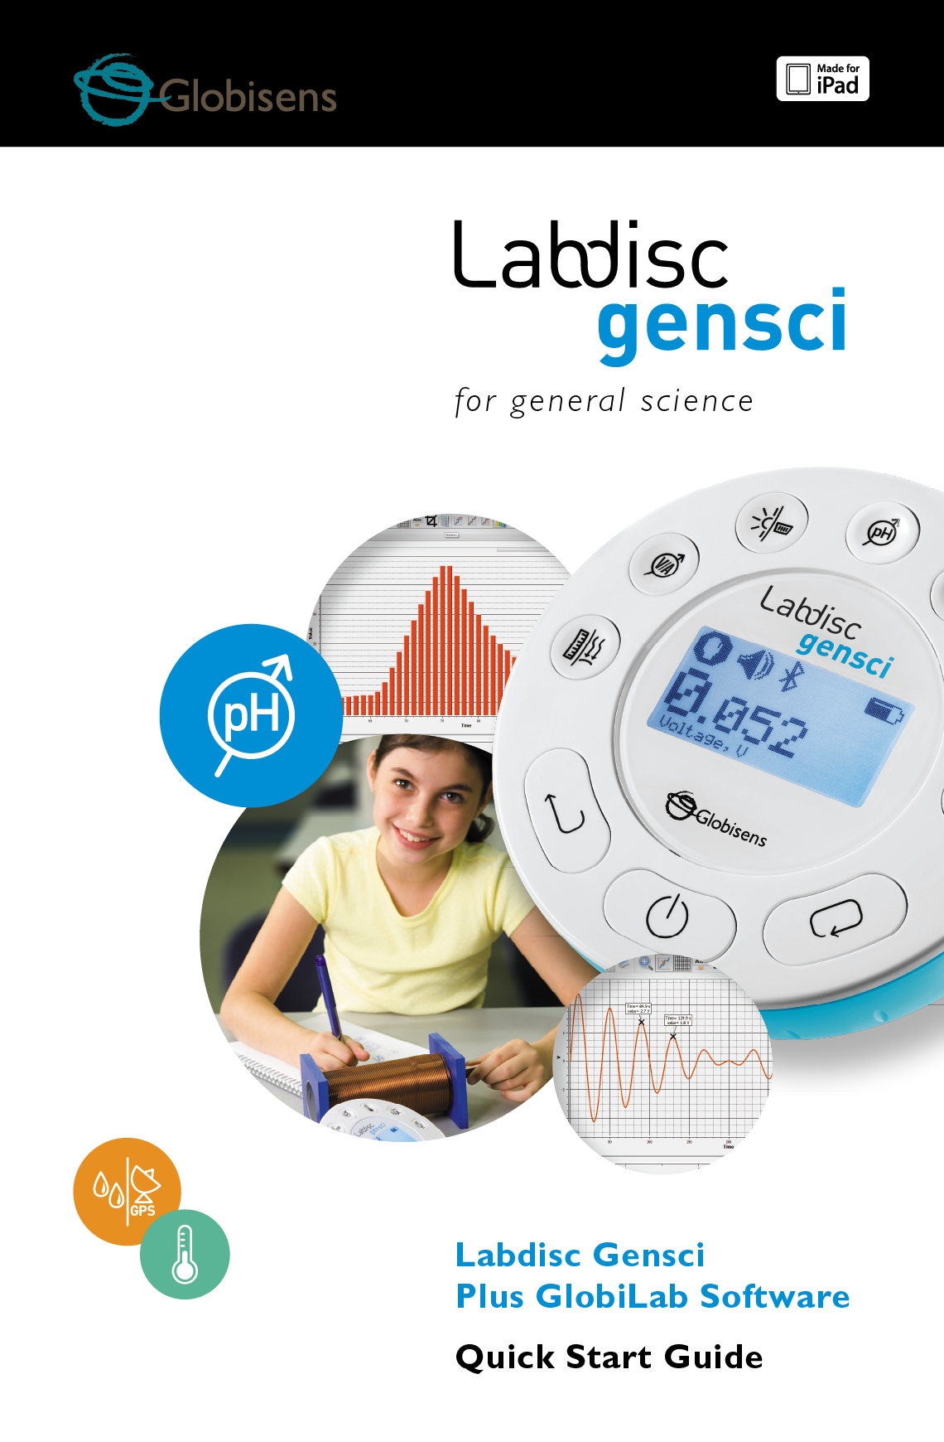

Contents

[1. Labdisc Hardware Overview 1](#_Toc489529734)

[1.1 What’s in the Pack 1](#_Toc489529735)

[1.2 Ports and Controls 1](#_Toc489529736)

[1.3 Built-in Sensors 3](#_Toc489529737)

[1.4 Using the Labdisc 4](#_Toc489529738)

[1.4.1 Labdisc display 5](#_Toc489529739)

[1.4.2 Labdisc keys 6](#_Toc489529740)

[1.4.3 Labdisc menu 7](#_Toc489529741)

[1.4.3.1 Setup the Labdisc for the next logging session 7](#_Toc489529742)

[1.4.3.2 Labdisc information 7](#_Toc489529743)

[1.4.3.3 Configuration of the Labdisc 8](#_Toc489529744)

[2. GlobiLab Analysis Software 9](#_Toc489529745)

[2.1 Software Installation 9](#_Toc489529746)

[2.2 Software Functions 9](#_Toc489529747)

[2.3 Software Popular Icons and their Functions 10](#_Toc489529748)

[2.4 GlobiLab Software for iPad 15](#_Toc489529749)

[2.5 GlobiLab Software for Android 18](#_Toc489529750)

[3 Labdisc – GlobiLab Communication 23](#_Toc489529751)

[3.1 USB Communication 23](#_Toc489529752)

[3.2 Bluetooth Wireless Communication 23](#_Toc489529753)

[3.2.1 Pairing with a PC running Windows OS 23](#_Toc489529754)

[3.2.2 Pairing with a Mac OS 24](#_Toc489529755)

[3.2.3 Pairing with an iPad 25](#_Toc489529756)

[3.2.4 Pairing with Android OS 25](#_Toc489529757)

[3.2.5 Pairing with Chromebook OS 26](#_Toc489529758)

[4 Experiment Samples 28](#_Toc489529759)

# 1. Labdisc Hardware Overview

## 1.1 What’s in the Pack

|  |  |
| --- | --- |
| ① **Labdisc** data logger  ② **Labdisc** AC charger  ③ USB cable  ④ Quick start guide  ⑤ Warranty page  ⑥ Software flyer | ⑦ Banana cables  ⑧ Temperature probe  ⑨ Air pressure tube  ⑩ pH electrode |

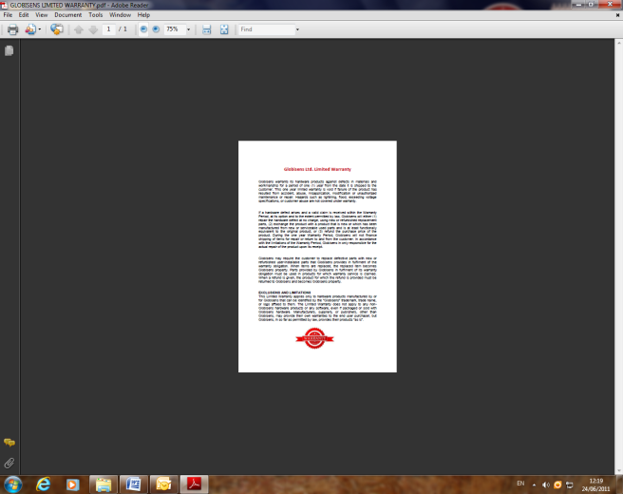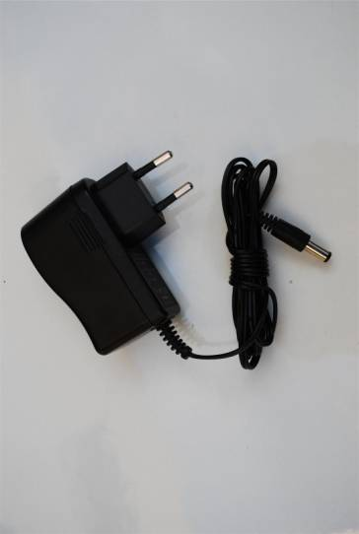

**3**

**2**

**1**

**11**

**8**

**9**

**6**

**5**

**2**

**3**

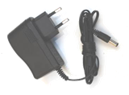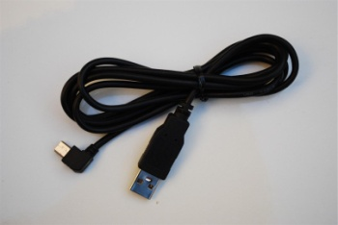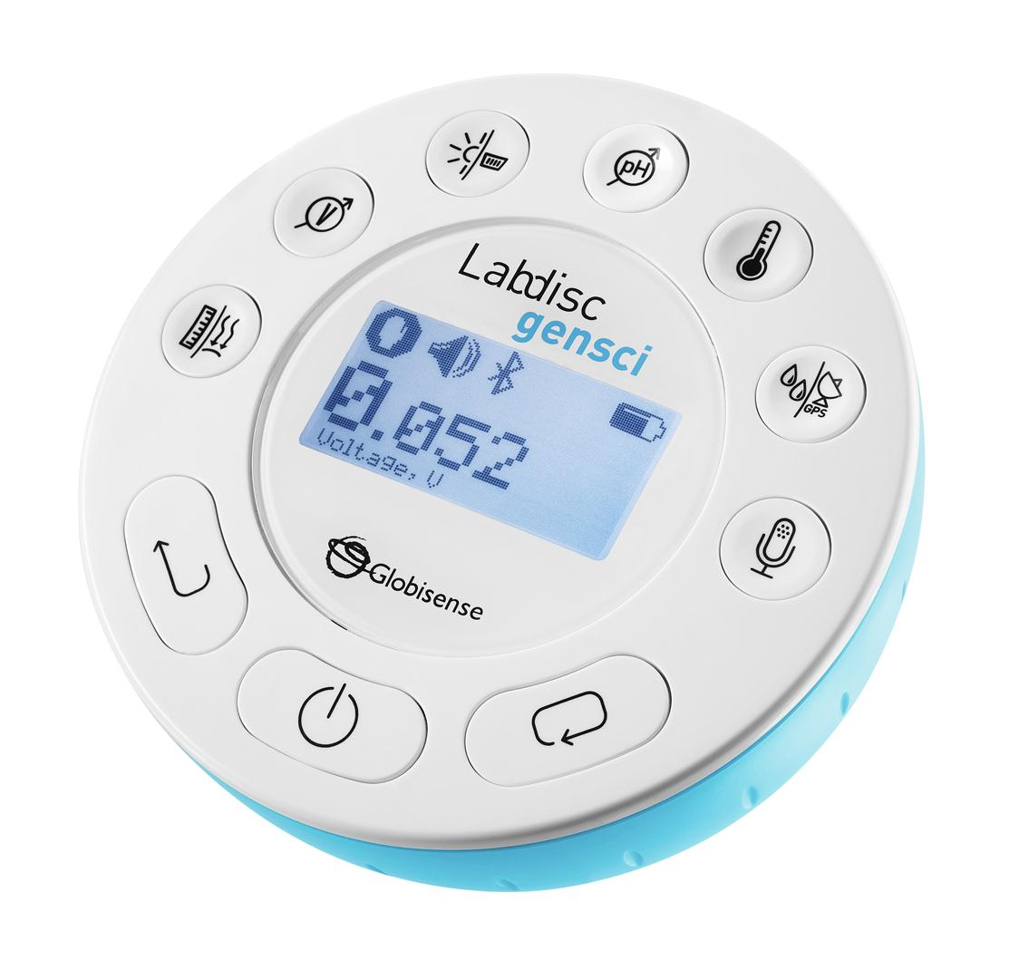

## Gensci_QSG_simulation.jpgGlLb_SW_flier.jpgC:\Users\rebecca\Desktop\QSG\Ext Temperature probe.jpgimagesCA35AYDD.jpgimagesCAJ10QVM.jpgDSC_0230.JPGUntitled.pngDSC_0230.JPGimagesCAGF6PWM.jpg1.2 Ports and Controls

**8**

**7**

**6**

**5**

**4**

**10**

**9**

The picture below reviews the **Labdisc** ports, sensors, keypad and display:

**1**

① On/Off and Escape key

**4**

② Scroll key

③ Select key

**5**

④ Sensor selection keys

**3**

⑤ Graphical display 128 x 64 pixels

⑥ Rotating ring

**1**

⑦ USB port

**2**

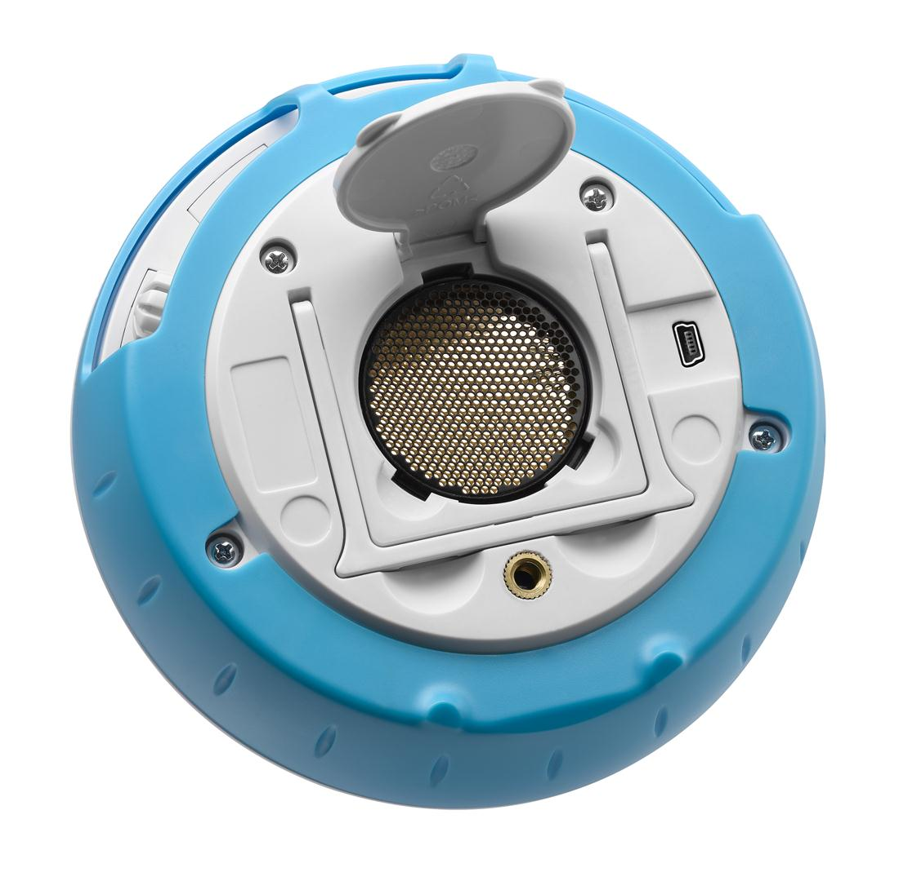⑧ Plastic leg

**7**

⑨ M5 screw insert

⑩ Distance sensor

**6**

⑪ Microphone, sound level sensors

⑫ Relative humidity sensor

**8**

⑬ External temperature input

⑭ pH input

**100**

**9**

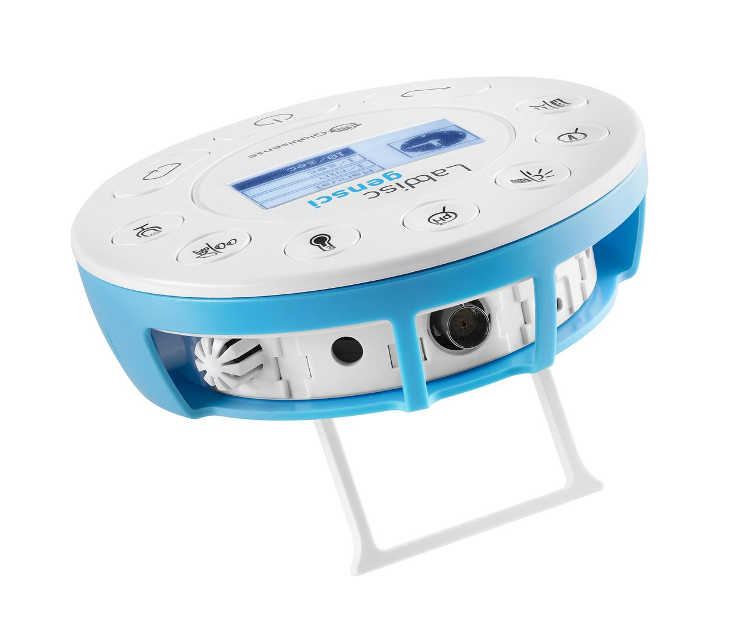⑮ Light sensor, universal input

**18**

⑯ Current and voltage sensor

⑰ Air pressure sensor

**17**

⑱ GPS sensor

**16**

**15**

**14**

**13**

**11**

**12**

## 1.3 Built-in Sensors

| ***Icon*** | ***Type*** | ***Range*** | ***Description*** | ***Max. Sample Rate*** | ***External Accessories (supplied with Labdisc)*** |
| --- | --- | --- | --- | --- | --- |
|  | Air pressure | 10 to 300 kPa | Measuring air pressure | 10/s | imagesCAGF6PWM.jpg  Plastic tube |
| TempInt.PNG | Ambient temp. | -10 °C to 50 °C | Measuring ambient temperature | 1/s | Not required |
|  | Current | -1 to +1 A | Measuring electric current | 24,000/s | imagesCA35AYDD.jpgimagesCAJ10QVM.jpg  Banana cable |
| Distance.PNG | Distance | 0.4 to 10 m | Measuring distance | 25/s | Not required |
| Temp.PNG | External temp. | -25 °C to 125 °C | General purpose stainless steel temperature probe | 100/s | DSC_0038.JPG  Temp. probe |
| GPS.PNG | GPS | N/A | Measuring 6 different parameters: Longitude, latitude, course, speed, date and time | 1/s | Not required |
| Light.PNG | Light | 0 to 55,000 lux | Measuring light level | 24,000/s | Not required |

|  |  |  |  |  |  |
| --- | --- | --- | --- | --- | --- |
| Sound.PNG | Sound | Sound level 56  to 95 dB | Measuring sound level | 10/s sound level | Not required |
| Sound.PNG | Microphone | Sound wave  0 to 5 V | Measuring sound waves | 24,000/s | Not required |
| pH.PNG | pH | 0 to 14 pH | Measuring pH level | 10/s | DSC_0230.JPG  pH electrode |
| Humidity.PNG | Relative humidity | 0 to 100% RH | Measuring relative humidity | 1/s | Not required |
| General.PNG | Universal input | 0 to 5 V | Connecting Fourier or Vernier analog sensors | 24,000/s | Universal input adapter cable |
|  | Voltage | -30 to +30 V | Measuring electric voltage | 24,000/s | imagesCAJ10QVM.jpg  imagesCA35AYDD.jpgBanana cable |

## 1.4 Using the Labdisc

***CHARGE THE LABDISC BATTERY BEFORE STARTING***

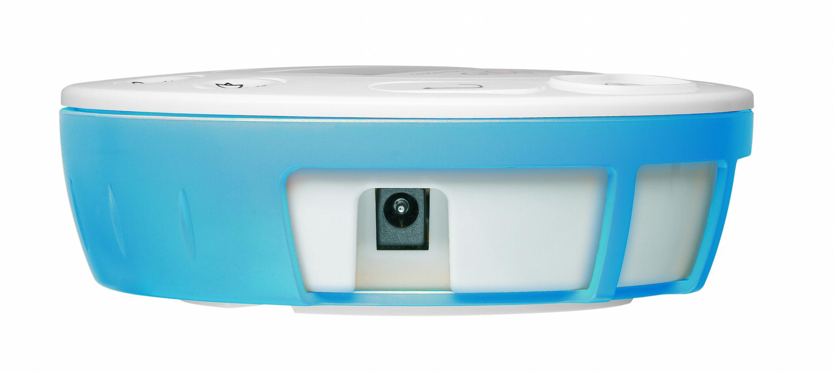Before working with the **Labdisc** for the first time, the unit should be charged for six hours with the supplied 6V charger. The **Labdisc** charging input is located to the left of the ***On/Off*** key. Simply rotate the orange ring until the charging input on the **Labdisc** is exposed and then connect the charger plug to the charging input.

Labdisc   
charging input

The **Labdisc** charger will accept any input voltage ranging from 100 to 240 VAC 50/60 Hz, making it functional worldwide.

### 1.4.1 Labdisc display

The **Labdisc** LCD display allows users to see the different sensor readings and to setup or re-configure the Labdisc parameters.



**① Run/Stop icon** – shows run_20px_4.jpg when the **Labdisc** is logging data, or stop_20px.bmp when the Labdisc is not logging sensor data.

**② Sound Status** – shows sound_on_20px.bmp active sound beep when the key is pressed and sound_off_20px.bmp when the sound beep is disabled.

**③ Communication Status** – shows bluetooth_20px.bmpwhen Bluetooth communication is enabled, orUSB_20px.jpgwhen the USB cable is connected from the host computer to the **Labdisc**.

**④ GPS Status –** shows GPP0_20px.bmpwhen the GPS is enabled, GPP3_20px.bmp when locked to GPS satellites and provides valid positioning parameters.

**⑤ Battery Level** – shows battery capacity at 3 levelsbattary3_20px.bmpbattary2_20px.bmpbattary1_20px.bmp, or battary_charge_20px.bmp when the **Labdisc** is connected to the external charger.

**⑥ Sensor Value** – shows the selected sensor value.

**⑦ Sensor Name and Unit** - shows the selected sensor name and unit.

### 1.4.2 Labdisc keys

The **Labdisc** 10 keys are divided into 7 sensor keys and 3 control keys. Using the sensor keys users can select and view different sensor readings. The control keys are used to turn on/off the **Labdisc**, setup the device for the next logging session and cofigurate all its parameters. The 3 control keys are:

7 sensor keys

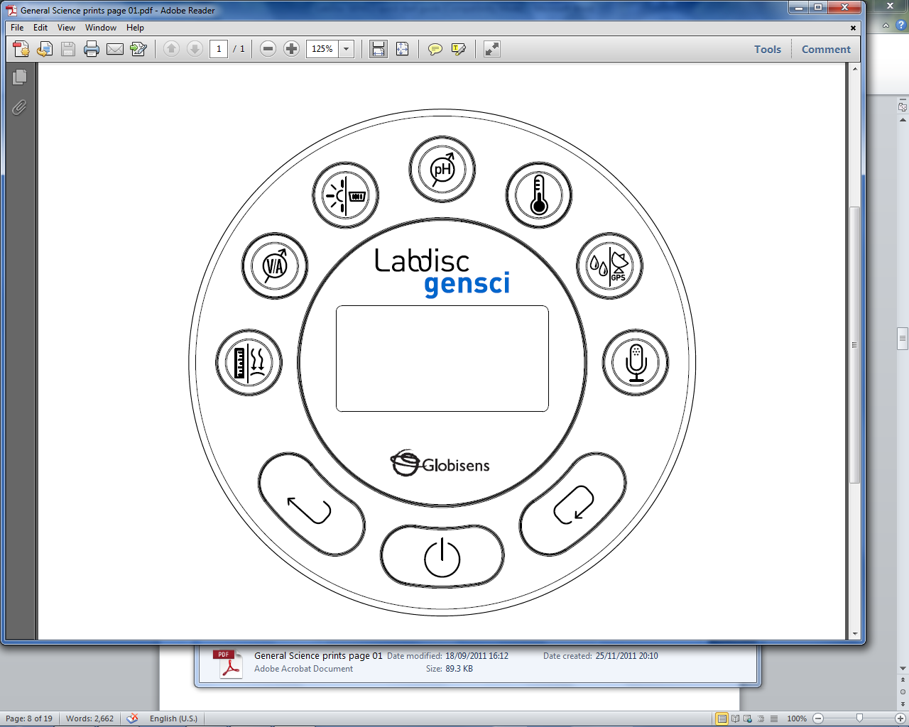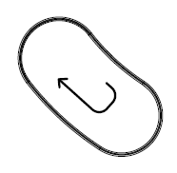

***Select*** key

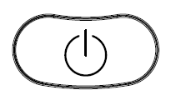

***Scroll*** key

***On/Off*** and ***ESC*** key

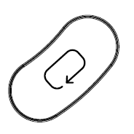

3 control keys

### 1.4.3 Labdisc menu

Press the ***Scroll*** key to enter the Labdisc menu. Then use the ***Scroll*** key to scan menu options, the select key to choose a menu option and the ***ESC*** key to go one level up in the menu.

### 1.4.3.1 Setup the Labdisc for the next logging session

***Select***

*SAMPLING RATE*



***Select***

*NUMBER of SAMPLES*

***Select***

*SETUP*

***Select*** *SENSOR*

***Scroll***

*options and*

***select***



***Scroll*** *options and* ***select***

*Use the Labdisc sensor keys to select/remove sensors for next recording*

### 1.4.3.2 Labdisc information



Information screen:

* Hardware version
* Software version
* Memory usage
* Time and Date

***Select*** *INFORMATION*

### 1.4.3.3 Configuration of the Labdisc

**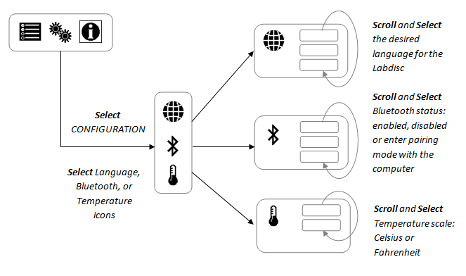**

2. GlobiLab Analysis Software

## 2.1 Software Installation

To install the software, users should run the following installers:

* For PC: GlobiLab-en-1.0-setup.exe
* For Mac: GlobiLab-en-1.0-setup

Then follow the simple installation instructions. These instructions take the user through the installation of the **GlobiLab** software and the USB driver needed for USB communication with the **Labdisc**.

## 2.2 Software Functions

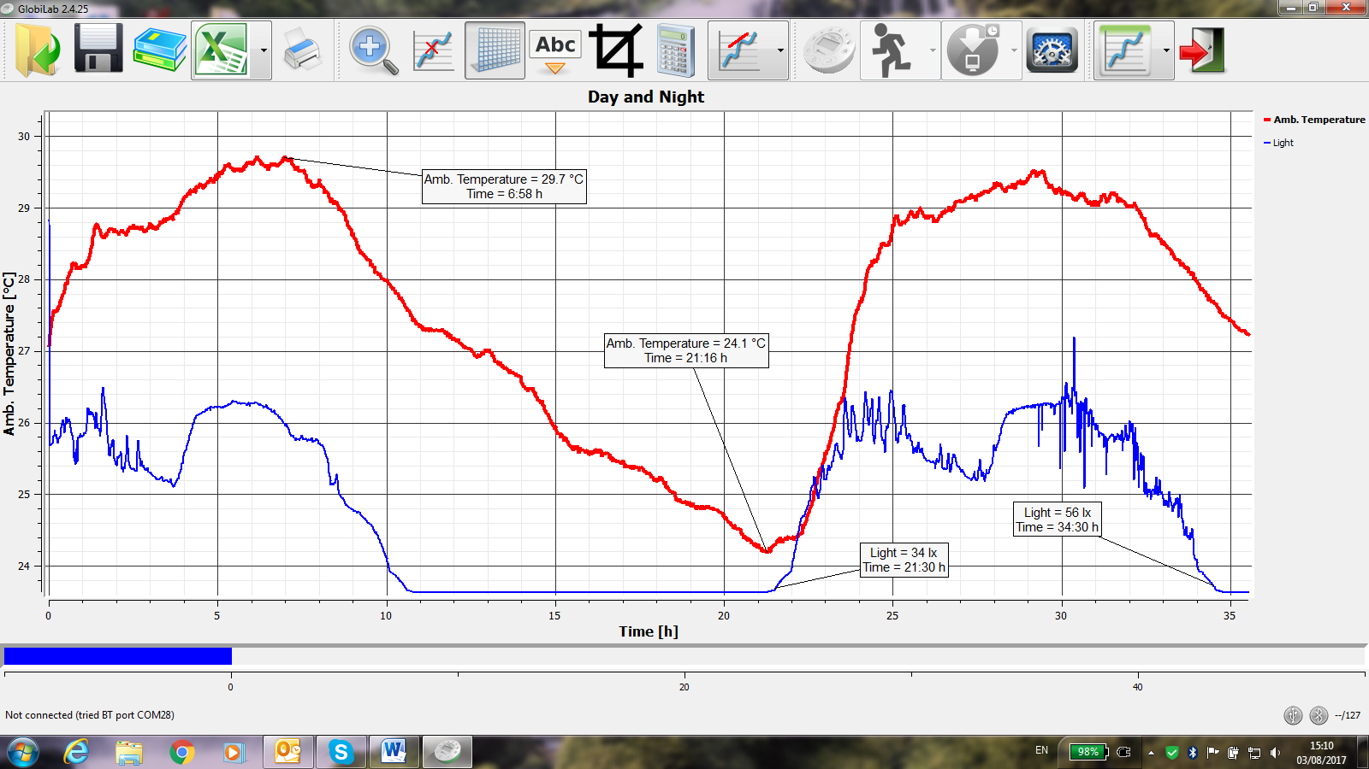

Open

Save

Lesson plans

Export to EXCEL

Print

Display types

Labdisc Setup

Crop Graph

Grid

Zoom

Marker

Annotation

Statistics

Functions

Start recording

Download data from Labdisc memory

Configuration

Exit

## 2.3 Software Popular Icons and their Functions

|  |  |
| --- | --- |
| *Open.png* | Selecting the **Open-project** icon opens the stored activity \*.XML files and displays all its graphs and graphical attributes. |
| books.png | Selecting the ***Workbook*** icon opens the activities folder, where users can choose from a variety of PDF activities. |
|  | Clicking the ***Display-options*** small triangle icon allows the user to select one of the following six display options:   1. viewGraph.png ***Line graph*** – showing a line graph for each of the sensors. If there is more than one active sensor, you can set the scale on the left for different active sensors by *left* clicking on the sensor name in the legend in the upper right hand corner of the screen. A single *right* click on the sensor name will change the line to individual data points. A second *right* click will hide the sensor data from the graph. A third *right* click will return the sensor graph to a line. To change the color of a line, *left* click on the line and select a new color. 2. ***Bar graph*** – showing bar graph data from only one sensor at a time. To change which data is displayed, left click the sensor name in the upper left hand corner of the screen. 3. viewTable.png ***Data table*** – shows sensors data in a chart format. This can be used to view exact measurements for all sensors. You may use the table display to edit data points of the sensors. 4. viewTableGraph.png ***Line graph and Data Table*** – shows both a line graph and a data table simultaneously. 5. viewMeters.png ***Meter view*** - shows changes in all sensors data values as are they are happening. There are several different options for meters including:   Right click on each Meter will allow you to change the Meter type or choose different sensor for this Meter.  Using the blue dots at the bottom of the screen allows you to sets the number of Meters displayed on the screen: 1,2,4 and 6.   1. viewMap *Google Map* – this allows you to overlay a Google Map of the area where your experiment was conducted with the data from all sensors in that experiment. You must have an Internet connection for this display mode to work properly. |
| Annotate.png | Selecting the ***Annotation*** icon activates the ***Annotation*** *mode*. Left mouse click opens a dialog box where users can enter text and images. Pressing the ***Annotation*** icon again exits the ***Annotation*** *mode*. |
|  | Pressing the ***Function-options*** small triangle icon allows the user to apply the mathematical functions listed below between the graph markers:   1. Selecting the ***Slope*** will display a slope-line on the active sensor graph. Moving the mouse pointer will move the slope line along the graph. A small text box will show the slope value. 2. Selecting the ***Linear regression*** will display the best linear line that fits the graph between the locations of two markers. Next to the line the software will open a small text box displaying the linear line equation: Y= aX+b. 3. Selecting the ***Quadric*** ***regression*** will display the best parabolic line (2nd degree) that fits the graph between the locations of two markers. Next to the line the software will open a small text box displaying the parabolic line equation: Y= aX²+bX+c. 4. Selecting the ***FFT*** will split the graphic display and show the original measurement on a time scale in the top graphic window, and its harmonics, on a frequency scale in the bottom graphic window. 5. Selecting ***Smooth*** will make an average all data points on the graph. Every sample is an average of the 2 readings before and 2 readings after. This function is useful in case the graph is very noisy. 6. Selecting ***Derivative*** will create a derivative graph on the active sensor data. 7. Selecting ***Integral*** will calculate the area under the sensor graph (Sensor value x Time). |
|  | Selecting the ***Run*** icon launches a new data collection session. |
|  | Selecting the ***Stop*** icon ends the current data collection session. |
|  | Selecting the ***Selective download*** icon opens a table listing all stored recordings. Selecting one of the lines on the table and pressing download will download this specific recording to the computer. |
| Setup.png | Setting up the **Labdisc** is done by selecting the ***Setup*** icon. The software will open a dialog box, where users can select/remove sensors, set the sampling rate and the amount of samples for the next data recording. |
| Excel.png | Selecting the ***EXCEL***icon saves the file in a \*.CSV format, prompts the user for a file name and then automatically opens EXCEL and exports the experiment data into the spreadsheet. |
|  | **GlobiLab** ***status bar***, is located at the bottom right corner of the software. It includes 3 icons:   1. **USB indicator** – where blue indicates a USB communication between the computer and the **Labdisc**. 2. **Bluetooth indicator** – where blue indicates a Bluetooth wireless communication between the computer and the **Labdisc**. A right mouse click on this icon will open a list of recognized **Labdiscs**, click on one to connect. 3. **Memory info** – shows how many experiments are stored in the **Labdisc** memory, out of a maximum of 127. In the example above there are 7 stored experiments out of 127. A right mouse click on this section will allow users to erase all stored data or just the last recording. |

# 

## 2.4 GlobiLab Software for iPad

The **GlobiLab** software for iPad (iPad, iPad 2 and 3rd generation iPad models) is available in the App Store and makes K-12 science experiments mobile, convenient and immediate. **GlobiLab** wirelessly integrates between the **Labdisc** data logger and the iPad. Allowing full **Labdisc** management (setup of all data logging parameters, online display of current measurements and download of the **Labdisc** sample memory), together with graph manipulations (markers, zoom, crop, text and image annotation) and data analysis (statistics and curve fitting etc.).

**GlobiLab** software for iPad was specifically designed to engage students and help visualize complex science concepts by harnessing the iPad built-in accelerometer sensor, data display, multimedia and multi-touch features. The following steps provide a guide on the installation and implementation of the **GlobiLab** App for iPad.

|  |  |
| --- | --- |
|  | ***Download and install of the GlobiLab application***   * Tap the iPad App Store icon * Search for **“GlobiLab”** * Press the FREE green key to install the application |
|  | ***Set wireless communication between the Labdisc and the iPad***   * Go to *iPad Setting - Bluetooth* and select your **Labdisc** from the Devices list * The iPad should immediately connect to your **Labdisc** and change its status to “connected” * Close the setting and open the **GlobiLab** software |
|  | ***Meter view***   * Tap Meter view  to see the current values of the **Labdisc** sensors * Tap one of the Meters and scroll the sensor wheel to select a different sensor type for an existing Meter * Select a different Meter type  from the horizontal line of icons |
|  | ***Data collection***   * Tap the SETUP icon  and enter the SETUP screen. This dialog box allows you to select the Sensors, Sampling rate and amount of samples for the next data recording. * Tap the RUN icon  to start recording and observe the graph build up on the screen * You may switch the display to a Bar Graph view by tapping the Bar Graph key * You may switch the display to a Table view by tapping the Table key * To stop recording tap the STOP icon |
|  | ***Download Labdisc stored measurements to the iPad***  The **Labdisc** can store up to 127 different experiments. This is very useful when conducting outdoor data collection or long measurements.   * Tap the Download icon * The iPad will list all **Labdisc** stored experiments Each line on this list shows what sensors were recorded, at what sampling rates and for how many samples. In addition it indicates the date and time of the recording. * Click on one of the lines in the list. The **Labdisc** transfers the data to the iPad. * After all data is transferred, the iPad will show a graph of the collected measurement |
|  | ***Data analysis (markers, curve fitting)***   * Tap the open icon  and select “Free fall”. This graph describes a real recording of a ping-pong ball bouncing on a table, as recorded by the **Labdisc** distance sensor. For more details see the Free Fall movie at: <http://www.globisens.com/resources/experiment-videos> * Long touch on the graph to add a Marker * Touch the Marker to cross and drag it with your finger. View the Marker text box data changing while the marker follows the graph line. * Tap the graph twice to view the actual sampling points * Long touch the graph to add a 2nd Marker * Place both the Markers on the beginning and end of a single ball jump * Tap the Curve Fitting icon  and select a Quadric Regression to get the mathematical equation representing the ping-pong ball jump. From this equation we can calculate earth gravitation. |
|  | ***Graph Annotation***   * Use a long touch anywhere on the background (not on a graph), create an empty annotation. The edit annotation box opens automatically. From here:   + Edit or write an annotation   + Add an image using the camera or the image gallery   + Remove the annotation |
|  | ***Use of Map view in field trip (Environment)***  Recording GPS together with other **Labdisc** sensors, enables the **GlobiLab** software to plot these sensors over the Apple maps.   * Make sure the iPad is connected to the Internet * Tap the Open icon and select the “Walk in the park”. In this experiment we measured the different climate in a city park compared to a nearby cross road. For more details check the Microclimates movie at: <http://www.globisens.com/resources/experiment-videos>. * Tap the color scale on the left and select Amb. Temperature. Observe the dramatic temperature change while walking from the city cross-road to the park. * Tap the colored samples on the map to get a marker with the temperature value. * Pinch to zoom in/out the map * See the experiment data in a table, by tapping the Table View  and observe the GPS longitude and latitude values. * You may show other experiments under this category like” Trip to the Dead Sea” or “Flight from Tel-Aviv to Istanbul” |
|  | ***Online help***  **GlobiLab** offers an online help for each of the 5 views: Line, Bar, Table, Meter and Map.   * Open the relevant View * Tap on the HELP icon  and observe a list of functions and controls |

## 2.5 GlobiLab Software for Android

The **GlobiLab** software for Android 4 and above is available for download from the Globisens web site: <http://www.globisens.net/support#2> and from Google Play.

The software makes K-12 science experiments mobile, convenient and immediate. **GlobiLab** wirelessly integrates between the **Labdisc** data logger and the Android tablet, allowing full **Labdisc** management (setup of all data logging parameters, online display of current measurements and download of the **Labdisc** sample memory), together with graph manipulations (markers, zoom, crop and text annotation) and data analysis (statistics and curve fitting etc.).

|  |  |
| --- | --- |
|  | ***Set wireless communication between the Labdisc and the Android tablet***   * Make sure the Labdisc is paired to the Android (see section 3.2.4) * Turn on the Labdisc * Launch the application * Tap the options icon in the top action bar  (rightmost, three vertical dots) * Tap  and select the name of the Labdisc you would like to connect with (e.g. Labdisc\_6588) * The App name (top right) will change to , indicating that the connection is established |
|  | ***Meter view***   * Tap the Meter view  to see the current values of the **Labdisc** sensors * Tap one of the meters and scroll the sensor wheel to select a different sensor type for an existing meter * Select a different meter type  from the horizontal line of icons |
|  | ***Data collection***   * Tap the SETUP icon  and enter the SETUP screen. This dialog box allows you to select the Sensors, Sampling rate and amount of samples for the next data recording. * Tap the RUN icon  to start recording and observe the graph build up on the screen * You may switch the display to a Bar Graph view by tapping the Bar Graph key * You may switch the display to a Table view by tapping the Table key * To stop recording tap the STOP icon |
|  | ***Download Labdisc stored measurements to the tablet***  The **Labdisc** can store up to 127 different experiments. This is very useful when conducting outdoor data collection or long measurements.   * Tap the Download icon * The application will list all **Labdisc** stored experiments. Each line on this list shows what sensors were recorded, at what sampling rate and for how many samples. In addition it indicates the date and time of the recording. * Click on one of the lines in the list. The **Labdisc** transfers the data to the tablet. * After all the data is transferred, GlobiLab will show a graph of the collected measurement |
|  | ***Data analysis (markers, curve fitting)***   * Tap the open icon  and select “Free Fall”. This graph describes a real recording of a ping-pong ball bouncing on a table, as recorded by the **Labdisc** distance sensor. For more details see the Free Fall movie at: <http://www.globisens.net/resources/experiment-videos> * Long touch on the graph to add a marker * Touch the marker to cross and drag it with your finger. View the marker text box data changing while the marker follows the graph line. * Tap the graph legend and select “Dots” to view the actual sampling points * Long touch the graph to add a second marker * Place both the markers at the beginning and end of a single ball jump * Tap the Curve Fitting icon , select a Quadric Regression to get the mathematical equation representing the ping-pong ball jump. From this equation we can calculate earth’s gravitation. |
|  | ***Graph Annotation***   * Use a long touch anywhere on the background (not on a graph), create an empty annotation. The edit annotation box opens automatically. From here:   + Edit or write an annotation   + Remove the annotation |
|  | ***Use of Map view in a field trip (Environment)***  Recording GPS together with other **Labdisc** sensors enables the **GlobiLab** software to plot these sensors over the Apple maps.   * Make sure the tablet is connected to the Internet * Tap the Open icon  and select “Walk in the Park”. In this experiment the different climate in a city park compared to a nearby cross road was measured. For more details check the Micro Climate experiment movie at: <http://www.globisens.net/resources/experiment-videos> * Tap the color scale on the left and select Amb. Temperature. Observe the dramatic temperature change while walking from the city cross-road to the park. * Tap the colored samples on the map to get a marker with the temperature value * Pinch to zoom in/out the map * See the experiment data in a table, by tapping the Table View  and observe the GPS longitude and latitude values |
|  | ***Workbook section***   * Tap the Workbook icon  to view GlobiLab experiment guides * Tap on one of the experiments on the list and view a comprehensive PDF guide of that experiment. |
|  | ***Online help***  **GlobiLab** offers a PDF quick start guide. To open the quick start guide, tap on the HELP icon . |

# **3 Labdisc – GlobiLab Communication**

## 3.1 USB Communication

Upon USB cable connection between the computer and the **Labdisc,** the **GlobiLab** software automatically detects the USB connection and begins communicating with the **Labdisc**.



## 3.2 Bluetooth Wireless Communication

Before wireless communication with a **Labdisc** for the first time, the **Labdisc** should be added as a device to the computer in a process called pairing. Pairing need be done only once for each **Labdisc**, after which the computer stores the connection information, including a unique name for each **Labdisc**. When no **Labdisc** is connected via USB, the computer will automatically try to wirelessly connect to the last connected **Labdisc**. To connect to a different or a new **Labdisc**, right click on the Bluetooth icon in the **GlobiLab** ***status bar,*** located at the bottom right corner of the screen, then click on the **Labdisc** you want to connect to.

### 3.2.1 Pairing with a PC running Windows OS

1. Turn on the **Labdisc**. Make sure the **Labdisc** is not showing the sleep icon http://www.globisens.net/sites/default/files/images/support/faqs/sleepicon.jpg. If it does, please press any button to leave the sleep mode.
2. Start the GlobiLab software.
3. Right click the Bluetooth icon located on the status bar at the bottom right corner of the screen 
4. From the new pop-up menu select ***"Find more Labdiscs and sensors".*** The computer opens the ***"add a device"*** dialog box and starts searching for the Bluetooth device.
5. Your Labdisc will be displayed as ***"Labdisc-xxxx"***, where "xxxx" are the last four digits of the Labdisc serial number sticker.
6. Select this device and press ***"Next"***
7. On the **Labdisc**: Press and hold the SCROLL key to put the Labdisc in Pairing mode. The Labdisc will produce a long "beep" while its screen shows ***"BT pairing".***
8. On the computer dialog box select the 2nd option: ***"Enter the device pairing code"*** and click ***“Next”.***
9. In the next dialog box enter "1234' as the pairing code, click “***Next”***
10. Wait for the computer to finish the process and announce ***"Your device is ready to use"***.
11. Right click the Bluetooth icon on the status bar. Choose the Labdisc you've just paired and click on it.
12. The computer will connect to the Labdisc and turn the Bluetooth icon blue .

### 3.2.2 Pairing with a Mac OS

1. Turn on the **Labdisc**. Make sure the **Labdisc** is not showing the sleep icon http://www.globisens.net/sites/default/files/images/support/faqs/sleepicon.jpg. If it does, please press any button to leave the sleep mode.
2. Open the Bluetooth menu from the Mac menu and select "***Set Up Bluetooth Device..."***
3. A dialog box opens. Your Labdisc will be displayed as ***"Labdisc-xxxx"*** where "xxxx" are the last four digits of the Labdisc serial number sticker.
4. Select this device and press ***“Continue”.***
5. Mac will try a quick default attempt to pair. This attempt will not succeed as Labdisc requires a pairing code.
6. Press the ***"Passcode options..."*** button and select the option ***"Use a specific passcode"***. Enter the passcode "1234", and don't press "OK" yet.
7. On the **Labdisc**: Press and hold the SCROLL key to put the Labdisc in Pairing mode. The Labdisc will produce a long "beep" while its screen shows ***"BT pairing".***
8. Press the ***"OK"*** button in the Mac dialog box.
9. Open the **GlobiLab** software.
10. Right click the ***Bluetooth*** icon  located at the bottom right corner of the software.
11. Choose the **Labdisc** you’ve just paired and click on it. The computer will connect to the **Labdisc** and turn the ***Bluetooth*** icon blue .

### 3.2.3 Pairing with an iPad

1. Turn on the **Labdisc**. Make sure the **Labdisc** is not showing the sleep icon http://www.globisens.net/sites/default/files/images/support/faqs/sleepicon.jpg. If it does, please press any button to leave the sleep mode.
2. Launch the iPad Setting 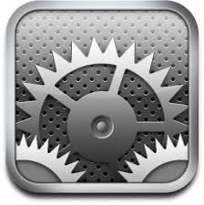
3. Open Bluetooth. Make sure the iPad Bluetooth is on.
4. From the devices list click the “***Labdisc-xxxx”***, where the xxxx digits match the last 4 digits of your **Labdisc** S/N sticker on the **Labdisc** back cover.
5. On the **Labdisc**: Press and hold the SCROLL key to put the Labdisc in Pairing mode. The Labdisc will produce a long "beep" while its screen shows ***"BT pairing".***
6. The iPad will ask for a PIN code. Enter “1234” and click Pair.
7. The iPad will show **Labdisc-xxxx** connected.
8. Start the iOS GlobiLab application 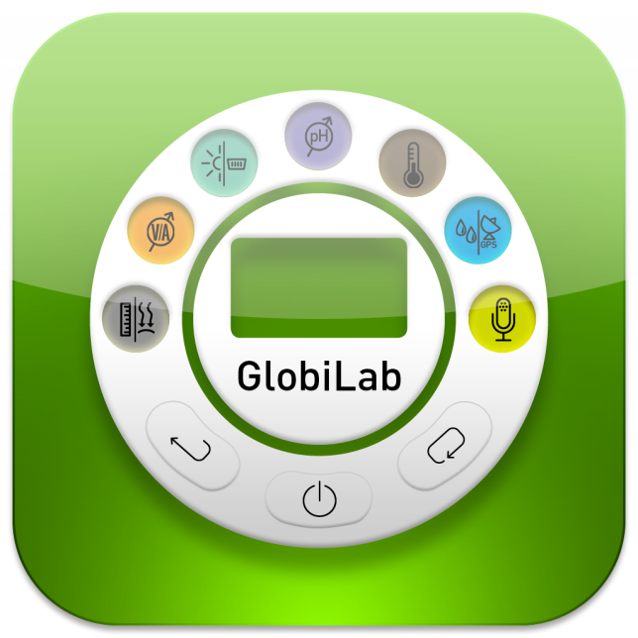. The application will automatically connect to the Labdisc you have paired.

### 3.2.4 Pairing with Android OS

1. Turn on the **Labdisc**. Make sure the **Labdisc** is not showing the sleep icon http://www.globisens.net/sites/default/files/images/support/faqs/sleepicon.jpg. If it does, please press any button to leave the sleep mode.
2. On the tablet go to setting 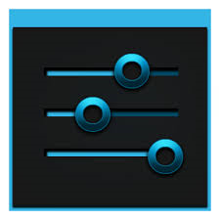 and select ***“Bluetooth”***
3. Make sure the Bluetooth radio is “ON”, then turn on ***“Search for Devices”***
4. On the **Labdisc**: Press and hold the SCROLL key to put the Labdisc in pairing mode. The Labdisc will produce a long "beep" while its screen shows ***"BT pairing".***
5. From the devices list on the tablet tap the “***Labdisc-xxxx”***, where the xxxx digits match the last 4 digits of your **Labdisc** S/N sticker on the **Labdisc** back cover.
6. The tablet will open the ***“Bluetooth pairing request”*** dialog box and display ***“Type the device’s required PIN”***
7. Enter the pairing code “1234” and tap ***“OK”***
8. Pairing process is complete and the **Labdisc** will appear on the tablet ***“paired devices”*** list.
9. Open the GlobiLab application on the tablet .
10. Tap on the options icon at the top Action Bar  (rightmost, 3 vertical dots)
11. Tap on ***"Connect Labdisc",*** and select the name of the **Labdisc** you’d like to connect (e.g. Labdisc\_1052).
12. The App name will change to ***"GlobiLab (Labdisc\_xxxx)" *** to indicate connection.

### 3.2.5 Pairing with Chromebook OS

1. Turn on your Labdisc.
2. Click on the Chromebook bottom right menu bar . The below dialog box opens:

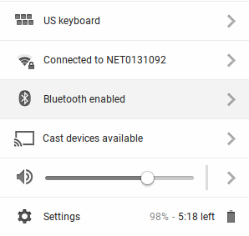

1. Click on the Bluetooth icon. Make sure that Bluetooth is enabled on your Chromebook. Click on ***Manage Devices…*** then click ***Add Device.*** The Chromebook start searching for new Labdisc devices.
2. Your Labdisc with its last 4 serial number digit will appear on the Chromebook screen as: ***Labdisc-XXXX*** - where the XXXX represent the Labdisc last four S/N digits.
3. From the Chromebook’s list of devices, select your Labdisc. Make sure that the four digit code on the back of the Labdisc matches the one you have selected on your Chromebook. Click ***Connect***.
4. On the **Labdisc**: Press and hold the SCROLL key to put the Labdisc in pairing mode. The Labdisc will produce a long "beep" while its screen shows ***"BT pairing".***
5. On the Chromebook use the PIN code “1234” to pair your Labdisc to your Chromebook.
6. Your Labdisc should be added to the Chromebook list of paired devices. On some Chromebooks you might see an error message. You may ignore it, as long as you see the Labdisc on the Paired devices list.

Connect the Labdisc to a Chromebook Laptop Using a Bluetooth Connection:

1. Open the GlobiLab software and turn on the Labdisc.
2. Make sure that your Labdisc has been paired with your computer. (see above) You will only have to pair the Labdisc at the first time you use your Labdisc with the Chromebook.
3. From the Globilab menu select “Connect Labdisc”.

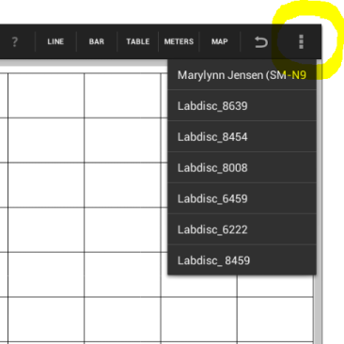

1. Select the Labdisc that you want to connect to from the pop up menu. Make sure the 4 digit code matches the one on the back of the Labdisc.

# 4 Experiment Samples

The GlobiLab software includes experiment samples, for teachers and students to view, analyze, modify or repeat. This section reviews some interesting recorded experiments found in the GlobiLab application. To open a recorded experiment, simply press the ***Open*** icon in the GlobiLab software and select the files below:

|  |  |
| --- | --- |
|  | **Day and Night Temperature Changes**  A long 48-hour recording of temperature and light levels, with the Labdisc located on the window shelf:   * ***Sensors selected:*** Light, ambient temperature * ***Sampling rate:*** 1/min * ***Amount of samples:*** 1000 * ***Experiment duration*:** 48 hours * ***Communication:*** Offline, data downloaded at recording’s end * **Data Analysis:** Use the ***Markers*** to show min/max. values |
|  | **Walk in the Park**  Micro climate activity. Comparing temperature and Relative humidity at a city cross-road and park:   * ***Sensors selected:*** External temperature, relative humidity, GPS * ***Sampling rate:*** 1/sec * ***Amount of samples:*** 1000 * ***Experiment duration*:** 15 minutes * ***Communication:*** Offline, data downloaded at recording’s end * **Data Analysis:** Temp./humidity changes in GlobiLab map view |
|  | **Free Fall**  A classic activity for Newton’s 2nd Law. Measuring the free fall acceleration of a ping pong ball bouncing on a wooden surface, with the distance sensor located 1.5 m above it:   * ***Sensors selected:*** Distance * ***Sampling rate:*** 25/sec * ***Amount of samples:*** 1000 * ***Experiment duration:*** Seconds * ***Communication:*** Online, preferably via wireless Bluetooth * ***Data Analysis:*** Use ***Markers*** and ***Crop*** functions to focus on the ball bounces. Then use ***quadric regression*** on a single bounce, to get the bounce equation and extract the free fall acceleration. |
|  | **Sound Beat**  Sound wave recording of 2 tuning forks, producing slightly different harmonics, of 440 Hz and 435 Hz.   * ***Sensors selected:*** Microphone * ***Sampling rate:*** 25,000/sec * ***Amount of samples:*** 10,000 * ***Experiment duration:*** < 1 second * ***Communication:*** Offline, data downloaded at recording’s end * ***Data Analysis:*** Use ***Zoom*** to see the sound sine wave and ***Markers*** to measure amplitude and frequency. |
| excel.jpg | **Boyle’s Gas Law**  Verifying the ideal gas law: P x V = CONSTANT. Using a 100ml syringe connected to the air pressure sensor. Manually recording air pressure while decreasing the syringe volume by 10ml at a time.   * ***Sensors selected:*** Air pressure * ***Sampling rate:*** Manual * ***Amount of samples:*** 10 * ***Communication:*** Online, preferably via wireless Bluetooth * ***Data Analysis:*** Use ***Bar-Graph*** view to see air pressure values***.*** Use ***Annotation*** to add the volume for each bar and ***Export to Excel*** to calculate P x V multiplication. |
|  | **pH level of Soft Drinks**  A fun and interesting activity, comparing the acidity of water, lemon juice and Coca-Cola.   * ***Sensors selected:*** pH * ***Sampling rate:*** 10/sec * ***Amount of samples:*** 1000 * ***Experiment duration:*** 2 minutes approx. * ***Communication:*** Online, preferably via wireless Bluetooth * ***Data Analysis:*** Using the ***Markers*** to measure the acidity level of the different liquids |

The FCC Wants You to Know:

This equipment has been tested and found to comply with the limits for a Class B digital device, pursuant to Part 15 of the FCC rules. These limits are designed to provide reasonable protection against harmful interference in a residential installation. This equipment generates, uses and can radiate radio frequency energy and, if not installed and used in accordance with the instructions, may cause harmful interference to radio communications. However, there is no guarantee that interference will not occur in a particular installation. If this equipment does cause harmful interference to radio or television reception, which can be determined by turning the equipment off and on, the user is encouraged to try to correct the interference by one or more of the following measures:

a) Reorient or relocate the receiving antenna.

b) Increase the separation between the equipment and receiver.

c) Connect the equipment to an outlet on a circuit different from

that to which the receiver is connected.

d) Consult the dealer or an experienced radio/TV technician.

**FCC Warning**

Modifications not expressly approved by the manufacturer could void the user authority to operate the equipment under FCC Rules.

NOTE: THE MANUFACTURER IS NOT RESPONSIBLE FOR ANY RADIO OR TV INTERFERENCE CAUSED BY UNAUTHORIZED MODIFICATIONS TO THIS EQUIPMENT. SUCH MODIFICATIONS COULD VOID THE USER’S AUTHORITY TO OPERATE THE EQUIPMENT.

**INSTRUCTIONS CONCERNING HUMAN EXPOSURE TO RADIO FREQUENCY ELECTROMAGNETIC FIELDS**

A distance of at least 20cm. between the equipment and all persons should be maintained during the operation of the equipment.

Copyright ©2011 Globisens. All rights reserved. Globisens Ltd. logos and product names are registered trademarks of Globisens Ltd. No part of this document may be reproduced by any means, nor translated to any electronic medium without the written consent of Globisens. Information contained in this document is believed to be accurate and reliable, however, Globisens assumes no responsibility for its use. Specifications are subject to change without notice. www.**GLOBISENS**.com

GlobiLab supports Android versions 4.0 and up.

Made for   
iPad (3rd generation)  
iPad 2  
iPad

iPad is a trademark of Apple Inc., registered in the U.S. and other countries.

“Made for iPad” means that an electronic accessory has been designed to connect specifically to iPod, iPhone, or iPad, respectively, and has been certified by the developer to meet Apple performance standards. Apple is not responsible for the operation of this device or its compliance with safety and regulatory standards. Please note that the use of this accessory with iPod, iPhone, or iPad may affect wireless performance.

REV: 23.02.14