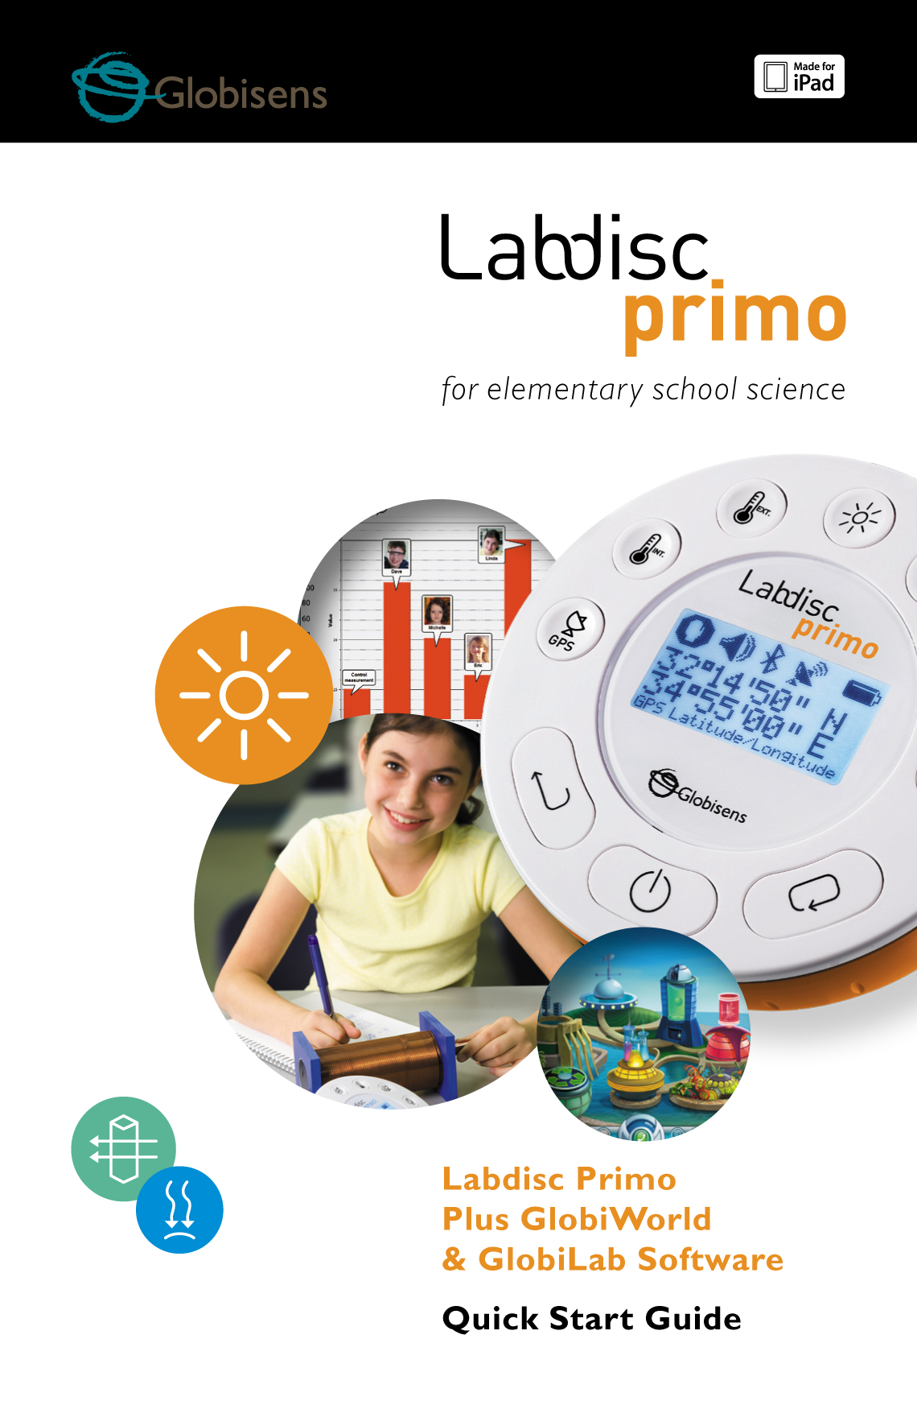

Contents

[1. Labdisc Hardware Overview 1](#_Toc380929908)

[1.1 What’s in the Pack 1](#_Toc380929909)

[1.2 Ports and Controls 2](#_Toc380929910)

[1.3 Built-in Sensors 3](#_Toc380929911)

[1.4 Using the Labdisc 4](#_Toc380929912)

[1.4.1 Labdisc display 4](#_Toc380929913)

[1.4.2 Labdisc keys 5](#_Toc380929914)

[1.4.3 Labdisc menu 6](#_Toc380929915)

[1.4.3.1 Setup the Labdisc for the next logging session 6](#_Toc380929916)

[1.4.3.2 Labdisc information 6](#_Toc380929917)

[1.4.3.3 Configuration of the Labdisc 7](#_Toc380929918)

[2. GlobiLab Junior Analysis Software 8](#_Toc380929919)

[2.1 Software Installation 8](#_Toc380929920)

[2.2 Software Popular Icons and Functions 8](#_Toc380929921)

[2.3 GlobiLab Software for iPad 12](#_Toc380929922)

[2.4 GlobiLab Software for Android 16](#_Toc380929923)

[3 Labdisc – GlobiLab Junior Communication 20](#_Toc380929924)

[3.1 USB Communication 20](#_Toc380929925)

[3.2 Bluetooth Wireless Communication 20](#_Toc380929926)

[3.2.1 Pairing with a PC running Windows OS 20](#_Toc380929927)

[3.2.2 Pairing with a Mac OS 21](#_Toc380929928)

[3.2.3 Pairing with an iPad 22](#_Toc380929929)

[3.2.4 Pairing with Android OS 22](#_Toc380929930)

[4 GlobiWorld Science Environment 24](#_Toc380929931)

[4.1 Seven Science Parks 24](#_Toc380929932)

[4.2 GlobiWorld Popular Icons and Functions 25](#_Toc380929933)

[5 Experiment Samples 26](#_Toc380929934)

# 1. Labdisc Hardware Overview

## 1.1 What’s in the Pack

|  |  |
| --- | --- |
| ① **Labdisc** data logger  ② **Labdisc** AC charger  ③ USB cable  ④ Quick start guide  ⑤ Warranty page  Globisense Primo View.jpg | ⑥ Software flyer  ⑦ External temperature probe  ⑧ Ear clip  ⑨ Plastic rod and screw |

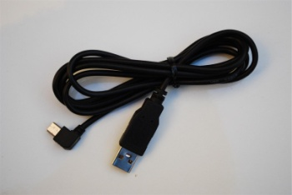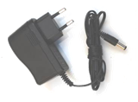

## GlWd_SW_flier.jpgEar Clip.jpgExt Temperature probe.jpgcid:151A1878-4EF1-4671-A588-0B985B47CA0B1.2 Ports and Controls

**9**

**8**

**7**

**5**

**2**

**6**

**3**

**1**

**4**

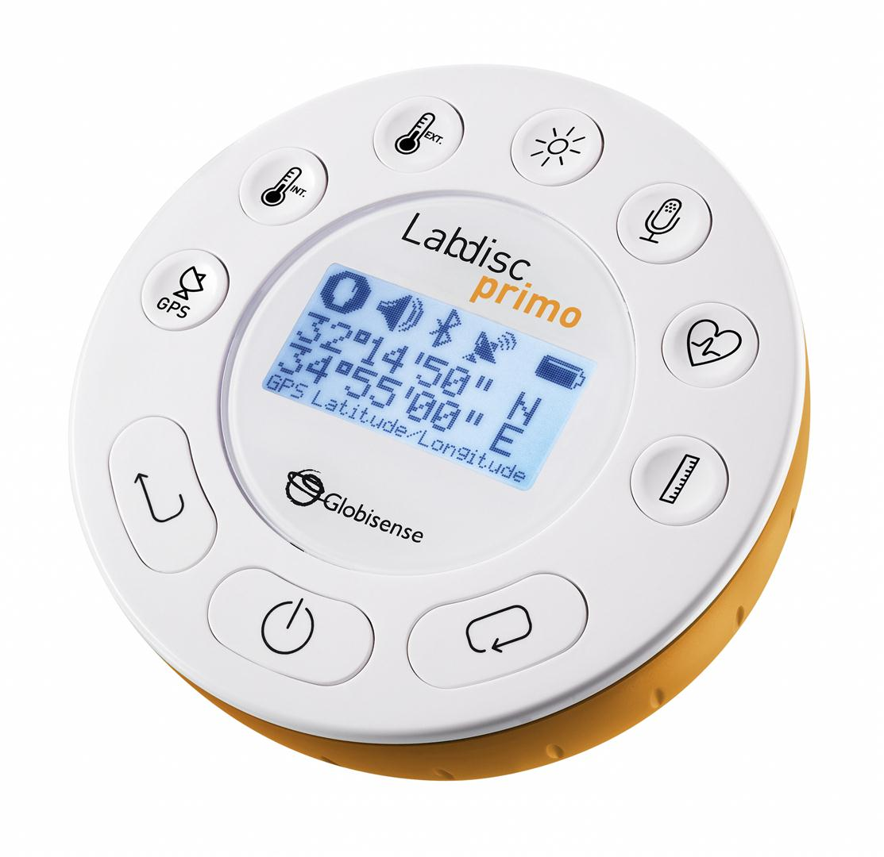The picture below reviews the **Labdisc** ports, sensors, keypad and display:

**1**

① On/Off and Escape key

**4**

② Scroll key

③ Select key

**5**

④ Sensor selection keys

**3**

⑤ Graphical display 128 x 64 pixels

⑥ Rotating ring

**1**

⑦ USB port

**2**

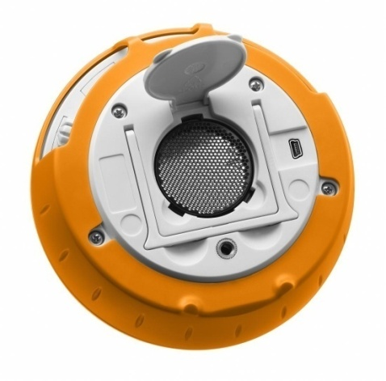⑧ Plastic leg

**7**

⑨ M5 screw insert

⑩ Distance sensor

**6**

⑪ Heart rate input

⑫ Microphone sensor

**8**

⑬ Light sensor

⑭ External temperature sensor

**100**

**9**

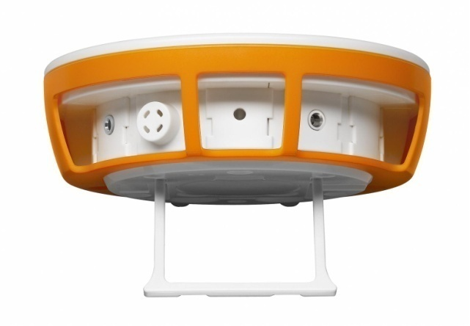⑮ Ambient temperature sensor

**16**

⑯ GPS sensor

**15**

**14**

**13**

**12**

**11**

## 1.3 Built-in Sensors

| ***Icon*** | ***Type*** | ***Range*** | ***Description*** | ***Max. Sample Rate*** | ***External Accessories (supplied with Labdisc)*** |
| --- | --- | --- | --- | --- | --- |
| TempInt.PNG | Ambient temp. | -10 °C to 50 °C | Measuring ambient temperature | 100/s | Not required |
| Distance.PNG | Distance | 0.2 to 10 m | Measuring distance | 25/s | Not required |
| Temp.PNG | External temp. | -25 °C to 125 °C | General purpose stainless steel temperature probe | 100/s | Ext Temperature probe.jpg  Temp. probe |
| GPS.PNG | GPS | N/A | Measuring 6 different parameters: Longitude, latitude, course, speed, date and time | 1/s | Not required |
| Pulse.PNG | Heart rate | 0 to 200 beats per minute (bpm) | Measuring human body pulse | 100/s | Ear Clip.jpg  Ear clip |
| Light.PNG | Light | 0 to 55,000 lux | Measuring light level | 24,000/s | Not required |
| Sound.PNG | Sound | Sound level 58  to 92 dB | Measuring sound level | 10/s sound level | Not required |

## 

## 1.4 Using the Labdisc

***CHARGE THE LABDISC BATTERY BEFORE STARTING***

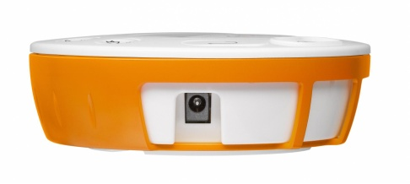Before working with the **Labdisc** for the first time, the unit should be charged for six hours with the supplied 6 V charger. The **Labdisc** charging input is located to the left of the ***On/Off*** key. Simply rotate the orange ring until the charging input on the **Labdisc** is exposed and then connect the charger plug to the charging input.

Labdisc   
charging input

The **Labdisc** charger will accept any input voltage ranging from

100 to 240 VAC 50/60 Hz, making it functional worldwide.

### 1.4.1 Labdisc display

The **Labdisc** LCD display allows users to see the different sensor readings and to setup or re-configure the Labdisc parameters.

**① Run/Stop icon** – shows run_20px_4.jpg when the **Labdisc** is logging data, or stop_20px.bmp when the Labdisc is not logging sensor data.

**② Sound Status** – shows sound_on_20px.bmp active sound beep when the key is pressed and sound_off_20px.bmp when the sound beep is disabled.

**③ Communication Status** – shows bluetooth_20px.bmpwhen Bluetooth communication is enabled, orUSB_20px.jpgwhen the USB cable is connected from the host computer to the **Labdisc**.

**④ GPS Status –** shows GPP0_20px.bmpwhen the GPS is enabled, GPP3_20px.bmp when locked to GPS satellites and provides valid positioning parameters.

**⑤ Battery Level** – shows battery capacity at 3 levelsbattary3_20px.bmpbattary2_20px.bmpbattary1_20px.bmp, or battary_charge_20px.bmp when the **Labdisc** is connected to the external charger.

**⑥ Sensor Value** – shows the selected sensor value.

**⑦ Sensor Name and Unit** - shows the selected sensor name and unit.

### 1.4.2 Labdisc keys

The **Labdisc** 10 keys are divided into 7 sensor keys and 3 control keys. Using the sensor keys users can select and view different sensor readings. The control keys are used to turn on/off the **Labdisc**, setup the device for the next logging session and configure all its parameters. The 3 control keys are:

7 sensor keys

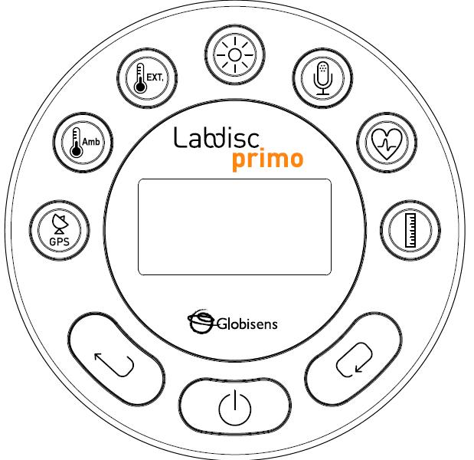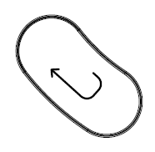

***Select*** key

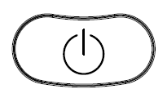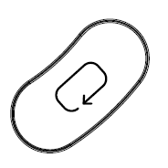

3 control keys

***On/Off*** and ***ESC*** key

***Scroll*** key

### 1.4.3 Labdisc menu

Press the ***Scroll*** key to enter the **Labdisc** menu. Then use the ***Scroll*** key to scan menu options, the select key to choose a menu option and the ***ESC*** key to go one level up in the menu.

### 1.4.3.1 Setup the Labdisc for the next logging session

### 1.4.3.2 Labdisc information

### 1.4.3.3 Configuration of the Labdisc

2. GlobiLab Junior Analysis Software

## 2.1 Software Installation

To install the software, users should run the following installers:

* For PC: GlobiLab-en-1.0-setup.exe
* For Mac: GlobiLab-en-1.0-setup

Then follow the simple installation instructions. These instructions take the user through the installation of the **GlobiLab Junior** software and the USB driver needed for USB communication with the **Labdisc**.

## 2.2 Software Popular Icons and Functions

|  |  |
| --- | --- |
| *Open.png* | Selecting the **Open-project** icon opens the stored activity \*.XML files and displays all its graphs and graphical attributes. |
| books.png | Selecting the ***Workbook*** icon opens the activities folder, where users can choose from a variety of PDF activities. |
|  | Clicking the ***Display-options*** small triangle icon allows the user to select one of the following six display options:   1. viewMeters.png Meter view 2. viewTable.png Table view 3. viewGraph.png Graph view 4. viewMap Map view 5. viewMetersGraph.png Mixed Meter and Graph view 6. viewTableGraph.png Mixed Table and Graph view |
| viewGraph.png | Selecting **Sensor legend**:   1. A left click on the sensor name will set it as the active sensor and will change the y-axis to reflect this sensor’s units and scale 2. First right click on the sensor name will change the line graphs to symbols 3. Second right click on the sensor name will remove this sensor graph from the display 4. Third right click on the sensor name will return to the default view for this sensor and will   show it as a line graph on the display  The graphic window includes a graph title. The default title is New Experiment. Changing this title is done with a double left mouse click over the title. A small text dialog box will open where the user can type in the new title.  When displaying two or more sensors – a right click on the graph x-axis title will open a dialog box for assigning a sensors or time as the x-axis. |
| viewMeters.png | Selecting **Meter view**:  A left mouse click on the four bottom blue dot icons will change the number of meters on the screen to: 1, 2, 4 or 6 meters.  A left click on any of the meters will open a dialog box for meter type selection and assigning a sensor for this meter. |
|  | Selecting the ***Marker*** icon enters into ***Marker*** mode. Left mouse click, near any of the graphs, will place a marker on the graph. Hovering over any of the markers, while pressing and holding the left mouse button and dragging the mouse, will move the marker over the graph. Selecting the ***Marker*** icon again, exits the ***Marker*** mode. |

|  |  |
| --- | --- |
| Annotate.png | Selecting the ***Annotation*** icon activates the ***Annotation*** *mode*. Left mouse click opens a dialog box where users can enter text and images. Pressing the ***Annotation*** icon again exits the ***Annotation*** *mode*. |
|  | For a quick start, simply press the ***Record*** icon and an online graph, bar graph or table, of the selected sensors will build on the screen, while all measurements are stored in the internal memory. |
|  | Selecting the ***Selective download*** icon opens a table listing all stored recordings. Selecting one of the lines on the table and pressing download will download this specific recording to the computer. |
| **Labdisc setup – 3 steps** | |
| input_icon.png | The ***Sensor*** icon opens the sensor selection bar. Clicking a sensor icon selects or removes the sensor from the list of sensors to be sampled during the next recording session. |
| Sample_10sec_icon.png | Select the ***Sampling rate*** icon to define how fast the sensor will take measurements: Manual sampling – represented by a hand icon, 1/min – One sample per minute, 1/s – One sample per second, 10/s – Ten samples per second or 100/s – One hundred samples per second. |
| crop.jpg | Finally, select the amount of samples to be taken during the recording. Recording time equals the sampling rate multiplied by the amount of samples, so 1000 samples at a rate of 100/s will result in a 10 second recording. |
| Excel.png | Selecting the ***EXCEL***icon saves the file in a \*.CSV format, prompts the user for a file name and then automatically opens EXCEL and exports the experiment data into the spreadsheet. |

|  |  |
| --- | --- |
|  | **GlobiLab Junior** ***status bar***, is located at the bottom right corner of the software. It includes 3 icons:   1. **USB indicator** – where blue indicates a USB communication between the computer and the Labdisc. 2. **Bluetooth indicator** – where blue indicates a Bluetooth wireless communication between the computer and the Labdisc. A right mouse click on this icon will open a list of recognized Labdiscs, click on one to connect. 3. **Memory info** – shows how many experiments are stored in the Labdisc memory, out of a maximum of 127. In the example above there are 7 stored experiments out of 127. A right mouse click on this section will allow users to erase all stored data or just the last recording. |

# 

## 2.3 GlobiLab Software for iPad

The **GlobiLab** software for iPad (iPad, iPad 2 and 3rd generation iPad models) is available in the App Store and makes K-12 science experiments mobile, convenient and immediate. **GlobiLab** wirelessly integrates between the **Labdisc** data logger and the iPad. Allowing full **Labdisc** management (setup of all data logging parameters, online display of current measurements and download of the **Labdisc** sample memory), together with graph manipulations (markers, zoom, crop, text and image annotation) and data analysis (statistics and curve fitting etc.).

**GlobiLab** software for iPad was specifically designed to engage students and help visualize complex science concepts by harnessing the iPad built-in accelerometer sensor, data display, multimedia and multi-touch features. The following steps provide a guide on the installation and implementation of the **GlobiLab** App for iPad.

|  |  |
| --- | --- |
|  | ***Download and install of the GlobiLab application***   * Tap the iPad App Store icon * Search for **“GlobiLab”** * Press the FREE green key to install the application |
|  | ***Set wireless communication between the Labdisc and the iPad***   * Go to *iPad Setting - Bluetooth* and select your **Labdisc** from the Devices list * The iPad should immediately connect to your **Labdisc** and change its status to “connected” * Close the setting and open the **GlobiLab** software |
|  | ***Meter view***   * Tap Meter view  to see the current values of the **Labdisc** sensors * Tap one of the Meters and scroll the sensor wheel to select a different sensor type for an existing Meter * Select a different Meter type  from the horizontal line of icons |
|  | ***Data collection***   * Tap the SETUP icon  and enter the SETUP screen. This dialog box allows you to select the Sensors, Sampling rate and amount of samples for the next data recording. * Tap the RUN icon  to start recording and observe the graph build up on the screen * You may switch the display to a Bar Graph view by tapping the Bar Graph key * You may switch the display to a Table view by tapping the Table key * To stop recording tap the STOP icon |
|  | ***Download Labdisc stored measurements to the iPad***  The **Labdisc** can store up to 127 different experiments. This is very useful when conducting outdoor data collection or long measurements.   * Tap the Download icon * The iPad will list all **Labdisc** stored experiments Each line on this list shows what sensors were recorded, at what sampling rates and for how many samples. In addition it indicates the date and time of the recording. * Click on one of the lines in the list. The **Labdisc** transfers the data to the iPad. * After all data is transferred, the iPad will show a graph of the collected measurement |
|  | ***Data analysis (markers, curve fitting)***   * Tap the open icon  and select “Free fall”. This graph describes a real recording of a ping-pong ball bouncing on a table, as recorded by the **Labdisc** distance sensor. For more details see the Free Fall movie at: <http://www.globisens.com/resources/experiment-videos> * Long touch on the graph to add a Marker * Touch the Marker to cross and drag it with your finger. View the Marker text box data changing while the marker follows the graph line. * Tap the graph twice to view the actual sampling points * Long touch the graph to add a 2nd Marker * Place both the Markers on the beginning and end of a single ball jump * Tap the Curve Fitting icon  and select a Quadric Regression to get the mathematical equation representing the ping-pong ball jump. From this equation we can calculate earth gravitation. |
|  | ***Graph Annotation***   * Use a long touch anywhere on the background (not on a graph), create an empty annotation. The edit annotation box opens automatically. From here:   + Edit or write an annotation   + Add an image using the camera or the image gallery   + Remove the annotation |
|  | ***Use of Map view in field trip (Environment)***  Recording GPS together with other **Labdisc** sensors, enables the **GlobiLab** software to plot these sensors over the Apple maps.   * Make sure the iPad is connected to the Internet * Tap the Open icon and select the “Walk in the park”. In this experiment we measured the different climate in a city park compared to a nearby cross road. For more details check the Microclimates movie at: <http://www.globisens.com/resources/experiment-videos>. * Tap the color scale on the left and select Amb. Temperature. Observe the dramatic temperature change while walking from the city cross-road to the park. * Tap the colored samples on the map to get a marker with the temperature value. * Pinch to zoom in/out the map * See the experiment data in a table, by tapping the Table View  and observe the GPS longitude and latitude values. * You may show other experiments under this category like” Trip to the Dead Sea” or “Flight from Tel-Aviv to Istanbul” |
|  | ***Online help***  **GlobiLab** offers an online help for each of the 5 views: Line, Bar, Table, Meter and Map.   * Open the relevant View * Tap on the HELP icon  and observe a list of functions and controls |

## 2.4 GlobiLab Software for Android

The **GlobiLab** software for Android 4 and above is available for download from the Globisens web site: <http://www.globisens.net/support#2> and from Google Play.

The software makes K-12 science experiments mobile, convenient and immediate. **GlobiLab** wirelessly integrates between the **Labdisc** data logger and the Android tablet, allowing full **Labdisc** management (setup of all data logging parameters, online display of current measurements and download of the **Labdisc** sample memory), together with graph manipulations (markers, zoom, crop and text annotation) and data analysis (statistics and curve fitting etc.).

|  |  |
| --- | --- |
|  | ***Set wireless communication between the Labdisc and the Android tablet***   * Make sure the Labdisc is paired to the Android (see section 3.2.4) * Turn on the Labdisc * Launch the application * Tap the options icon in the top action bar  (rightmost, three vertical dots) * Tap  and select the name of the Labdisc you would like to connect with (e.g. Labdisc\_6588) * The App name (top right) will change to , indicating that the connection is established |
|  | ***Meter view***   * Tap the Meter view  to see the current values of the **Labdisc** sensors * Tap one of the meters and scroll the sensor wheel to select a different sensor type for an existing meter * Select a different meter type  from the horizontal line of icons |
|  | ***Data collection***   * Tap the SETUP icon  and enter the SETUP screen. This dialog box allows you to select the Sensors, Sampling rate and amount of samples for the next data recording. * Tap the RUN icon  to start recording and observe the graph build up on the screen * You may switch the display to a Bar Graph view by tapping the Bar Graph key * You may switch the display to a Table view by tapping the Table key * To stop recording tap the STOP icon |
|  | ***Download Labdisc stored measurements to the tablet***  The **Labdisc** can store up to 127 different experiments. This is very useful when conducting outdoor data collection or long measurements.   * Tap the Download icon * The application will list all **Labdisc** stored experiments. Each line on this list shows what sensors were recorded, at what sampling rate and for how many samples. In addition it indicates the date and time of the recording. * Click on one of the lines in the list. The **Labdisc** transfers the data to the tablet. * After all the data is transferred, GlobiLab will display a graph of the collected measurement |
|  | ***Data analysis (markers, curve fitting)***   * Tap the open icon  and select “Free Fall”. This graph describes a real recording of a ping-pong ball bouncing on a table, as recorded by the **Labdisc** distance sensor. For more details see the Free Fall movie at: <http://www.globisens.net/resources/experiment-videos> * Long touch on the graph to add a marker * Touch the marker to cross and drag it with your finger. View the marker text box data changing while the marker follows the graph line. * Tap the graph legend and select “Dots” to view the actual sampling points * Long touch the graph to add a second marker * Place both the markers at the beginning and end of a single ball jump * Tap the Curve Fitting icon , select a Quadric Regression to get the mathematical equation representing the ping-pong ball jump. From this equation we can calculate earth’s gravitation. |
|  | ***Graph Annotation***   * Use a long touch anywhere on the background (not on a graph), create an empty annotation. The edit annotation box opens automatically. From here:   + Edit or write an annotation   + Remove the annotation |
|  | ***Use of Map view in a field trip (Environment)***  Recording GPS together with other **Labdisc** sensors enables the **GlobiLab** software to plot these sensors over the Apple maps.   * Make sure the tablet is connected to the Internet * Tap the Open icon  and select “Walk in the Park”. In this experiment the different climate in a city park compared to a nearby cross road was measured. For more details check the Micro Climate experiment movie at: <http://www.globisens.net/resources/experiment-videos> * Tap the color scale on the left and select Amb. Temperature. Observe the dramatic temperature change while walking from the city cross-road to the park. * Tap the colored samples on the map to get a marker with the temperature value * Pinch to zoom in/out the map * See the experiment data in a table, by tapping the Table View  and observe the GPS longitude and latitude values |
|  | ***Workbook section***   * Tap the Workbook icon  to view GlobiLab experiment guides * Tap on one of the experiments on the list and view a comprehensive PDF guide of that experiment. |
|  | ***Online help***  **GlobiLab** offers a PDF quick start guide. To open the quick start guide, tap on the HELP icon . |

# **3 Labdisc – GlobiLab Junior Communication**

## 3.1 USB Communication

Upon USB cable connection between the computer and the **Labdisc,** the **GlobiLab Junior** software automatically detects the USB connection and begins communicating with the **Labdisc**.



## 3.2 Bluetooth Wireless Communication

Before wireless communication with a **Labdisc** for the first time, the **Labdisc** should be added as a device to the computer in a process called pairing. Pairing need be done only once for each **Labdisc**, after which the computer stores the connection information, including a unique name for each **Labdisc**. When no **Labdisc** is connected via USB, the computer will automatically try to wirelessly connect to the last connected **Labdisc**. To connect to a different or a new **Labdisc**, right click on the Bluetooth icon in the **GlobiLab** ***status bar,*** located at the bottom right corner of the screen, then click on the **Labdisc** you want to connect to.

### 3.2.1 Pairing with a PC running Windows OS

1. Turn on the **Labdisc**. Make sure the **Labdisc** is not showing the sleep icon http://www.globisens.net/sites/default/files/images/support/faqs/sleepicon.jpg. If it does, please press any button to leave the sleep mode.
2. Start the GlobiLab software.
3. Right click the Bluetooth icon located on the status bar at the bottom right corner of the screen 
4. From the new pop-up menu select ***"Find more Labdiscs and sensors".*** The computer opens the ***"add a device"*** dialog box and starts searching for the Bluetooth device.
5. Your Labdisc will be displayed as ***"Labdisc-xxxx"***, where "xxxx" are the last four digits of the Labdisc serial number sticker.
6. Select this device and press ***"Next"***
7. On the **Labdisc**: Press and hold the SCROLL key to put the Labdisc in Pairing mode. The Labdisc will produce a long "beep" while its screen shows ***"BT pairing".***
8. On the computer dialog box select the 2nd option: ***"Enter the device pairing code"*** and click ***“Next”.***
9. In the next dialog box enter "1234' as the pairing code, click “***Next”***
10. Wait for the computer to finish the process and announce ***"Your device is ready to use"***.
11. Right click the Bluetooth icon on the status bar. Choose the Labdisc you've just paired and click on it.
12. The computer will connect to the Labdisc and turn the Bluetooth icon blue .

### 3.2.2 Pairing with a Mac OS

1. Turn on the **Labdisc**. Make sure the **Labdisc** is not showing the sleep icon http://www.globisens.net/sites/default/files/images/support/faqs/sleepicon.jpg. If it does, please press any button to leave the sleep mode.
2. Open the Bluetooth menu from the Mac menu and select "***Set Up Bluetooth Device..."***
3. A dialog box opens. Your Labdisc will be displayed as ***"Labdisc-xxxx"*** where "xxxx" are the last four digits of the Labdisc serial number sticker.
4. Select this device and press ***“Continue”.***
5. Mac will try a quick default attempt to pair. This attempt will not succeed as Labdisc requires a pairing code.
6. Press the ***"Passcode options..."*** button and select the option ***"Use a specific passcode"***. Enter the passcode "1234", and don't press "OK" yet.
7. On the **Labdisc**: Press and hold the SCROLL key to put the Labdisc in Pairing mode. The Labdisc will produce a long "beep" while its screen shows ***"BT pairing".***
8. Press the ***"OK"*** button in the Mac dialog box.
9. Open the **GlobiLab** software.
10. Right click the ***Bluetooth*** icon  located at the bottom right corner of the software.
11. Choose the **Labdisc** you’ve just paired and click on it. The computer will connect to the **Labdisc** and turn the ***Bluetooth*** icon blue .

### 3.2.3 Pairing with an iPad

1. Turn on the **Labdisc**. Make sure the **Labdisc** is not showing the sleep icon http://www.globisens.net/sites/default/files/images/support/faqs/sleepicon.jpg. If it does, please press any button to leave the sleep mode.
2. Launch the iPad Setting 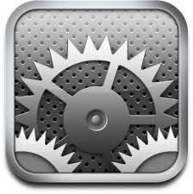
3. Open Bluetooth. Make sure the iPad Bluetooth is on.
4. From the devices list click the “***Labdisc-xxxx”***, where the xxxx digits match the last 4 digits of your **Labdisc** S/N sticker on the **Labdisc** back cover.
5. On the **Labdisc**: Press and hold the SCROLL key to put the Labdisc in Pairing mode. The Labdisc will produce a long "beep" while its screen shows ***"BT pairing".***
6. The iPad will ask for a PIN code. Enter “1234” and click Pair.
7. The iPad will show **Labdisc-xxxx** connected.
8. Start the iOS GlobiLab application 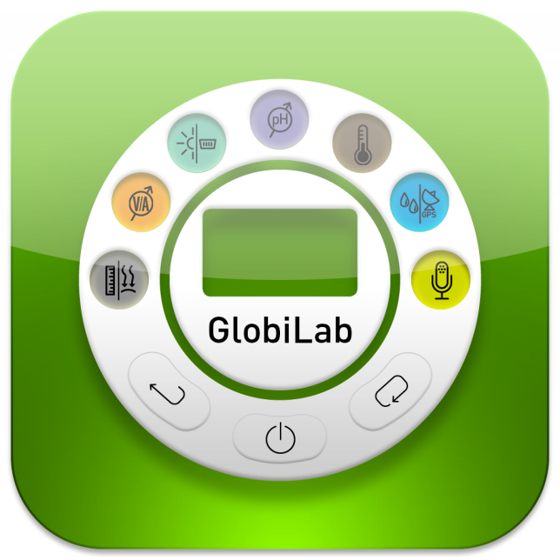. The application will automatically connect to the Labdisc you have paired.

### 3.2.4 Pairing with Android OS

1. Turn on the **Labdisc**. Make sure the **Labdisc** is not showing the sleep icon http://www.globisens.net/sites/default/files/images/support/faqs/sleepicon.jpg. If it does, please press any button to leave the sleep mode.
2. On the tablet go to setting 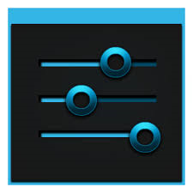 and select ***“Bluetooth”***
3. Make sure the Bluetooth radio is “ON”, then turn on ***“Search for Devices”***
4. On the **Labdisc**: Press and hold the SCROLL key to put the Labdisc in pairing mode. The Labdisc will produce a long "beep" while its screen shows ***"BT pairing".***
5. From the devices list on the tablet tap the “***Labdisc-xxxx”***, where the xxxx digits match the last 4 digits of your **Labdisc** S/N sticker on the **Labdisc** back cover.
6. The tablet will open the ***“Bluetooth pairing request”*** dialog box and display ***“Type the device’s required PIN”***
7. Enter the pairing code “1234” and tap ***“OK”***
8. Pairing process is complete and the **Labdisc** will appear on the tablet ***“paired devices”*** list.
9. Open the GlobiLab application on the tablet .
10. Tap on the options icon at the top Action Bar  (rightmost, 3 vertical dots)
11. Tap on ***"Connect Labdisc",*** and select the name of the **Labdisc** you’d like to connect (e.g. Labdisc\_1052).
12. The App name will change to ***"GlobiLab (Labdisc\_xxxx)" *** to indicate connection.

# **4 GlobiWorld Science Environment**

## 4.1 Seven Science Parks

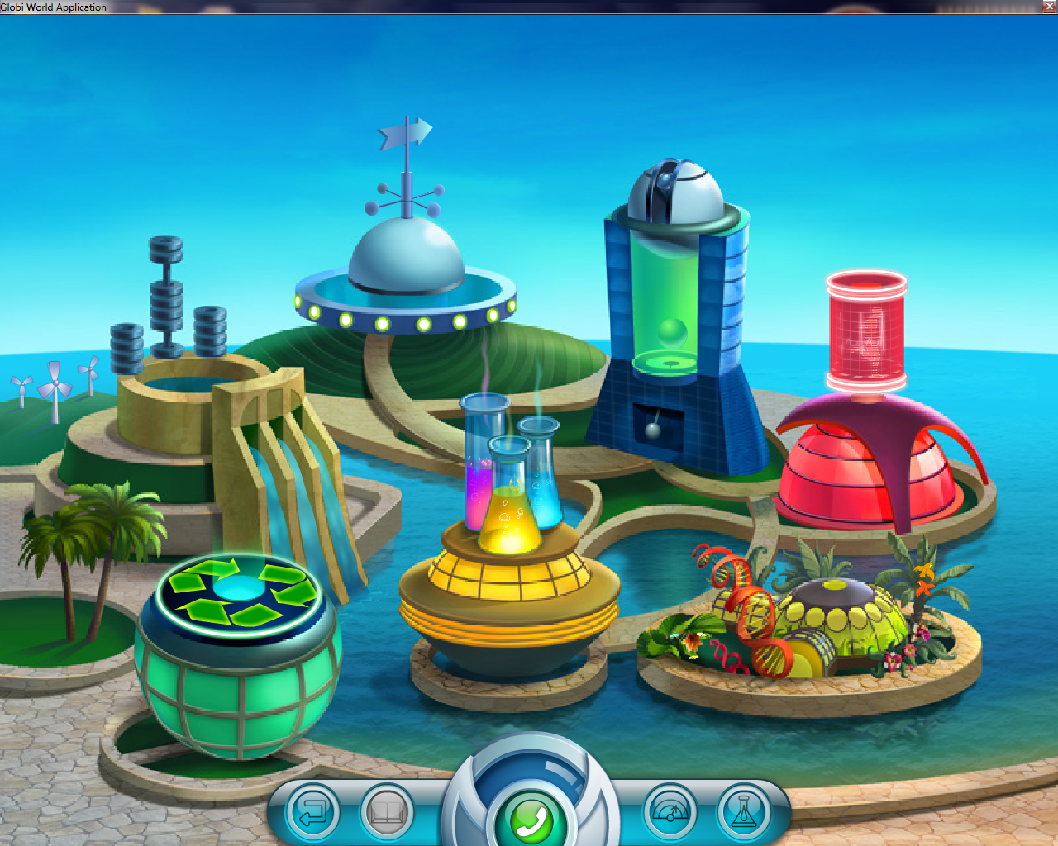Starting science at young age is key in enabling student long-term success in the subject. **GlobiWorld** provides a learning platform for seven different scientific disciplines using a theme park environment to engage and enhance elementary school students’ understanding. In each park students can read biographies of famous scientists; learn scientific facts and trivia; operate the flash animated **Labdisc** laboratory and analyze data using tools such as graphs, meters and functions.

1

5

1

4

3

1

2

1

1

1

7

6

1

1

① **Environmental** Science Park  
② **Electricity** Science Park  
③ **Weather** Science Park  
④ **Motion** Science Park  
⑤ **Human Body** Science Park  
⑥ **Plant** Science Park  
⑦ **Chemistry** Park

Clicking on any one of the seven theme parks will lead the student inside each park. Here, further learning resources can be found including science facts per subject, activity workbooks and famous scientists’ biographies.

## 4.2 GlobiWorld Popular Icons and Functions

The simple tool bar on the **GlobiWorld** landing page has five buttons carrying the following functionality:

|  |  |
| --- | --- |
| *btn_back.png* | When selecting the ***Exit*** button from the entry screen the user exits the **GlobiWorld** software. Clicking the same button from within a science park returns the user to the previous screen. |
| btn_book.png | Clicking on the ***Workbook*** button from within a science park opens up an activity workbook.. |
| btn_meters.png | The ***Meters*** button opens the meters window. This window displays the current sensor readings of the **Labdisc** in a variety of meter displays. |
| btn_lab.png | The ***Lab*** button launches the laboratory section of the **GlobiWorld** software. From this laboratory, users can control the **Labdisc**, collect samples from the sensors and view the data in tables, graphs and other display types. Students can then analyze their findings and create Lab reports. |

# 5 Experiment Samples

The **GlobiLab Junior** software includes experiment samples, for teachers and students to view, analyze, modify or repeat. This section reviews some interesting recorded experiments found in the **GlobiLab Junior** application. To open a recorded experiment, simply press the ***Open*** icon in the **GlobiLab Junior** software and select the files below:

|  |  |
| --- | --- |
|  | **Day and Night Temperature Changes**  A long 48-hour recording of temperature and light levels, with the Labdisc located on the window shelf:   * ***Sensors selected:*** Light, ambient temperature * ***Sampling rate:*** 1/min * ***Amount of samples:*** 1000 * ***Experiment duration*:** 48 hours * ***Communication:*** Offline, data downloaded at recording’s end * **Data Analysis:** Use the ***Markers*** to show min/max. values |
|  | **Heart Rate**  Measuring our heart rate before and after exercise:   * ***Sensors selected***: Heart rate * ***Sampling rate***: 1/sec * ***Amount of samples***: 1000 * ***Communication***: Online, preferably wireless with Bluetooth * ***Data Analysis***: View both pulse and beat per minute graphs. Compare recordings from different students. |
| sunglasses.jpg | **Light Absorbance**  Measuring of light absorbance by different sunglasses:   * ***Sensors selected:*** Light * ***Sampling rate:*** Manual * ***Communication:*** Online * ***Display:*** Bar graph * ***Data Analysis:*** Use Annotation to add comments and pictures of the sunglasses to the graph |

Copyright ©2011 Globisens. All rights reserved. Globisens Ltd. logos and product names are registered trademarks of Globisens Ltd. No part of this document may be reproduced by any means, nor translated to any electronic medium without the written consent of Globisens. Information contained in this document is believed to be accurate and reliable, however, Globisens assumes no responsibility for its use. Specifications are subject to change without notice. www.**GLOBISENS**.com

GlobiLab supports Android versions 4.0 and up.

Made for   
iPad (3rd generation)  
iPad 2  
iPad

iPad is a trademark of Apple Inc., registered in the U.S. and other countries.

“Made for iPad” means that an electronic accessory has been designed to connect specifically to iPod, iPhone, or iPad, respectively, and has been certified by the developer to meet Apple performance standards. Apple is not responsible for the operation of this device or its compliance with safety and regulatory standards. Please note that the use of this accessory with iPod, iPhone, or iPad may affect wireless performance.

REV: 12.05.14