**GlobiLab 1.0 App for Android**

**Quick Start Guide**

Contents

GlobiLab overview 1

Getting started – establishing communication 2

Working with the different display types 3

Graph and Labdisc controls 6

Working with a smaller screen 8

Welcome to the GlobiLab analysis application for Android. This app enables users to setup and control the Labdisc, get sensor measurements, display data in colorful meters, line graphs, bar graphs, tables and as a layer of data over Google maps. In addition GlobiLab includes a set of analysis tools and functions for easy application to collected measurements.

# GlobiLab overview

GlobiLab is a very intuitive and easy-to-learn application: 100% icon-based with no text menus. The screen can be divided into three different sections as shown in the picture below:

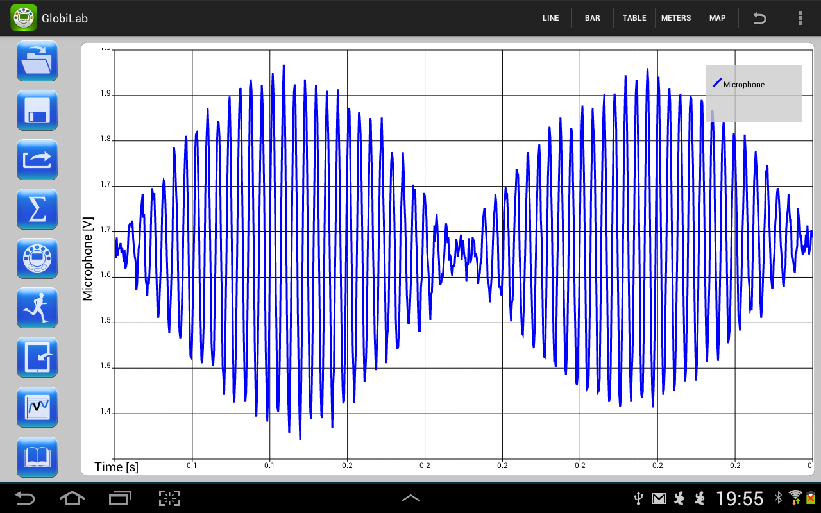

Graph and Labdisc controls

Display type controls

Sensor display area

1. **Sensor display area** – main area for measurement display. Single or multiple sensors are displayed here in a variety of presentations: Graphs, tables, maps and meters.
2. **Display type control** – toggle the same data between five different display modes: Line graphs, bar graphs, tables, meters and maps.
3. **Graph and Labdisc controls** – a set of icons for file management, Labdisc setup, data logging start/stop, graph analysis and for viewing experiment guides.

# Getting started – establishing communication

The Labdisc communicates wirelessly with the GlobiLab app through Bluetooth communication. Connecting to the Labdisc is done via the following steps:

1. Turn on the Labdisc.
2. Launch the application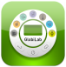.
3. Tap the options icon in the top action bar  (rightmost, three vertical dots). In some tablets the action bar is part of the fixed tablet keys: 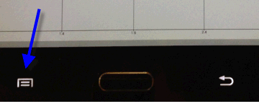
4. Tap ******and select the name of the Labdisc you would like to connect with (e.g. Labdisc_6588).
5. The App name (top right) will change to  indicating that the connection is established.

**First time pairing** - When trying to establish communication for the first time, the Labdisc needs to be paired with the tablet. Please follow the steps below for pairing:

1. Turn on the Labdisc.
2. On the tablet go to Settings 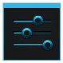 and select *“Bluetooth”*.
3. Make sure the Bluetooth radio is ON, and then select *“Search for Devices”.*
4. On the Labdisc: Press and hold the SCROLL 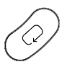key to place the Labdisc in pairing mode. The Labdisc will produce a long "beep" while its screen shows *"BT pairing".*
5. From the devices list on the tablet tap the “*Labdisc-xxxx”*, where the xxxx digits match the last 4 digits of your Labdisc S/N sticker on the Labdisc back cover.
6. The tablet will open the *“Bluetooth pairing request”* dialog box and display *“Type the device’s required PIN”*.
7. Enter the pairing code “1234” and tap *“OK”.*
8. The pairing process is complete and the Labdisc will appear on the tablet’s *“paired devices”* list.
9. Now you may open the GlobiLab application and connect to the Labdisc as described above.

# Working with the different display types

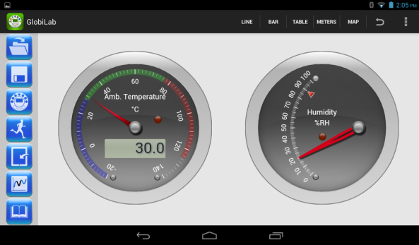

This section describes all the GlobiLab display types - their features and attributes:

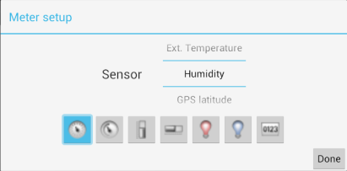 Tapping the meters key on the “Display Type” section enters meters mode. Here users can view between one to three meters on a 7” tablet and between one to six meters on a 10” tablet. Meters will show the current value of the Labdisc sensors and will update once per second. Tapping on any meter opens a *“Meter-Setup”* dialog box. Here users can select different a meter type and deferent sensor for that meter.

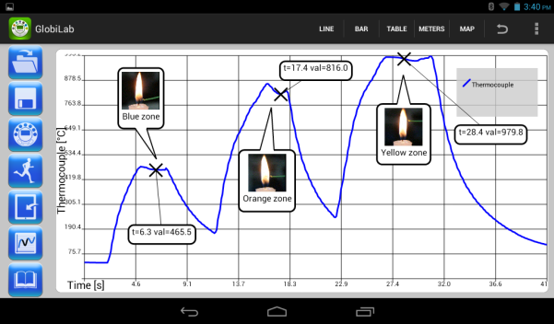Tapping line key on the “Display Type” section opens the line graph display. In this mode the graph area will show graphs for one or more sensors on the same time axis. Users can display saved graphs - online graphs received from the Labdisc during logging (up to 100 samples per seconds) or graphs of measurements downloaded from the Labdisc memory.

Graph features include:

* **Zoom** – Zoom-in on the graph by placing two fingers on the screen simultaneously and move them apart. Zoom-out on the graph by placing two fingers on the screen simultaneously and move them together (pinch). Zoom-in and Zoom-out work on both the Y and X axes.
* **Marker** – place a marker by tapping and holding one of the graphs. The marker text window shows the graph coordinates (time, value). Tapping and holding the marker “X” point enables users to move the marker along the graph. To delete the marker, tap and hold the marker text window and select delete. There is no limit to the amount of markers users can place on the graph.
* **Text annotation** – Tapping and holding anywhere on the graph window, but not on one of the graphs, opens an annotation text box. Tap and hold the annotation text box to add a text massage. To delete the annotation tap and hold the annotation text window and select delete.
* **Graph legend** – In the top right of the graph window is the graph legend. 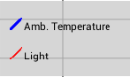 Tapping it will open the “curve setup” dialog box. Here users can change graph colors and the graph plot from lines to dots.
* **Scale change** – Tapping a graph will make its sensor the “active graph” and change the Y scale to the sensor units and values.

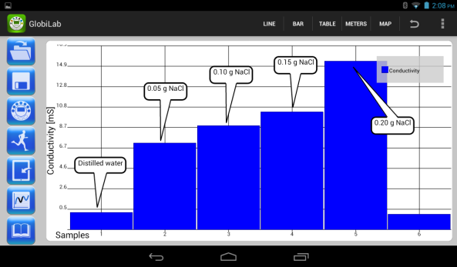 Tapping the bar key on the “Display Type” section opens the bar graph display. In this mode each sample is represented by a horizontal bar. Only a single sensor can be displayed as a bar graph. Both text annotation and legend features work in this mode.

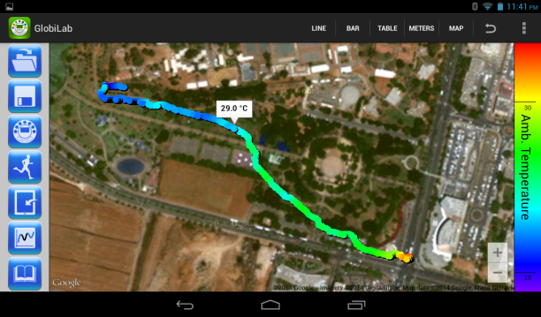 Tapping the map key on the “Display Type” section opens the Google map display (tablets need to be connected to the Internet). In this mode the application will display the sensor values as a layer over a Google map. Measurements are displayed as colored dots, with a color changing from blue to red according to the measurement value. Tapping on the right color legend enables users to change the displayed sensor. By including the Labdisc GPS sensor among the sensors being recorded, the map view automatically plots each sensor’s measurement in the exact location where it was collected. Tapping the color dots will open a marker showing the sensor value.

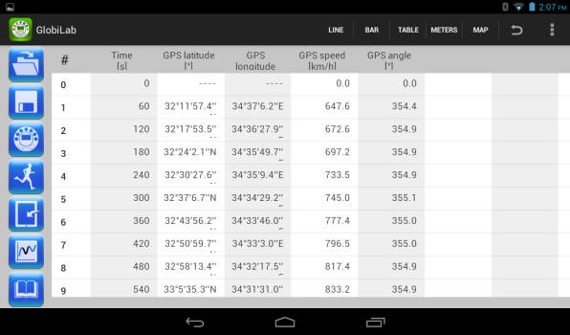 Tapping the table key on the “Display Type” section will open the table view. In this mode each sensor value is displayed in a separate column. The furthest left columns show the sample number and time.

# Graph and Labdisc controls

This section describes the icons found in the GlobiLab left column:

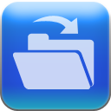 Tap this icon to open saved experiments. Users can toggle between the Globisens gallery of experiments and their own experiments section. Tapping on a selected experiment will open it in the graph window.

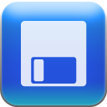 Tap this icon to save the current experiment. GlobiLab will open a dialog box, where users can fill-in the experiment names before saving.

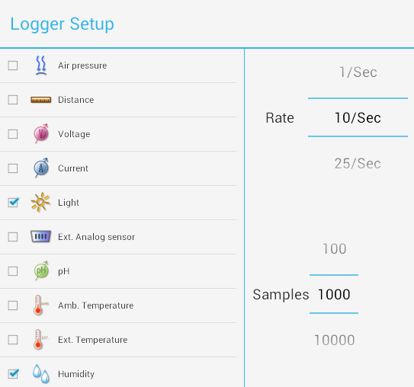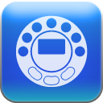 Tap this icon to setup the Labdisc. GlobiLab will open the *“Logger Setup”* dialog box, allowing users to select the sensors, sampling rate and the total amount of samples for the next recording. Note that different sensors have different maximum sampling rates. For example, the GPS max sampling rate is one sample per second, while the voltage sensor can be sampled at up to 25,000 samples per second. The application will limit the sampling rate according to the “slowest” selected sensor.

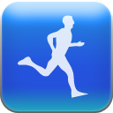 Tap RUN to start recording. The icon will change to a STOP icon 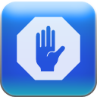, allowing users to stop recording. When the Labdisc memory is full – the GlobiLab will not allow users to start a new recording session. To clean the Labdisc memory, tap on the options icon in the top action bar , then select the “Clean Labdisc” option.

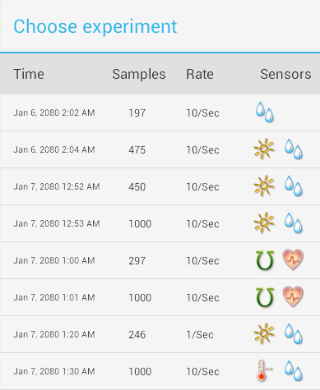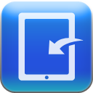 The Labdisc’s memory stores up to 127 recordings: Users can download each of these recordings in order to view and analyze them. Tapping the download icon will open the *“Choose Experiment”* dialog box which provides full information about each of the stored recordings. This information includes: Date and time of the recording, number of sampling points, sampling rate and sensors measured for that particular recording. Tapping on one of the stored experiments will start downloading it and then display the experiment.

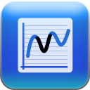 The function icon allows users to apply either linear regression or quadric regression analysis to the line graph. Both regressions operate between two markers. Both regressions will add a plot (either linear or parabolic) to the graph with a text box holding the mathematical formula of the plot.

 GlobiLab includes a comprehensive gallery of experiment guides supplied by Globisens. Tapping this icon will open the list of stored guides. Users can tap on each of the listed guides which will then automatically open in a PDF viewing window.

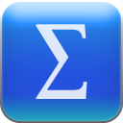 Tapping the statistic icon, will provide full statistic information about the graph, including minimum, maximum, average, standard deviation, sensor type, sampling speed and the amount of samplings collected in the experiment.

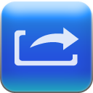 Tapping the EXPORT icon will save the experiment data in CSV format which can be opened with any spreadsheet.

# Working with a smaller screen

The application adjusts itself to any screen size. On screens smaller than 7”, the above icons are stored in a “sliding drawer” which the user can open with a “left to right” finger swift. Closing the “drawer” is done with a “right to left” finger swift.

