**GlobiLab-Collaborate software**

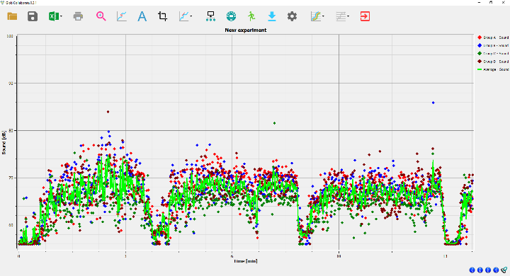**Quick start guide**

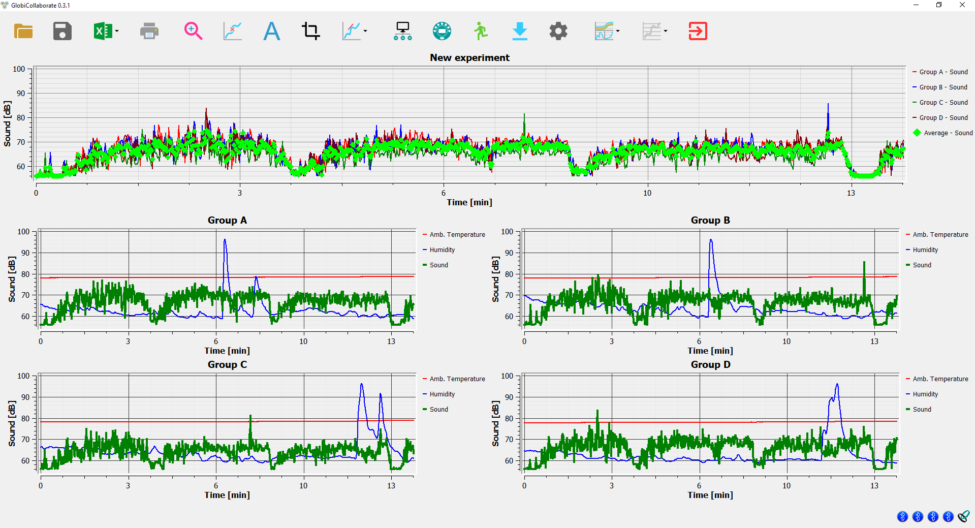



www.globisens.com

Contents

Introduction 2

Install the GlobiCollab software 2

Pair all Labdisc units with your computer 2

Connect all Labdisc units to GlobiCollab via Bluetooth 3

Set-up of all Labdisc units from GlobiCollab menu 4

GlobiCollab special display options 4

Individual Labdisc display 4

Combined display 4

Individual + Combined display 5

Customize the Display Window 5

Setting the combined graph title 5

Setting Y axis 5

Adjusting the Scale 5

Changing graph color 5

Using a function on the graph 6

Erasing the Labdisc Memory 6

GlobiCollab software icons 7

The Menu/Tool Bar 7

Open Data Files 7

Save 7

Export 7

Print 7

Zoom 7

Marker 7

Annotate 7

Crop 7

Mathematical Functions 8

Connect all Labdisc units 8

Setup 8

Run/Stop 8

Download 8

Configuration 8

Multi Labdisc display 9

Individual Labdisc display Options Menu 9

Exit GlobiCollab 9

# Introduction

GlobiCollab allows teachers to display, control and analyze the entire classroom measurements using a single computer. This new software can wirelessly connect to up to 8 Labdisc units at the same time, simultaneously setting them to measure any combination of sensor and display in real time each Labdisc measurements in its designated graphic window. Additionally, GlobiCollab will show a combined graphic of all connected Labdisc units with an average measurement graph of the entire classroom.

Students can now compare their experiment data to graphs and data collected by other student groups, and immediately take steps to change or improve their experiment setup. Different student groups can conduct the same experiment under different condition and compare the results. E.g. measuring light and temperature in different parts of the classroom, or measuring oxygen production during photosynthesis of plants projected with lights in different colors. Just a few examples demonstrating the power of collaborative classroom research made possible by our new GlobiCollab.

GlobiCollab may save the need for using a computer per Labdisc, and is **ideal for Interactive White Boards (IWB) or Interactive Flat Panels**, where teachers cannot just project the collected data to all student, but also use the IWB or panels to analyze it.

# Install the GlobiCollab software

The GlobiCollab software is compatible with Windows OS, and available for download on our WEB.

Simply go to: <https://www.globisens.net/support#2> and choose:

1. GlobiCollab MSI installation 1.0.X for PC (WIN 7,8,10 64b)

Then follow the simple installation instructions. These instructions take the user through the installation of the GlobiCollabsoftware. At the end of the installation process – you’ll see the GlobiCollab icon on your desktop .

# Pair all Labdisc units with your computer

Pairing is a process linking the Labdisc with your computer through Bluetooth wireless communications. Pairing is done once, at the first time you are using a new Labdisc with your computer.

For pairing – please follow the below steps:

1. Make sure that Bluetooth is enabled on your computer.
2. Turn on the Labdisc. Make sure the Labdisc is not showing the sleep icon  . If it does, please press any button to leave the sleep mode.
3. From the PC ***Start*** menu select ***Setting->Devices***, then select “***Add Bluetooth or other Device***” and choose “***Bluetooth***”. The PC will open the below dialog box and starts searching for Bluetooth devices.

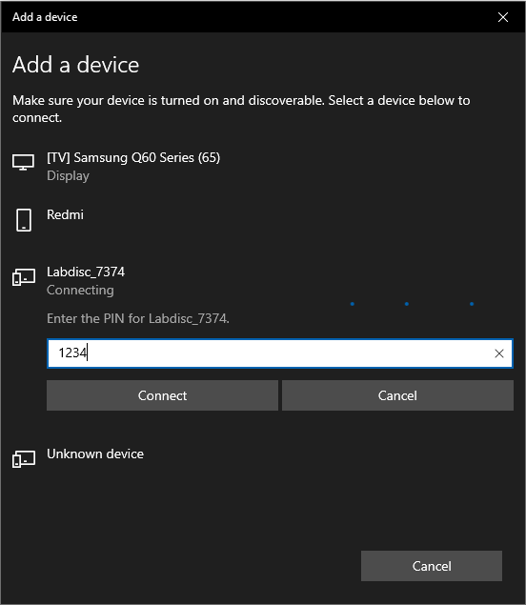

1. Your Labdisc will be displayed as "Labdisc-xxxx", where "xxxx" are the last four digits of the Labdisc serial number sticker.
2. Click on the Labdisc you would like to pair.
3. On the Labdisc: Press and hold the Scroll key  to put the Labdisc in Pairing mode. The Labdisc will produce a long "beep" while its screen shows "**BT pairing**"
4. In the PC dialog box enter "**1234**" as the pairing code and click ***Connect***.
5. Wait for the computer to finish the process and announce "***Your device is ready to use***". Now your Labdisc is paired and ready to use by the GlobiCollab software.

# Connect all Labdisc units to GlobiCollab via Bluetooth

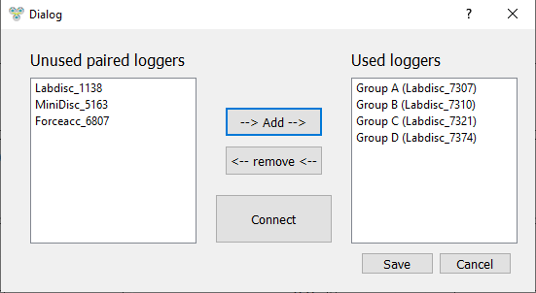After pairing all Labdisc units - open the GlobiCollab software and click on the Connect icon . The dialog box to the right will open, allowing you to ***Add*** up to 8 paired Labdisc to GlobiCollab. Press ***Connect*** and the software will open individual graphic windows for each of the Labdisc units (in this case 4 windows) and will connect to all.

**Connecting to all Labdisc may take up to 60 seconds**. Once a Labdisc unit is connected – its Bluetooth icons, at the low right corner of the screen, turns blue. If one of the Labdisc is still not connect  make a left mouse click on its Bluetooth icon at the bottom of the screen. Wait till all icons are blue  before using GlobiCollab.

# Set-up of all Labdisc units from GlobiCollab menu

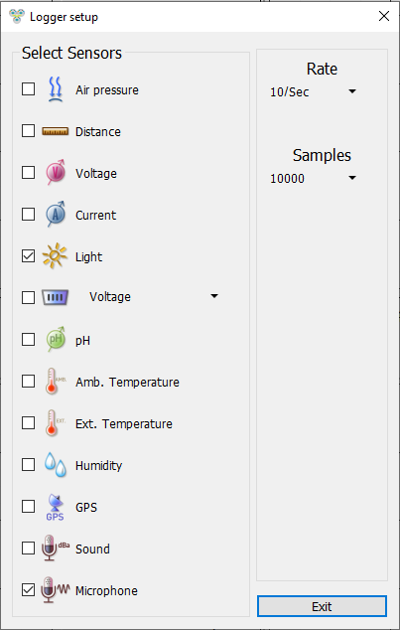

1. GlobiCollab **can only use Labdisc from the same model**.
2. Click on  to configure all Labdisc units.
3. Select sensors that you wish to use in the “Logger Set-up” window. Different sensors will show for different models of Labdisc, depending on what sensors are available.

If you are using a Globisens brand external sensor attached to the Universal Adapter port, it will show up in the set-up menu after you have attached it.

1. Click the dropdown arrow under ***Rate*** to select the sample frequency.
2. Click the dropdown arrow under ***Samples*** to select the number of samples you wish to collect.
3. Click ***Exit*** to complete the set up. At this point the GlobiCollab software will set all Labdisc units one after the other. A black Bluetooth icon at the bottom right corner of the screen  indicates the Labdisc being Setup.
4. Once all units have completed the Setup process – click on ***Run*** to simultaneously start the data collection on all Labdisc units.

# GlobiCollab special display options

GlobiCollab offers the following 3 display options:

|  |  |
| --- | --- |
|  | Individual Labdisc display – up to 8 individual graph windows, one for every Labdisc. Clicking on the window title will make it the active window, changing its background to dark gray. While you can Zoom, and place Markers in any of the Labdisc windows – the Active window will allow you to use the function menu on it graphs and also select either Bar Graph  or Line graph  as its display. |
|  | Combined display – a single graphic window showing a graph for each of the Labdisc units. The display will show a single sensor from any of the connected Labdisc. This will be the *Active Sensor* selected in each of the individual graphs. To select an active sensor – simply click on the sensor name in the individual graph legend. You should see the Y axis change to this sensor unit and scale. In addition to the Active sensors – the Combined display will show an average graph made as a calculation of all other graphs in this window. This can be used as a classroom average of the current experiment measurement.  ***Save*** and ***Open*** functions are all operating on the Combined graph data. |
|  | Individual + Combined display – displays both individual graphic windows and a single combined graph at the top of the screen. |
|  |  |
|  |  |

# Customize the Display Window

Setting the combined graph title – to customize the combined graph with the name of your experiment, double click on the combined graph title to get a pop-up window. You can then add the title of your experiment. The default title will be the date and time that the experiment was conducted.

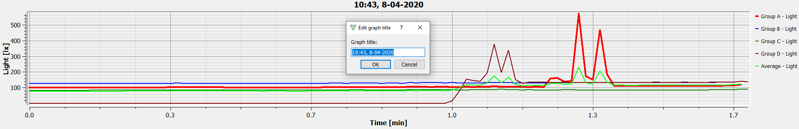

Setting Y axis – to set the Y axis for a specific sensor, left click on the sensor name in the upper right hand side graph legend. This will set this sensor to the *Active Sensor* in the window and have the Y axis show its name and scale.

Adjusting the Scale – right click on the Y axis scale to get a pop up window. Type in a minimum number slightly lower than your lowest reading and a maximum number slightly higher that your highest reading. This will give you the greatest detail on your graph.

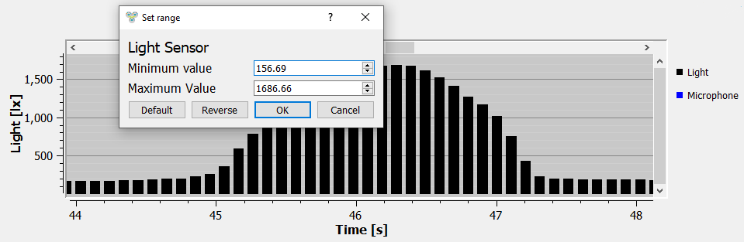

Changing graph color – right click on any of the graph, will open a dialog box where you can select a different color to your graph.

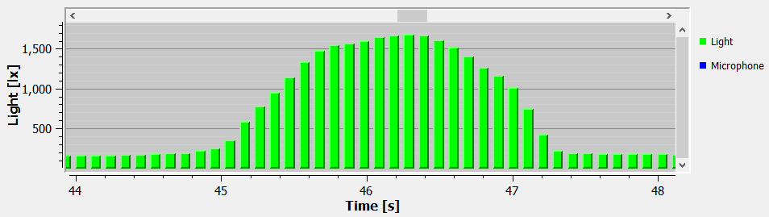

Using a function on the graph – you may use the functions either on the Combined graph or on the individual graphs. When in combined graph display mode  simply select the function you desire. Use the mareks to set the area for the function to be applied.

In the individual Labdisc windows you need to first select the active window. Do that by a left click on the individual window title. Then mark the graph with markers and select the function to be used. Below is an example of an Integral function operated on a Light sensor graph in one of the individual graphs.

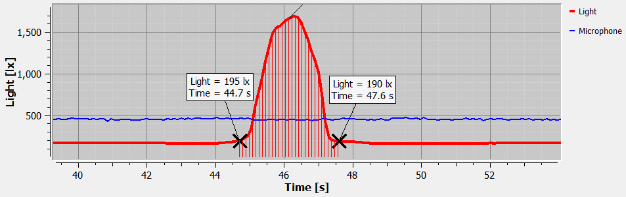

Erasing the Labdisc Memory – The Labdisc memory can hold up to 127 recorded experiments or a total of 1,000,000 samples. When each of this limit is reached, the Labdisc memory needs to be erased before collecting any more data. To erase an individual Labdisc memory do a left mouse click on the relevant Bluetooth icons at the botom right of the screen. The first icon is the Labdisc marked Group A, the second is Labdisc marked Group B etc. A dialog box will pop-up and ask you to confirm erasing momory of this individual Labdisc unit. Click Yes if you would like to erase the entire Labdisc memory.

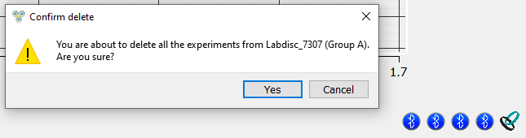

# GlobiCollab software icons

## The Menu/Tool Bar



|  |  |
| --- | --- |
|  | Open Data Files – this opens graphs showing experiment data previously collected and saved. The GlobiCollab software will save and open only the Combined display data. |
|  | Save – this saves data from a current or downloaded experiment. The GlobiCollab software will save and open only the Combined display data. |
|  |  |
|  | Export – Exporting the measurements of the Combined display, or the Labdisc Active individual window, into EXCEL in CSV format. Clicking the small rectangle to the right of the icon will open other export options, such as  for saving the Combined display screenshot as an image. |
|  | Print – Prints a copy of the Combined display graphs, |
|  | Zoom – Allows you to enlarge a section of the graph. Use a left click and drag the mouse to make a box over the area that you want to enlarge. You can do this multiple times, zooming in closer and closer on a chosen section. To return to the original size, right click on the graph. The Zoom toggles on and off, so be sure to turn it off before manipulating the graph when it’s zoomed in or before selecting other buttons, like the Marker or Annotate buttons. |
|  | Marker – this allows you to place markers along a graph line using a left mouse click. The pop-up window gives you detailed information about the data at that specific point in time. Hold down the left mouse button to slide the marker along the graph line to see details at different points in time or you can drag them to a different line to see information about other types of data in the same collection. Only two markers can be set on the screen at one time. By double clicking on the marker you can lock it in place. Markers are also used to set the parameters of an area that you want to crop from within the graph. To remove a marker, right click on it and select “yes” when asked if you want to delete the marker. The marker button toggles on and off. To exit marker mode, click the marker button again |
|  |  |
|  | Annotate – this allows you to add labels to your graph explaining what is happening on the graph. There are two types of annotations – a rectangle and a bubble shape that can be linked to specific places on the graph. You can also add pictures to your annotations by clicking the “add image” button. You can an unlimited number of annotations to a graph. To remove an annotation, right click on it and select “yes” when asked if you want to delete the annotation. The annotation button toggles on and off, so to exit marker mode, just click the annotation button again. |
|  | Crop – this allows you to select a specific portion of the graph to be extracted. To crop a section of the graph, use the marker button to set a marker at the beginning and the end of the area that you want to save. Then select the crop button. All other data will be removed permanently from the graph. The Crop function can either work on the Active individual Window, or the Combined graph. |
|  |  |
|  | Mathematical Functions – GlobiCollab allows you to apply many different mathematical functions to your data. Functions can be used on the Combined display, or on the Active individual display. This drop-down menu will allow you to select from:  Slope – is used to show the slope at any point on the Active graph. You can move the slope along the graph, seeing the slop value in the function pop up box.  Linear Regression – is used to display the best linear line to fit the graph between two markers. A pop-up box will display the mathematic formula for the line between the two markers in the Y = aX + b format.  Quadratic Regression – is used to display the best parabolic line to fit the graph between the two markers. The pop-up box will display the mathematic formula for the line between the two markers in the Y = aX2 + bX + c format.  Smooth graph – Calculate a new value for each of the graph points made of an average of 2 previous points and 2 following points.  Derivative – is used to measures the sensitivity to change of a quantity in one data source (a function or dependent variable) which is determined by another quantity or another data source (the independent variable). i.e. light as a function of time. |
|  | Integral – is used to calculate the area under the graph between the two markers. Value is shown in the Integral pop up box. |
|  | Connect all Labdisc units – This allows you to ***Add*** up to 8 paired Labdisc to GlobiCollab. Press ***Connect*** and the software will open individual graphic windows for each of the Labdisc units, and connect to all through their Bluetooth radio. |
|  | Setup – this allows you to select which sensors and set up the desired collection rate and collection size from the computer rather than from the Labdisc itself. When clicking the Setup *Exit* button, the setup parameters will be sent to all connected Labdisc units. |
|  | Run/Stop – this allows you to begin or stop the collection of data. Run/Stop commands will be sent to all connected Labdisc units. |
|  | Download – Download the last measurments from all connected Labdisc units, one after the other. |
|  | Configuration – this allows you to set up the physical running of the Labdisc including; sound on/off, temperature in Celcius/Farenheit, GPS enabled/disabled and to set the language used by the Labdisc. When clicking the Setup *Exit* button, the setup parameters will be sent to all connected Labdisc units. |
|  | Multi Labdisc display – A set of 3 display options displaying the data collected by up to 8 Labdisc units. For more details see section GlobiCollab special display options |
|  | Individual Labdisc display Options Menu – This allows you to select the format for data display in the Individual Active Window: |
|  | Line graph – if there is data of more than one type displayed, you can set the scale on the left for different active sensors by ***left*** clicking on the sensor name in the legend in the upper right-hand corner of the screen. A single ***right*** click on the sensor name will change the line to individual data points. A second ***right*** click will hide the sensor data from the graph. A third ***right*** click will return the sensor graph to a line. To change the color of a line, ***left***click on the line and select a new color. |
|  | Bar graph –bar graphs will show data from only one sensor at a time. To change which data is displayed, left click the sensor name in the upper left-hand corner of the screen. |
|  | Exit GlobiCollab – Exit GlobiCollab software. |