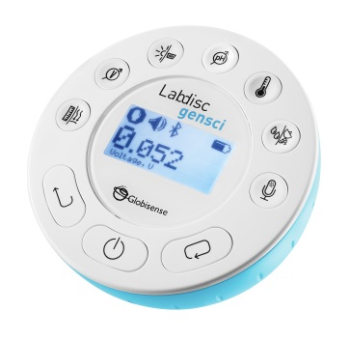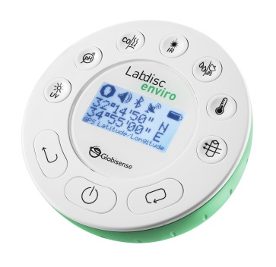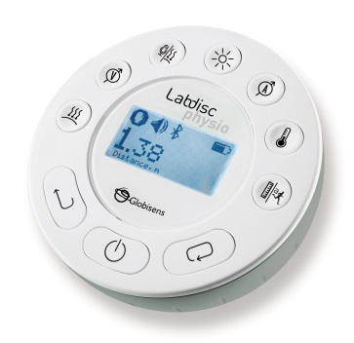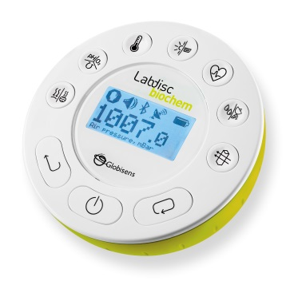

**Getting to Know the Labdisc**

**PC version**

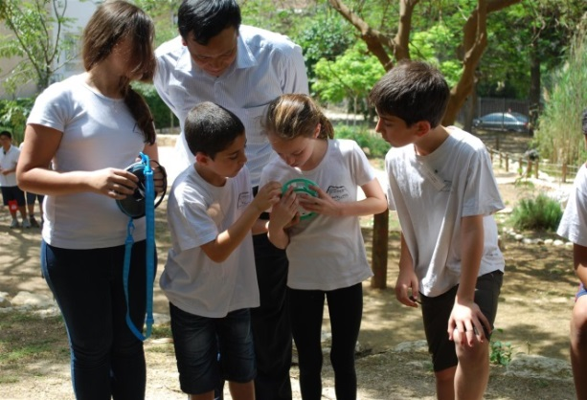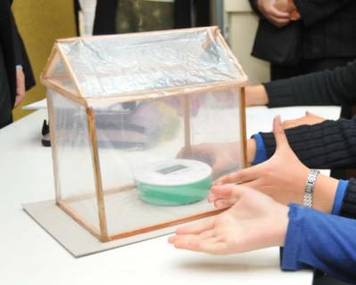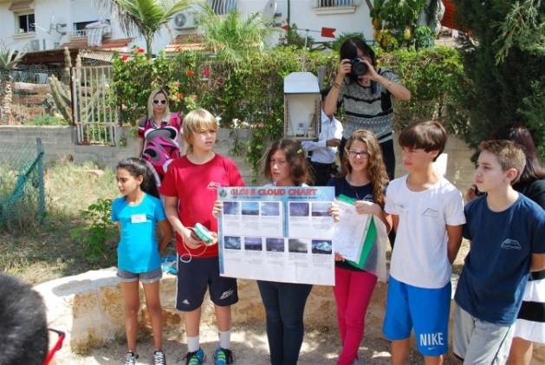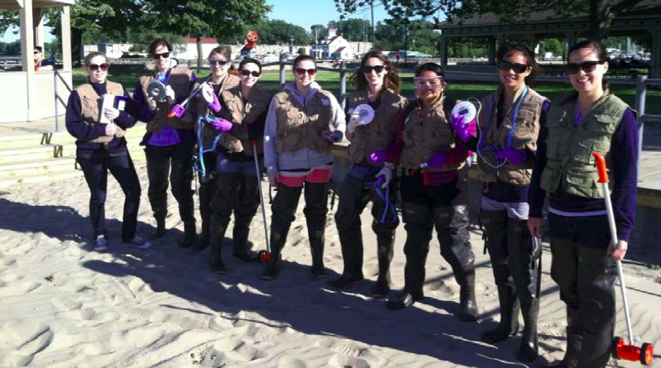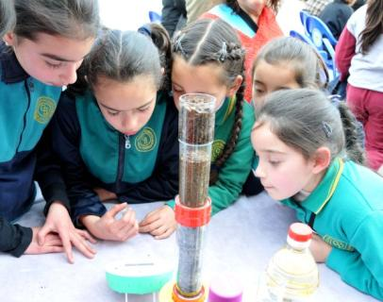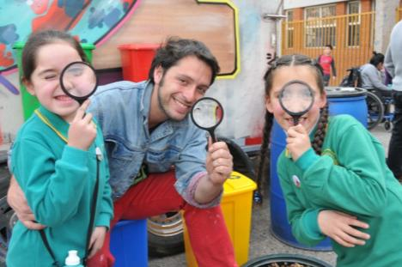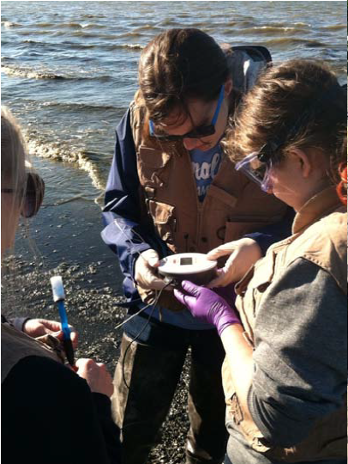



www.globisens.com

How to….

Set up the Labdisc from the Labdisc Menu 1

Pair your Labdisc with Your Computer via Bluetooth 1

Set up the Labdisc from the Globilab Menu Using a Bluetooth Connection 2

Download Your Data 3

Clear the Labdisc Memory 3

Use the Globilab Software (PC/Mac) 4

The Menu/Tool Bar 4

Open Data Files 4

Save 4

Activities 4

Export 4

Print 4

Zoom 4

Marker 4

Grid 4

Annotate 4

Crop 5

Statistics 5

Mathematical Functions 5

Set up 5

Run/Stop 5

Download 5

Display Options Menu 6

Google Earth Map 6

Customize the Display Window 7

Setting the graph title 7

Setting Y axis legend 7

Adjusting the Scale 7

Use the Labdisc Sensors 8

Accelerometer 8

Air Pressure 8

Ambient Temperature Sensor 8

Barometric Pressure Sensor 8

Colorimeter 8

Conductivity Sensor 9

Current Sensor 9

Dissolved O2 Sensor 9

Distance/Motion Sensor 9

External Temperature Sensor 10

GPS (Global Positioning Satellite) Sensor 10

Heart Rate Sensor 10

Humidity Sensor 10

Infrared Sensor 10

Light Sensor 11

Microphone 11

pH Sensor 11

Sound Sensor 11

Thermocouple 11

Turbidity Sensor 12

UV Sensor 12

Voltage 12

Available External Sensors 12

Dymo Wireless Force & Accelerometer 12

Voltage Sensor 13

CO2 Sensor 13

Heart Rate/Pulse 13

Respiration 13

Current 13

Magnetic Field 14

# Set up the Labdisc from the Labdisc Menu

1. **Turn on** the Labdisc by pressing the On/Off key. 
2. **Rotate the Labdisc plastic ring** to expose the sensors. Connect any external sensors that you might be using (pH, Dissolved O2, Conductivity, Thermocouple, External Temperature, Force/Accelerometer, Heart Rate, Current, Voltage or Magnetic Field).
3. **Select Sensors** - Press Scroll key  to open the sensor menu. Press the Select key  to open the Set Up menu  and then choose the Set Sensor icon  using the Select  key again. Select the sensors that you wish to use by pushing the buttons on the perimeter of the Labdisc. Some buttons control more than one sensor. Push the button multiple times to scroll through the available options. When the sensor(s) that you want is/are highlighted push the Escape key  to return to the set-up menu. *Note: Some buttons can only activate one sensor at a time because of the external connections needed by the sensors*
4. **Set Sampling Rate** - Press the Escape key  to return to the previous menu and use the scroll key  to move to the Sampling Rate icon  and push the Select key. Use the Scroll key  to move through the options. Use the Select key  to choose the rate at which you want to select samples. Press the Select key to confirm your choice. Options include manual, 1/second, 10/second, 100/second, 1000/second and 25000/second. The rate of collection by some sensors is limited and so you may not see all of the options for every sensor.  *Note if you choose to sample manually, skip Step #5.*
5. **Set the Number of Samples** - Press the Escape key  to leave the previous menu and use the scroll key to move to the Number of Samples icon  and push the Select key.  Use the Scroll key  to choose the number of samples you wish to collect. Options include 10, 100, 1000, 10000. Press the Select key  to confirm your choice. Press the Escape key  three times (3x) to exit the set-up menu
6. **Begin Collecting Data** - When you are ready, press the Select key  to begin the data collection.

# Pair your Labdisc with Your Computer via Bluetooth

1. Make sure that Bluetooth is enabled on your computer.
2. Turn on the Labdisc. Make sure the Labdisc is not showing the sleep icon . If it does, please press any button to leave the sleep mode.
3. Start the GlobiLab software, and right click the Bluetooth icon  located on the status bar at the bottom right corner of the screen.
4. From the new pop-up menu select "***Find more Labdiscs and sensors***"
5. The computer opens the "add a device" dialog box and starts searching for the Bluetooth device. This may take few minutes.
6. Your Labdisc will be displayed as "Labdisc-xxxx", where "xxxx" are the last four digits of the Labdisc serial number sticker.
7. Select this device and press "Next"
8. On the Labdisc: Press and hold the Scroll key  to put the Labdisc in Pairing mode
9. The Labdisc will produce a long "beep" while its screen shows "BT pairing"
10. Select the 2nd option: "Enter the device pairing code" and click Next
11. In the next dialog box enter "1234' as the pairing code and click Next
12. Wait for the computer to finish the process and announce "Your device is ready to use"
13. Right click the Bluetooth icon on the status bar. Choose the Labdisc you've just paired and click on it.
14. The computer will connect to the Labdisc and turn the Bluetooth icon blue

You can see a video of how to pair your Labdisc with your computer at <http://tinyurl.com/ParingTheLabdisc>

# Set up the Labdisc from the Globilab Menu Using a Bluetooth Connection

1. Open the GlobiLab software and turn on the Labdisc by pressing the On/Off key. 
2. If you plan to use a Bluetooth connection between the Labdisc and computer, make sure that your Labdisc has been paired with your computer. (see above) You will only have to do this the first time you use your Labdisc with a computer.
3. 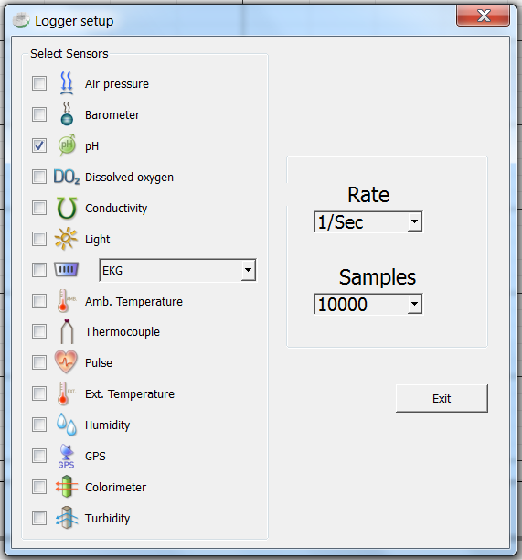Right click on the Bluetooth icon in the bottom right corner of the Globilab screen.  Select the Labdisc you are using. Once the Labdisc has been recognized by the software, the icon will turn from grey to blue and you will hear a small chirp.
4. Click on to configure the Labdisc.
5. Select sensors that you wish to use in the “Logger Set-up” window. Different sensors will show for different models of Labdisc, depending on what sensors are available.

If you are using a Globisens brand external sensor attached to the Universal Adapter port, it will show up in the set-up menu after you have attached it.

If you are using a sensor from another company, you will need to select it from the dropdown menu.

1. Click the dropdown arrow under Rate to select the sample frequency.
2. Click the dropdown arrow under Samples to select the number of samples you wish to collect.
3. Click Exit to complete the set up.

# Download Your Data

* 1. Start the Globilab software on your computer and connect to the Labdisc to the computer. This can be done using a Bluetooth or a USB connection.
     1. Click on the **Bluetooth** icon in the bottom right corner of the Globilab screen. Select the Labdisc you are using. Once the Labdisc has been recognized by the software, the icon will change from grey to blue. If you have more than one Labdisc paired with your computer, you may have to right click and select the ID number of the Labdisc with which you are trying to connect.
     2. If you prefer a **USB** connection, connect your Labdisc to the computer by plugging the USB plug into the computer and the mini USB plug into the opening on the bottom of the Labdisc (not in the sensor ring). You will hear a beep and see the color change on the USB icon at the lower right corner of the Globilab software when the Labdisc is recognized. 

1. Click on the download button  the software will open a table listing all experiments stored in the Labdisc memory. Simply select one of the experiments and hit the download key at the bottom of the table. Save the data collection by clicking the save icon.  Be sure to clearly label your data collection so that you will not confuse it with the other data collections.

# Clear the Labdisc Memory

1. Click on the Bluetooth icon in the bottom right corner of the Globilab screen. Select the Labdisc you are currently using. Once the Labdisc has been recognized by the software, the icon will turn from grey to blue.  If you have more than on Labdisc paired with your computer, you may have to right click and select the ID number of the Labdisc with which you are trying to connect. If you prefer a USB connection, follow the previous instruction, clicking on the USB icon. You will see the same color change when the Labdisc is recognized. 
2. Right click on the numbers to the bottom far right of the screen (3/127 in the example above) and select “Delete last” from the pop up menu to remove the most recent data collection from the Labdisc or you can select “Delete all” to remove all data from the Labdisc’s memory. *Be sure to save any data you wish to use later* ***before*** *clearing the Labdisc’s memory.*

***You cannot clear the Labdisc memory directly from the Labdisc.***

***You must be connected to a computer, iPad or tablet.***

# Use the Globilab Software (PC/Mac)

## The Menu/Tool Bar



|  |  |
| --- | --- |
|  | Open Data Files – this opens graphs showing experiment data previously collected and saved. Clicking on the small triangle to the right of the icon will offer another option for opening data files: . Using this option, you can open another data file in the same graph window, for comparing two or more experiment. This option is only possible if the two experiments are sampled at the same sampling rate. |
|  | Save – this saves data from a current or downloaded experiment. |
|  | Activities – this opens pdf files of lesson plans. |
|  | Export – Exporting the measurements into EXCEL in CSV format. Clicking the small rectangle to the right of the icon will open other export options, such as  for saving a screenshot of exporting the graphic window. |
|  | Print – Prints a copy of the experiment graph |
|  | Zoom – Allows you to enlarge a section of the graph. Use a left click and drag the mouse to make a box over the area that you want to enlarge. You can do this multiple times, zooming in closer and closer on a chosen section. To return to the original size, right click on the graph. The Zoom toggles on and off, so be sure to turn it off before manipulating the graph when it’s zoomed in or before selecting other buttons, like the Marker or Annotate buttons. |
|  | Marker – this allows you to place markers along a graph line using a left mouse click. The pop-up window gives you detailed information about the data at that specific point in time. Hold down the left mouse button to slide the marker along the graph line to see details at different points in time or you can drag them to a different line to see information about other types of data in the same collection. Only two markers can be set on the screen at one time. By double clicking on the marker you can lock it in place. Markers are also used to set the parameters of an area that you want to crop from within the graph. To remove a marker, right click on it and select “yes” when asked if you want to delete the marker. The marker button toggles on and off. To exit marker mode, click the marker button again |
|  | Grid – this turns the background grid on and off. |
|  | Annotate – this allows you to add labels to your graph to explain what is happening on the graph. There are two types of annotations – a rectangle and a bubble shape that can be linked to specific places on the graph. You can also add pictures to your annotations by clicking the “add image” button.” You can an unlimited number of annotations to a graph. To remove an annotation, right click on it and select “yes” when asked if you want to delete the annotation. The annotation button toggles on and off, so to exit marker mode, just click the annotation button again. |
|  | Crop – this allows you to select a specific portion of the graph to be extracted and saved separately. To crop a section of the graph, use the marker button to set a marker at the beginning and the end of the area that you want to save. Then select the crop button. All other data will be removed permanently from the graph. |
|  |  |
|  | Statistics – this allows you to quickly see the maximum and minimum values for a specific data collection as well as the average reading, the standard deviation and the number of samples and sampling rate. If you have collected multiple types of data in a single experiment, you’ll need to click on the data labels in the upper right-hand corner of the graph to select which type of data you want to see in the statistics. |
|  | Mathematical Functions – Globilab allows you to apply many different mathematical functions to your data. This drop-down menu will allow you to select from:  Slope – is used to show the slope at any point on the graph. You can move the slope along the graph, seeing the slop value in the function pop up box.  Linear Regression – is used to display the bets linear line to fit the graph between two markers. A pop-up box will display the mathematic formula for the line between the two markers in the Y = aZ + b format.  Quadratic Regression – is used to display the best parabolic line to fit the graph between the two markers. The pop-up box will display the mathematic formula for the line between the two markers in the Y = aX2 = bX = c format.  FFT – is used to split the graphic display to show the original measurements in a time scale in the top window and to show its harmonics, on a frequency scale in the lower window.  Smooth – is used to average a graph. Every sample is an average of the 2 readings before and 2 after samples. It can be useful in case the graph is very noisy.  Derivative – is used to measures the sensitivity to change of a quantity in one data source (a function or dependent variable) which is determined by another quantity or another data source (the independent variable). i.e. light as a function of time. |
|  | Integral – is used to calculate the area under the graph between the two markers. Value is shown in the Integral pop up box. |
|  | Set up – this allows you to select which sensors and set up the desired collection rate and collection size from the computer rather than from the Datahub itself. In order to use the set-up button, the Datahub must be connected to the computer/tablet by either a Bluetooth or USB connection and must not be running and experiment. |
|  | Run/Stop – this allows you to begin or stop the collection of data. Like the set-up button, this button will only work if the Datahub is connected to the computer/tablet by a Bluetooth or USB connection. |
|  | Download – the Labdisc can hold up to 127 different experiments in its memory. this allows you to download experiments stored in the Labdisc memory. |
|  | **Configuration** – this allows you to set up the physical running of the Labdisc including; sound on/off, temperature in Celcius/Farenheit, Bluetooth on/off, GPS enabled/disabled and to set the language used by the Labdisc. |
|  | Display Options Menu – This allows you to select the format for data display. It includes: |
|  | Line graph – if there is data of more than one type displayed, you can set the scale on the left for different active sensors by ***left*** clicking on the sensor name in the legend in the upper right-hand corner of the screen. A single ***right*** click on the sensor name will change the line to individual data points. A second ***right*** click will hide the sensor data from the graph. A third ***right*** click will return the sensor graph to a line. To change the color of a line, ***left***click on the line and select a new color. |
|  | Bar graph –bar graphs will show data from only one sensor at a time. To change which data is displayed, left click the sensor name in the upper left-hand corner of the screen. |
|  | Data table –shows data that in a chart format. This can be used to view exact measurements for every collection. If you have an outlier data point, it can be eliminated or corrected in this format. |
|  | Line graph and Data Table – shows both a line graph and a data table simultaneously. |
|  | Meters – meters are best used when the Labdisc is connected to the computer during the data collection since they show changes in the data values as they are happening. There are several different options for meters including; |
|  | |  |  |  |  |  |  | | --- | --- | --- | --- | --- | --- | | Full Dial | Half Dial | Vertical  Bar | Horizontal  Bar | Numeric  Readout | Red, Blue & Green Colorimeter Bulb | |  |  |  |  |  |  |     To change between different meter types or to adjust the range of a meter, left click on the meter to open a pop-up window where you can select options. You can select to view 1, 2, 4 or 6 meters by clicking on the meter icons at the bottom of the screen. |
|  | Google Earth Map – this allows you to overlay a Google Earth map of the area where your experiment was conducted with the data from the sensors in that experiment. You must have an Internet connection for this to work properly. |

# 

# Customize the Display Window

Setting the graph title – To customize the graph with the name of your experiment, double click on the graph title to get a pop-up window. You can then add the title of your experiment. The default title will be the date and time that the experiment was conducted.

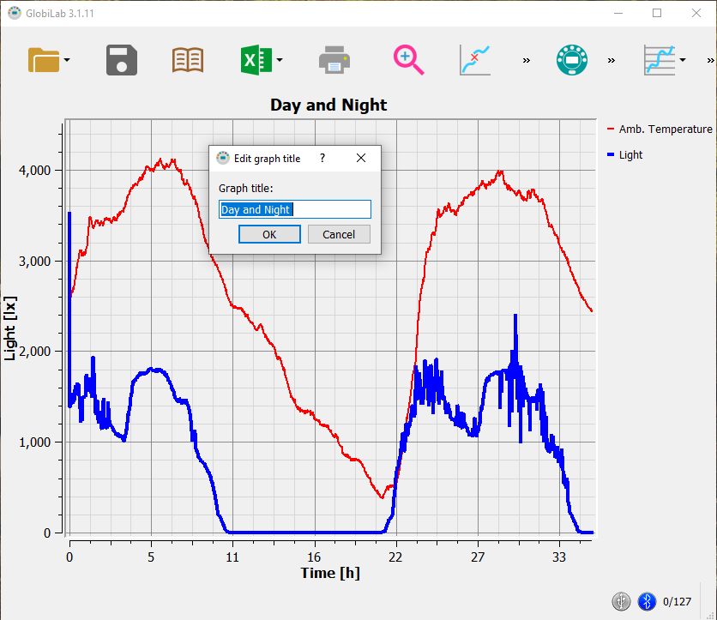

Setting Y axis legend – to set the Y axis for a specific sensor, left click on the sensor name in the upper left hand side of the screen (A) to activate that sensor’s reading.

Adjusting the Scale – right click on the Y axis scale to get a pop up window. Type in a minimum number slightly lower than your lowest reading and a maximum number slightly higher that your highest reading. This will give you the greatest detail on your graph (B).

A. 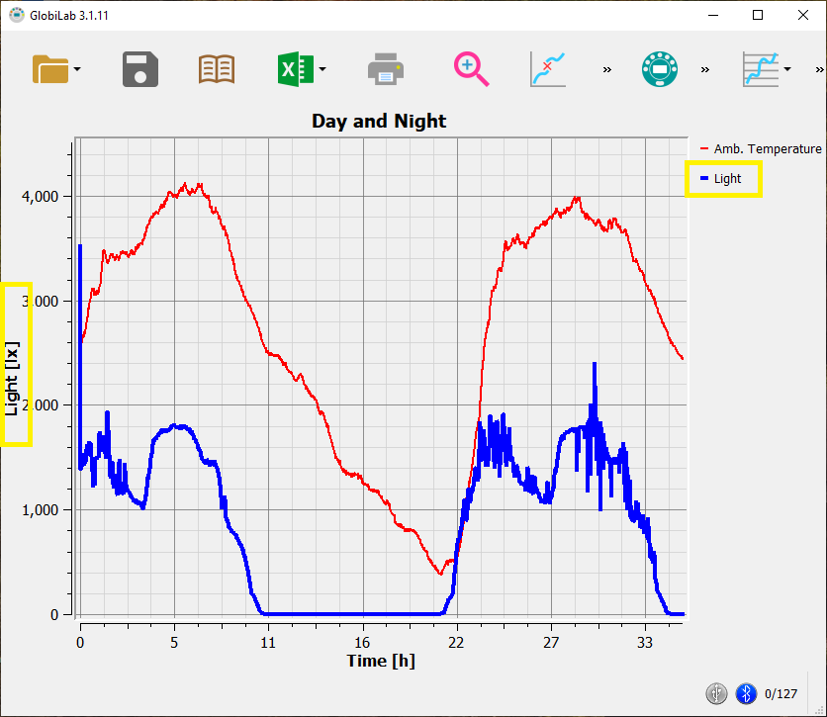 B. 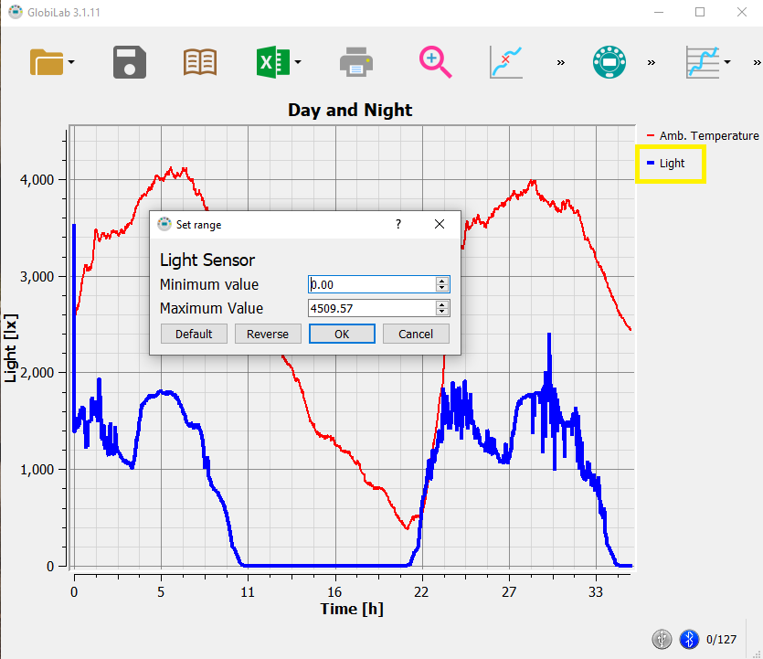

# Use the Labdisc Sensors

When using any of the Labdisc sensors, be sure to rotate the outer ring so that the sensor is exposed to the environment during the experiment unless otherwise noted.

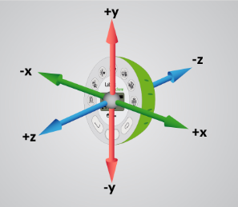

Accelerometer (Physio)

No additional set up is needed for the Accelerometer. This sensor measures changes in velocity over time.  For acceleration measurements to have any meaning, they must be given in reference to a specific coordinate frame. Acceleration is measured in meters/second2.

Air Pressure (GenSci, Physio & BioChem)

No additional set up is needed for the Air Pressure sensor, but be sure that the outer ring of the Labdisc is rotated to a fully open position to ensure that the sensor is exposed to the environment. Air pressure is measured in kilo Pascals (kPa) which is a metric measure of force per unit area, defined as one newton per square meter. Standard air pressure on Earth is 101.325 kPa.

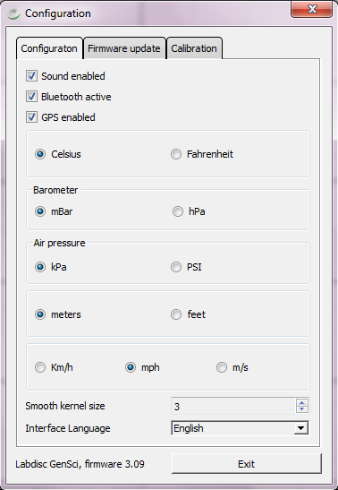

Ambient Temperature Sensor (All Labdisc Models)

No additional set up is needed for the Ambient Temperature sensor. This sensor is best when used for data collections longer than 30 minutes. Because it is an internal sensor, it may take up to 15 minutes to equalize to the environmental temperature. The Ambient Temperature sensor is primarily used for long term, environmental temperature measurements. The Ambient Temperature sensor can be set to measure in either Celsius or Fahrenheit. To set this, select the Configuration Button  and either check or uncheck the Temperature in Fahrenheit tick box.

Barometric Pressure Sensor (Enviro & BioChem)

No additional set up is needed for the Barometer, but be sure that the outer ring of the Labdisc is rotated to a fully open position to ensure that the sensor is exposed to the environment. Barometric pressure is measured in millibars (mb). Standard sea level pressure is 1013.23 mb

Colorimeter (BioChem & Enviro)

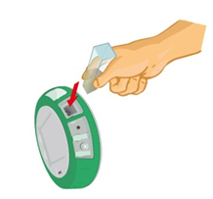Before each use, calibrate the colorimeter with the solvent you will use during the experiment. This is important to minimize experimental error of the measurement. To calibrate, fill the cuvette ¾ full with solvent (often distilled water) and place the cuvette in the output. Press and hold the colorimeter button on the Labdisc until you hear a long beep. When finished the calibration, remove the cuvette from the colorimeter. To take a data reading, fill the cuvette ¾ full with solution from the sample. Be sure to ALWAYS hold the upper part of the cuvette to avoid leaving fingerprints on the cuvette. Insert the cuvette into the appropriate space and, keeping the top of the cuvette pointed upwards; rotate the outer protective ring shut over the cuvette.

Conductivity Sensor (BioChem)

*Prior to first use,* soak the conductivity sensor in distilled water for 30 minutes. Connect the probe to the Labdisc and dip in a 0.1 M KCl solution or other standard with known value. The cell portion of the probe must be fully immersed in the known solution. Stir with the probe to remove any air bubbles trapped within the cell chamber. No air bubbles can be present when measuring. If a 0.1 KCl solution is used to calibrate the meter adjust the meter reading according to the standard value printed on the bottle. After calibration, rinse the probe thoroughly with distilled water.

Submerge the end of the probe in the solution being measured, being sure to completely submerge the cell membrane. Shake the probe well to remove any air bubbles trapped within the cell chamber and check the readout for the solutions conductivity. While the conductivity probe does not tell you which specific ions are present in the sample, it does quickly confirm the total concentration of ions in that sample. Do not touch the probe’s cell surface with any hard object. If the cell surface becomes contaminated, soak the probe cell portion in a light detergent and a mile acid for about 15 minutes each and then rinse thoroughly with distilled water. The Conductivity Probe is used to measure the ability of a solution to conduct electrical current. This is done by measuring the concentration of dissolved solids which have been ionized in a polar solution like water. Conductivity is measured in micro-Siemens (mS).

Current Sensor (GenSci & Physio or External Sensor on any Labdisc)

Rotate the outer ring of the Labdisc to expose the Current Sensor connection port and plug the smaller end of the banana cables into the appropriate ports (red to red, black to black). When using the Current sensor with a GenSci, Enviro or BioChem Labdisc, plug the external sensor into the external sensor micro USB port and then plug the smaller end of the banana cables into the appropriate ports on the external sensor. Wait for the Current sensor to auto calibrate and show a zero reading before beginning data collection. Labdisc measures electrical current in Amperes or Amps (A).

Dissolved O2 Sensor (BioChem & Enviro)

Prior to first use, unscrew membrane module at the bottom of the electrode. Rinse the membrane module with distilled water and blot dry. Completely fill the membrane module with dissolved oxygen electrolyte solution for Galvanic DO Probes. Rinse the internal anode/cathode element with distilled water and blot dry. Screw the membrane module onto the end of the electrode being careful not to over tighten. Rinse with distilled water. Attach the Dissolved O2 sensor to the input bracket by inserting and turning ¼ turn. Use an aquarium pump to bubble air through 100 ml of water in a 150 ml beaker to completely saturate the water with oxygen, stirring gently with the DO sensor. Keep the sensor at a 20◦ angle to avoid trapping air bubbles in the sensor. After 20 minutes, hold the Labdisc DO2 key down for 3 seconds until you hear a long chirp. The Labdisc should read 8.25 mg/l with is the reading for water saturated with oxygen at room temperature. To use, insert the sensor into the liquid sample and stir slowly and continuously until the value on the Labdisc stays constant. Dissolved O2 is measured in milligrams per liter (mg/l)

Distance/Motion Sensor (GenSci & Physio)

The distance sensor is used to measure distance between or the change in distance between the Labdisc and an object. The distance sensor has a viewing angle of +/-15 degrees, so when using it (especially with moving objects) be sure that there are no other objects within that viewing field that might interfere with the distance reading. The distance sensor is located on bottom of the Labdisc with a round plastic door covering it. Be sure to fully open the door before beginning data collection with the distance sensor. The distance sensor measures distance in meters with a range of 0.4 meter to 10 meters. Be sure to have your object at least 40cm away from the distance sensor.

External Temperature Sensor (All Labdisc models)

Plug the External Temperature sensor into the outlet in the Labdisc and insert the tip (at least 2cm) into the item/area where temperature is being measured. The External Temperature sensor is suitable for taking environmental temperatures as well as the temperature of liquids and loosely packed solids like soil or sand. The External Temperature sensor can be set to measure in either Celsius or Fahrenheit. To set this, select the Configuration Button  and either check or uncheck the Temperature in Fahrenheit tick box.

The External Temperature sensor is also available as an external sensor, which allows for the collection of two different temperature readings simultaneously. The external sensor is plugged into the Universal USB port and then the Temperature Probe is plugged into the sensor.

GPS (Global Positioning Satellite) Sensor (GenSci, Enviro & BioChem)

The GPS sensor is located behind the housing of the Humidity sensor. It can be used to measure location or speed of movement over a large area. The GPS sensor can also be used to position other collected data onto a Google Map, providing accurate information about where the data was collected. The GPS sensor will report the longitude/latitude, speed/course and time/date of the data collected.

The GPS needs to sync to three or more satellites in order to provide accurate global positioning coordinates. As such, it should be used in an outdoor environment. Once it has synced you'll see three arcs above the small GPS antenna icon  on the Labdisc LCD. When the Labdisc is first used, the GPS is in a "cold start" mode and it might take it 20 to 30 minutes to sync. After the GPS syncs for the first time it will remember the sync data of the specific satellites, even when the Labdisc is turned off. This assures a fast sync of up to one minute in all future recordings.

Heart Rate Sensor (BioChem or External Sensor on any Labdisc)

The ear clip has an IR light source on one side and a light detector on the other side. Blood flowing through the body changes the skin IR transparency, which is measured by this sensor. The ear clip should be placed on the soft section of the ear lobe (an earring hole may interfere with the senor). You can also attach the sensor clip to the tip of the index finger or the webbing between the thumb and index finder.

If a clear pulse is not observed in the first 5 seconds of measurement, the IR intensity will be increased and check again for 5 seconds. If a pulse is still not registered, the IR intensity will increase to the maximum intensity. At this point, if there is not pulse detected, it may mean that the clip is connected improperly. For each pulse, the Labdisc will produce a short beep.

There are two possible configurations for the Heart Rate sensor.

On the *Biochem Labdisc*, the Heart Rate sensor is internal. Plug the ear clip into the port on the Labdisc and place the clip onto your ear lobe. The clip will measure both the overall heart rate and the individual waveforms of each heartbeat. After a pulse is detected, the Labdisc will count 16 pulses and then start to display the heart rate in beats per minute (bpm).

When using the external heart rate sensor with a GenSci, Enviro or Physio Labdisc, plug the external sensor into the external sensor micro USB port and then plug the ear clip into the external sensor. In this format, the clip will measure the individual wave forms of each heartbeat, but will not show a graph line indicating the overall heart rate.

Humidity Sensor (Enviro, BioChem & GenSci)

No additional set up is needed for the Humidity sensor, but be sure that the outer ring of the Labdisc is rotated to a fully open position to ensure that the sensor is exposed to the environment. It is used to measure the amount of water vapor in the air expressed as a percentage of the amount needed for saturation at that same temperature. Humidity is measured as a percentage value comparing these two.

Infrared Sensor (Enviro)

No additional set up is needed for the IR sensor, but be sure that the outer ring of the Labdisc is rotated to a fully open position to ensure that the sensor is exposed to the environment. An infrared sensor infers temperature from a portion of the thermal radiation emitted by the object being measured. IR by measured as the heat that is radiated off of objects. IR temperatures are measured in Celsius degrees.

Light Sensor (GenSci, BioChem & Physio)

No additional set up is needed for the light sensor, but be sure that the outer ring of the Labdisc is rotated to a fully open position to ensure that the sensor is exposed to the environment. Do not point the light sensor directly at the sun. This sensor measures the brightness of light in lux. One lux is equal to one lumen per square meter. It is used as a measure of the intensity, as perceived by the human eye, of light that hits or passes through a surface.

Microphone (GenSci & Physio)

There is no additional set up needed to use the Microphone sensor, but be sure that the outer ring of the Labdisc is rotated to a fully open position to ensure that the sensor is exposed to the environment. The Microphone measure the sound wave form in voltage. With the Microphone sensor, you typically record at a very fast rate of 25,000 samples per second.

pH Sensor (Enviro, GenSci & BioChem)

Attach the pH sensor to the input bracket by inserting and turning ¼ turn. The pH meter will measure the H ion activity in a solution. The pH sensor is factory calibrated and under normal conditions does not require any calibration. If you need to calibrate this sensor; insert the Labdisc pH electrode into a 7.0pH buffer and wait for the pH reading to stabilize. Press and hold the pH key for 3 seconds, until you hear a long beep sound and the pH sensor is calibrated and will show a reading between 6.95pH to 7.05pH. To take a pH measurement with the sensor, completely insert the tip into the liquid sample without touching the sides of the container. After each measurement the pH probe should be cleaned with distilled water. Always keep the wash bottle and distilled water close at hand. If you don’t have a wash bottle you will need a syringe of at least 10 ml in order to clean the sensor properly. When not in use, the pH sensor should be stored in the buffer solution. The pH sensor measures the number of Hydrogen ions in a solution and is measured on the pH scale of 0 to 14 with readings in the 0 to 6.9 range being considered basic/alkaline and readings in the 7.1 to 14 range being considered acidic. Readings of 7 are considered to be neutral – neither acidic nor alkaline.

Sound Sensor (Enviro)

There is no additional set up needed to use the Sound sensor, but be sure that the outer ring of the Labdisc is rotated to a fully open position to ensure that the sensor is exposed to the environment. The Sound sensor measures sound level in decibels. With the Sound sensor, you typically use 10/second as the sampling rate.

Thermocouple (BioChem)

Rotate open the outer ring to expose the thermocouple outlet. Firmly push the plug of the sensor into the Labdisc with the wider prong of the plug to the right. The thermocouple is used to measure temperatures in situations that might not be well suited to a thermometer. Thermocouples have a wider range of temperature measurement; as much as -200◦C to +2500◦C. Because they are small and have low thermal capacity, they offer a rapid response. Thermocouples are robust and are not prone to self-heating and are safe. The thermocouple sensor measures temperature in degrees Celsius.

Turbidity Sensor (BioChem & Enviro)

To use the sensor, fill the cuvette to a 75% volume with the samples and measure the turbidity, being sure the cuvette is dry outside. Insert the cuvette into the appropriate space and, keeping the top of the cuvette pointed upwards; rotate the outer protective ring shut over the cuvette.

This sensor is factory calibrated. Recalibration is a very simple process and can be done by users. Calibrate the turbidity sensor by placing a cuvette full with distilled water (<10 NTU) into the sensor. Place the Labdisc on the table and rotate the outer protective ring shut over the cuvette. Press and hold the turbidity key for 3 seconds until a long beep is heard. The Labdisc will store the calibration value for 0NTU and will ask you to replace the cuvette with another cuvette filled with a 1000 NTU standard. Once ready, press and hold the turbidity key for 3 seconds until a long beep is heard. Now the turbidity sensor is fully calibrated. Calibration values are kept even when the Labdisc unit is turned off.

UV Sensor (Enviro)

Be sure that the outer ring of the Labdisc is rotated to a fully open position to ensure that the sensor is exposed to the environment. Point the UV sensor directly at the light source for which you wish to measure UV rays. The Ultraviolet sensor measures UV levels with the UVI or Ultraviolet Index. The UV Index is designed as a linear scale, directly proportional to the intensity of UV radiation that causes sunburn. An index of 0 corresponds to zero UV irradiation, while an index of 10 corresponds roughly to midday summer sun with a clear sky. Measurements greater than 11 are quite common in summer at low latitudes, high altitudes, or in areas with above-average ozone layer depletion.

Voltage (Physio or External Sensor on any Labdisc)

Rotate the outer ring of the Labdisc to expose the Voltage Sensor connection port and plug the smaller end of the banana cables into the appropriate ports (red to red, black to black). When using the Voltage sensor with a GenSci, Enviro or BioChem Labdisc, plug the external sensor into the external sensor micro USB port and then plug the smaller end of the banana cables into the appropriate ports on the external sensor. Wait for the Voltage sensor to auto calibrate and show a zero reading before beginning data collection. Labdisc measures Voltage in volts. The volt (V) is the unit of measurement for the electric potential difference between two points.

## Available External Sensors

Some of these sensors come built in on various Labdisc models but are available as external sensors for use with other Labdisc models.

### Dymo Wireless Force & Accelerometer

This sensor allows for wired (via USB) or wireless (via Bluetooth) communication of data relating to force and acceleration. If using Bluetooth communication (recommended for all motion/acceleration activities), you will need to pair the Dymo with your computer the first time you use the sensor. To do this, turn on the Dymo using the on/off button. Press and hold the Bluetooth button for 3 seconds to enable Bluetooth communication. You will see the blue light flash 3x. Then right click on the Bluetooth icon  in the lower right corner of the Globilab window and click on “Find More Labdiscs and sensors.” When the “add a device” window pops up, select your Dymo using the last 4 digits from the sticker on the back of the Dymo to identify it. Use 1234 as the pairing code and click “next.” Then right click the Bluetooth icon again and select the Dymo that you just paired.

To use the Dymo, press the on/off key. The LED will flash green and the device will be on. To start data collection, push the on/off button again (a 3 second hold on the on/off button will turn the Dymo off). When you are finished your data logging, push the on/off button again to stop logging. You can also use the start/stop button in the Globilab software to start/stop your data logging.

If you wish to Zero Force Offset, turn the Dymo off. Remove any weights from the sensor. Disconnect it from the Globilab software. Turn the sensor on again and press both the Bluetooth *and* the On/Off keys simultaneously until the Bluetooth LED is a constant blue. A flashing red light indicates that the battery is low (if unplugged) or charging (if plugged in). Acceleration is measured in meters/second2. Force is measured in Newtons (N). A Newton is unit of force needed to move a 1 Kg mass at the rate of 1 m/sec2. Since *F=ma*, 1N=1 kg*m/s2.

### Voltage Sensor

When using an external voltage sensor with a GenSci, Enviro or BioChem Labdisc, plug the external sensor into the external sensor micro USB port and then plug the smaller end of the banana cables into the appropriate ports (red/red, black/black). When using the Voltage sensor with a GenSci, Enviro or BioChem Labdisc, plug the external sensor into the external sensor micro USB port and then plug the smaller end of the banana cables into the appropriate ports on the external sensor. Wait for the Voltage sensor to auto calibrate and show a zero reading before beginning data collection. Voltage is measured in volts (V), the unit of measurement for the electric potential difference between two points

External Temperature Sensor



When using an External Temperature sensor with any Labdisc model, plug the external sensor into the external sensor micro USB port and then plug the Temperature Probe is plugged into the sensor. Since all Labdisc models come with an External Temperature sensor built-in, the USB connected External Temperature sensor can be used to measure the temperature of two substances simultaneously. The External Temperature sensor can be set to measure in either Celsius or Fahrenheit. To set this, select the Configuration Button  and either check or uncheck the Temperature in Fahrenheit tick box.

### CO2 Sensor

When using a CO2 sensor with any Labdisc model, plug the external sensor into the external sensor micro USB port. The first time the CO2 is used, you will need to connect the Labdisc to its AC/DC adapter and allow the CO2 sensor to run for 24 hours, to reach calibration.

### Heart Rate/Pulse

When using an External Heart Rate sensor with a GenSci, Enviro or Physio Labdisc, plug the external sensor into the external sensor micro USB port and then plug the ear clip into the external sensor. Place the clip on the fleshy part of the ear lobe, in a small “pinky” finger or on the webbing of skin between the thumb and index finger. With an External Heart Rate sensor, the clip will measure the individual wave forms of each heartbeat, but will not show a graph line indicating the overall heart rate. The pulse waveform will be measured in Volts (V).

### Respiration

Prior to using the Respiration sensor with any Labdisc model, wash the silicon mouthpiece and dry well before installing it on the Respiration probe. Then connect the Respiration sensor to the Micro USB socket. Turn on the Labdisc. If the airflow through the Respiration sensor is within ±10% around zero, the Respiration sensor will auto calibrate and show a zero reading. Have students insert the mouthpiece and begin breathing through the Respiration probe. Respiration is measured in liters per minute (L/min).

### Current

When using the External Current sensor with an Enviro or BioChem Labdisc, plug the external sensor into the external sensor micro USB port and then plug the smaller end of the banana cables into the appropriate ports (red to red, black to black). When using the Current sensor with a GenSci, Enviro or BioChem Labdisc, plug the external sensor into the external sensor micro USB port and then plug the smaller end of the banana cables into the appropriate ports on the external sensor. Wait for the Current sensor to auto calibrate and show a zero reading before beginning data collection. Labdisc measures electrical current in Amperes or Amps (A).

### Magnetic Field

When using the Magnetic Field sensor with any Labdisc model, plug the external sensor into the external sensor micro USB port and use the probe’s switch to select the Earth’s magnetic field range. Use ±0.2 mT for measuring the Earth’s magnetic field or any other very weak field. Use ±10 mT for measuring the magnetic field near wires carrying current, inside coils and for constant magnetic fields. Magnetic fields are measures in millitesla (mT) units.