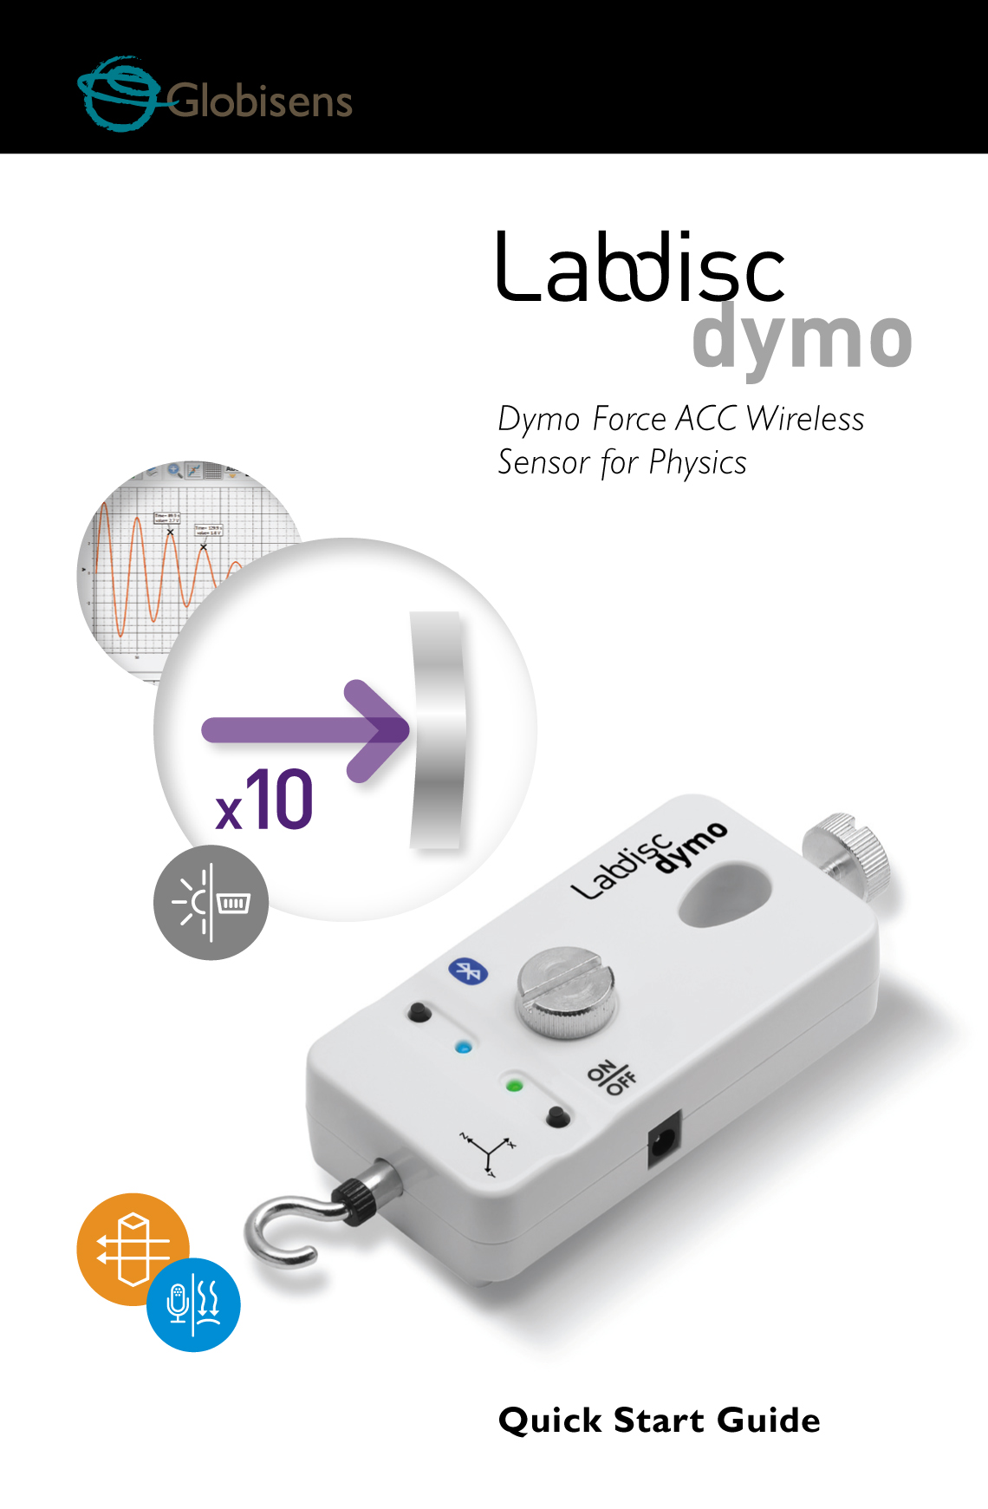

Contents

[1. Dymo Sensor Hardware Overview 1](#_Toc472761426)

[1.1 What’s in the Pack 1](#_Toc472761427)

[1.2 Ports and Controls 2](#_Toc472761428)

[1.3 Hardware Specifications 3](#_Toc472761429)

[1.4 Dymo Operation, Keys and Indicators 4](#_Toc472761430)

[2 Dymo Sensor – GlobiLab Communication 5](#_Toc472761431)

[2.1 USB Communication 5](#_Toc472761432)

[2.2 Bluetooth Wireless Communication 5](#_Toc472761433)

[2.2.1 Set the Dymo to “pairing mode” 5](#_Toc472761434)

[2.2.2 Pairing with Windows OS 6](#_Toc472761435)

[2.2.3 Pairing with a Mac OS 6](#_Toc472761436)

[2.2.4 Pairing with an iPad 7](#_Toc472761437)

# 1. Dymo Sensor Hardware Overview

## 1.1 What’s in the Pack

|  |  |  |  |  |  |  |
| --- | --- | --- | --- | --- | --- | --- |
| ① Dymo sensor  ② USB cable  ③ Bumper head  ④ Warranty page  ⑤ Quick Start Guide     |  |  |  | | --- | --- | --- | | cid:image004.jpg@01CDBF21.1D0A4250  **1** | DSC_0011.JPG  **2** | **3**  C:\Users\ilancitrin\Desktop\Untitled.jpg | | **4** | **5**  cid:151A1878-4EF1-4671-A588-0B985B47CA0B |  | |

## 

## http://www.altayscientific.com/red/en/images/accessories/RED-Force-Sensor-Accessory-Pack.jpg1.2 Ports and Controls

**5**

**4**

The picture below reviews the **Dymo** ports, controls and indicators:

**1**

① Bluetooth key and LED

② USB port

③ Lab stand locking screw

④ Lab stand hole

⑤ Screw for locking to a trolley

⑥ Charger input

⑦ On/Off key and LED

⑧ Hook

**7**

**1**

**3**

**4**

**2**

**8**

**6**

**5**

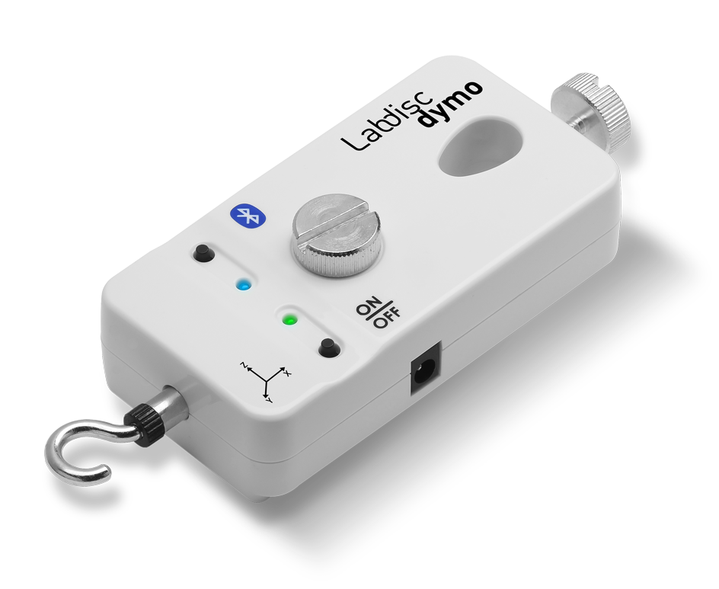

## 1.3 Hardware Specifications

| ***Parameter*** | ***Specification*** |
| --- | --- |
| **Measurement** | Force, 3-axis acceleration |
| **Force Range** | ± 50 N |
| **Acceleration Range** | ± 8 g |
| **Sampling Rate** | 500 Hz |
| **Transmission Rate** | * PC/MAC: 25 times per second * iPad: 10 times per second |
| **Onboard Memory** | None |
| **GlobiLab Software Communication Interface** | * Bluetooth * USB cable |
| **External Power Supply** | 6V AC/DC adapter (**use Labdisc adapter**) |
| **Internal Battery Type** | Single 3.7 V Li-PO cell |
| **Push Buttons** | * On/Off button:  On, Run, Stop (short press), Off (long press) * Bluetooth button (long press for pairing) |
| **Communication LED** | LED (Blue) |
| **Working Mode LED** | Bi-color LED (Red, Green) |

## 1.4 Dymo Operation, Keys and Indicators

| ***Operation*** | ***Key*** | ***LED indicator*** |
| --- | --- | --- |
| **Turn Dymo on** | Press On/Off key when Dymo is Off | On/Off LED flashes green |
| **Turn Dymo off** | Press On/Off key for 3 seconds when Dymo is On | Both LED off |
| **Start logging data** | Press the On/Off key when the Dymo is On | On/Off LED constant green light |
| **Stop logging date** | Press On/Off key when Dymo is logging data | On/Off LED flashes green |
| **Bluetooth pairing** | Press Bluetooth key for 3 secons | Bluetooth LED flashes 3 times in blue, then turns off. |
| **Zero Force Offset** | Turn Off the sensor. Remove any weight from the Force sensor. Disconnect it from the computer. Turn the sensor On. Press BOTH keys for 3 seconds. | After both keys are pressed for 3 seconds, Bluetooth LED lights in constant blue |
| **Battery charging** | N/A | On/Off LED slow flashing red. |
| **Low battery** | N/A | On/Off LED fast flashing red light |

# 2 Dymo Sensor – GlobiLab Communication

## 2.1 USB Communication

Upon USB cable connection between the computer and the **Dymo,** the **GlobiLab** software automatically detects the USB connection and begins communicating with the sensor.

## 2.2 Bluetooth Wireless Communication

Before wireless communication with a **Dymo** for the first time, the **Dymo** should be added as a device to the computer in a process called pairing. Pairing need be done only once for the **Dymo**, after which the computer stores the connection information, including a unique name for each **Dymo** sensor. When no **Dymo** is connected via USB, the computer will automatically try to wirelessly connect to the last connected **Dymo**. To connect to a different or a new **Dymo**, right click on the Bluetooth icon in the GlobiLab ***status bar,***  located at the bottom right corner of the screen, then click on the **Dymo** you want to connect to.

### 2.2.1 Set the Dymo to “pairing mode”

1. Turn on the **Dymo**.
2. Press the **Dymo** Pairing button for at least three seconds until the Pairing LED flashes green three times. The **Dymo** is now in Bluetooth mode.

### 2.2.2 Pairing with Windows OS

1. Start the GlobiLab software.
2. Right click the ***Bluetooth***  icon, located on the ***status bar*** at bottom right corner of the GlobiLab.
3. This action opens a pop-up menu. From the menu select “***find more Labdisc and sensors***”. The computer opens the “***add a device***” dialog box and starts searching for the Bluetooth device.
4. Your **Dymo** will be displayed as “***Dymo\_xxxx***” where “xxxx” are the 4 last digits of the **Dymo** serial number sticker. Select this device and press ***Next***.
5. Select the 2nd option: “***Enter the device pairing code***” and press ***Next***.
6. In the next dialog box enter “1234” as the pairing code and click ***Next***. Wait for the computer to finish the process and announce that the **Dymo** and computer were paired successfully.
7. Right click the ***Bluetooth*** icon on the ***status bar***. Choose the **Dymo** you’ve just paired and click on it. The Computer will connect to the **Dymo** and will turn the ***Bluetooth*** icon blue.

### 2.2.3 Pairing with a Mac OS

1. Open the ***Bluetooth*** menu from the Mac menu bar and select "Set Up Bluetooth Device...".
2. A dialog box opens. Your **Dymo** will be displayed as “***Dymo\_xxxx***” where “xxxx” are the 4 last digits of the **Dymo** serial number sticker. Select this device and press ***Continue***.
3. Put your **Dymo** in pairing mode again (see 2.2.1)
4. In the next dialog box press the “**Passcode Options…**” button and select the 3rd option: “***Use a specific passcode***”. Enter the passcode “1234”, press “**OK**” and “**Continue**”.
5. When the wizard action is complete wait for the computer to confirm that the **Dymo** was added successfully. The **Dymo** is now paired, and the software can connect to it.
6. Open the **GlobiLab** software.
7. Right click the ***Bluetooth*** icon  located at the bottom right corner of the software.
8. Choose the **Dymo** you’ve just paired and click on it. The computer will connect to the **Dymo** and turn the ***Bluetooth*** icon blue.

### 2.2.4 Pairing with an iPad

1. Launch the iPad Setting cid:image004.jpg@01CDB096.820AEEF0
2. Open Bluetooth. Make sure the iPad Bluetooth is on.
3. From the devices list click the ***Dymo\_xxxx***, where the ***xxxx*** digits match the last 4 digits of your **Dymo** serial number sticker on the **Dymo** back cover.
4. The iPad will ask for a PIN code. Enter “1234” and click Pair.
5. The iPad will show ***Dymo\_xxxx*** connected.

Rev: 31.01.17